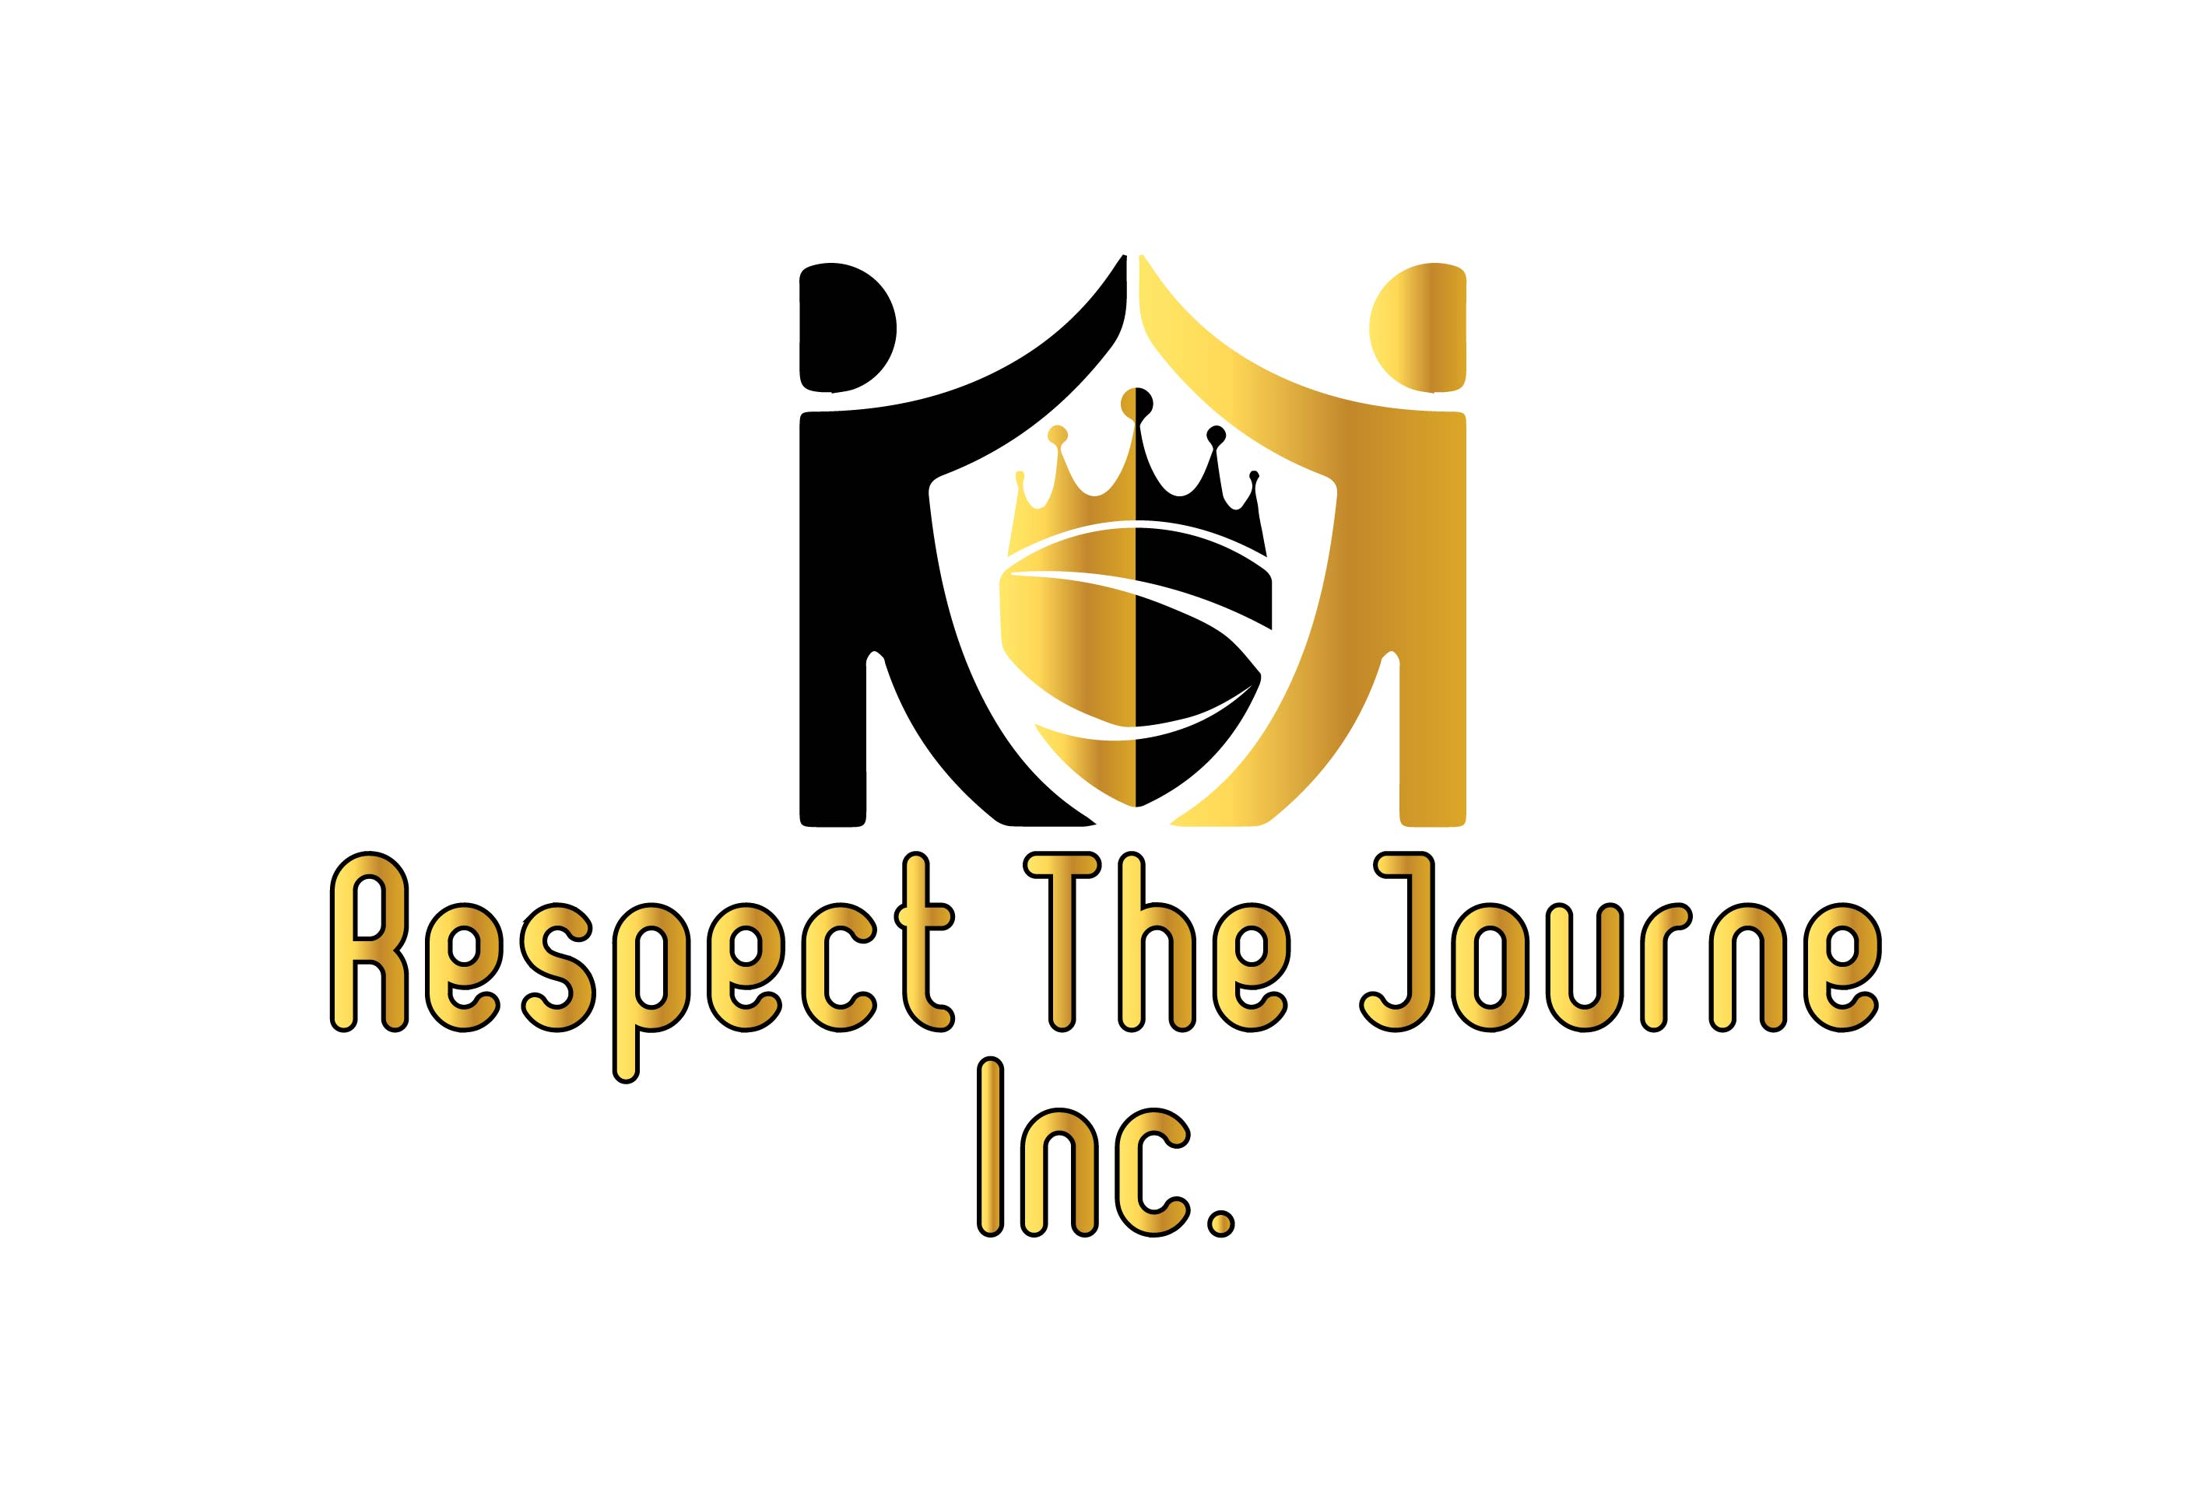Respect The Journe,

Work hard, dream big! The "Vision and Effort" is to initiate the proper foundation and blueprint, needed to establish for the younger generation to achieve success in all areas of life through basketball.

"Respect The Journe" or R.T.J was founded by Jamal Long and Bryan Smith in (2019) becoming an official 501(c)(3)non-profit organization. Never letting the odds, keep us from doing what we know in our hearts, we were meant to do. We started mentoring the youth and using basketball as a tool. We would instill and embody those same fundamentals on and off the court, to be utilized in the everyday walk of life. We place a strong emphasis on working hard off the court just as much as on the court. Education is such major importance for the healthy upbringing of our youth today. We want to make sure that isn’t forgotten. Being student-athletes come with a lot of responsibility. As the saying goes, “to whom much is given, much is required.” Basketball is a privilege and should be treated as such. For our program, great grades and school attendance will be held to a high standard and required.

Homework checks and test scores will be requested to ensure our athletes are keeping up with the academic standards expected. Our goal is to create great outstanding human beings as well as great athletes. The game itself is 95% mental and 5% physical. By incorporating these fundamentals, they could be harnessed on and off the court. Our objective is designed to abet student-athletes of any skill level to become versed, moreover honing the basic components of basketball. The clinic is based upon the core precept of the game, such as dribbling, shooting techniques, and one on one moves. Although the foundation of our program is being built around the aspects of basketball, it is not limited to only sports. In addition to our basketball program, we would be implementing activities such as cultural arts, museums, and a host of team-building field trips and events. Our main objective is to build a positive community-based program and safe place, for the future of our world to grow, learn, and prepare themselves to be the leaders of tomorrow.

All it takes is for one soul to care enough. Our actions will speak to the identity of who we are as individuals collectively wanting to make a positive change first in our community and then communities around the world. The lesson is within the journey and the benefits of the knowledge you obtain along the way. We respect each individual's journey and we want to take those steps with you. We truly need your help to make an impact and difference in their young lives. Any donation will make a tremendous significance in turning a vision into a reality.

- “If you can’t feed a hundred people, then just feed one.” - Vince Lombardi