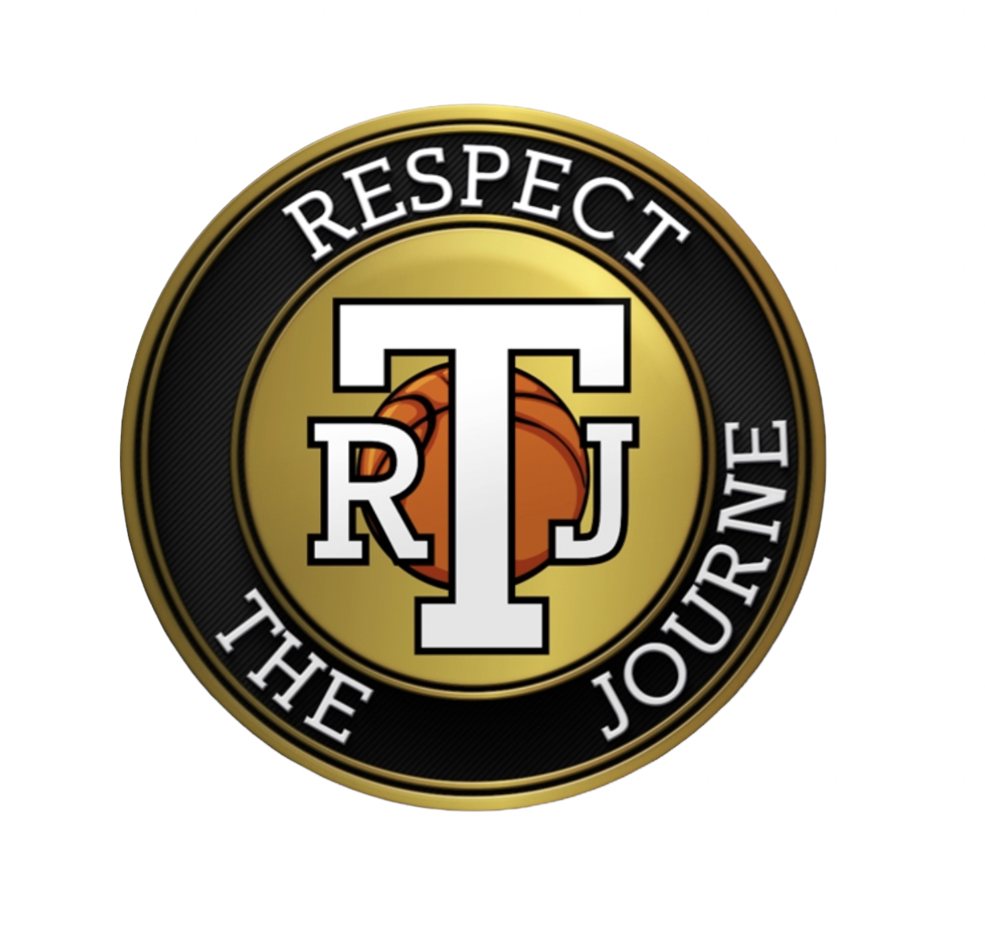

**TEAM JOURNE CODE OF CONDUCT**

As a participant, I will follow the Team Journe Code of Conduct:

[ ] I will maintain a positive attitude and be enthusiastic throughout my time during the program.

[ ] I will be a team player and show good sportsmanship whether I win or lose.

[ ] I will be respectful and considerate of all other participants and staff.

[ ] I will not use offensive language

[ ] I will follow directions the first time they are given.

[ ] I will treat others at RTJ the way I would like to be treated.

[ ] Bullying behavior by any participant is strictly prohibited. Any participant who is involved in the harassment or intimidation of another, will immediately be removed from the participation.

Any violations of this agreement can result in a phone call to parents, temporary suspension from team or full removal from the program pending severity and information regarding the incident.

NO REFUNDS WILL BE ISSUED DUE TO PLAYER BREACH OF AGREEMENT.

[ ] I have read the above and agree with the terms of this Code.

Player signature: ___________________________________________ Date: _______________