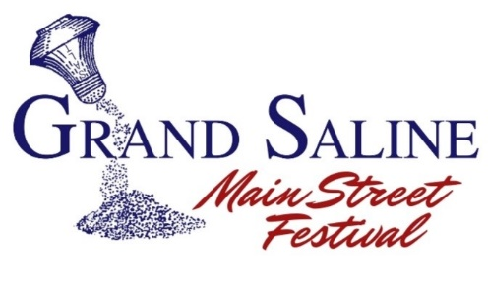

**Fun**

**Music**

**Shopping**

**Prizes**

**Games**

**Food**

**Second Saturday in April, save the date! It’s April 13th, 2019**

**10:30am -6pm**

**Festival is held in Historic Downtown Grand Saline.**

**Merchandise Vendor Registration**

*Grand Saline Main Street Program reserves the right to cancel this event due to weather conditions.*

*Registration fees are NON-REFUNDABLE.*

*Application and Payment must be received by April 1st,2019.*

**Return this completed with payment to**:Grand Saline Salt Palace, Attn: Main Street, 100 W. Garland Street, Grand Saline, TX 75140

**Make Checks payable to Grand Saline Main Street Program**

For more info call 903-962-5631 or email saltpalacemuseum@yahoo.com

Business/Individual Name _______________________________________________________________

Person in Charge _______________________________________________________________________

Address _________________________________________________City__________________________

State _______________________________________ Zip_____________________________

Best Phone to Reach You ___________________________Email _________________________________________

**Please describe items, products, and services solicited in booth.** In order to assure variety, there will be limited duplication of vendors. Items not listed or approved should not be sold. Please send a photo of your booth. **We are no longer accepting food vendors.**

____________________________________________________________________________________________________________________________________________________________________________________________________________________________________________________________________________________________________________________________________

**Booths are 10’ x 10’. Please purchase additional space if all of your booth, people and supplies do not sit comfortably in space.**

**Regular vendors: _______ ($25.00) Food Vendor: _______ ($35.00)** All prices are **plus $5.00** if electricity is needed for 110 outlet.

**One plug per vendor**. If using electricity please bring long enough extension cords to reach from the middle of the street to the alley or sidewalk.

_____________ (Initial) I **agree to not tear down any part of my booth prior to 4:00pm, once live band “Flashback Five” begins I can choose to stay or close down.** Remember to have your Tax ID and Health Permits available at your booths.

**HOLD HARMLESS AGREEMENT**

Neither the Grand Saline Main Street Program nor the City of Grand Saline (“Sponsors”) assumes any responsibility or liability or claim any loss or damages to Exhibitor or Exhibitor’s property arising from Exhibitor’s participation in the Grand Saline Main Street Festival. Exhibitor discharges Sponsors from any liability or claim that may arise with respect to any bodily injury, personal injury, illness, death, or property damage resulting from any action or inaction by the Sponsors. Exhibitor does hereby release and forever discharge and hold harmless Sponsors from any and all claims related to Exhibitor’s participation in the Grand Saline Main Street Festival.

**Signature __________________________________________________________ Date_______________________**

**----------------------------------------------------------- Office Use Only --------------------------------------------------------------------------**

Date Received: ___________________ Initial: ________________ Paid _____________ Cash/ Check /Credit

Number of booth spaces: ________________