Bed Covers: {all prices may vary between trucks; prices have been going up}
- Pro-Tek does not keep bedcovers in stock because there are so many different types and styles. If the company, we order them from has them in stock we can get it on Tuesdays and Thursdays.
- Information we need to order a bedcover: year, make, and model of the truck; exact bed length (measure from inside of bed, front to back); if there is anything in the truck like a ram box; we sometimes get asked if the tailgate is multifunctional.
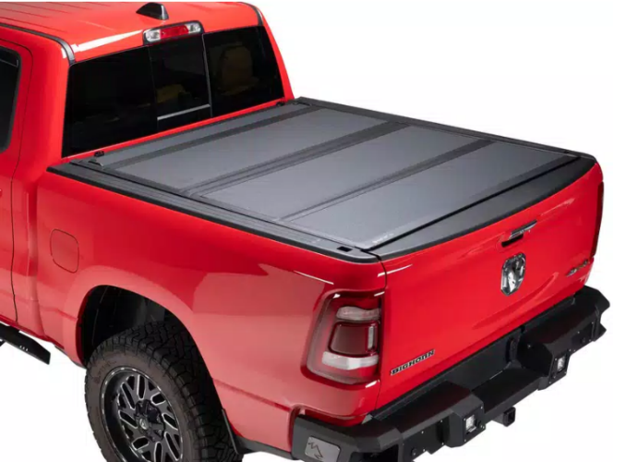
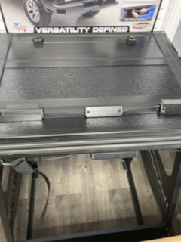
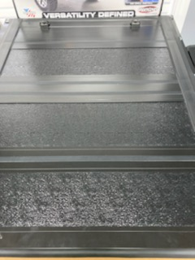
- Not all bed covers are fully leak proof, some water may still get in.

*our display is a different name brand that we do not use anymore, but it is similar in style.
{this brand does not have a lock and a key; the bedcover is locked when the tailgate is locked}
BAKflip MX4: estimated amount is $1200

-Material: aluminum
-Multi-function tailgate seal
-Tonneau finish: matte black
-Weight capacity: 400 lbs.
-Warranty: check with company; it may be a 5 year warranty

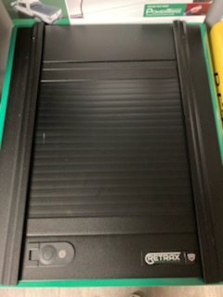
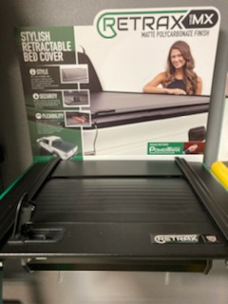
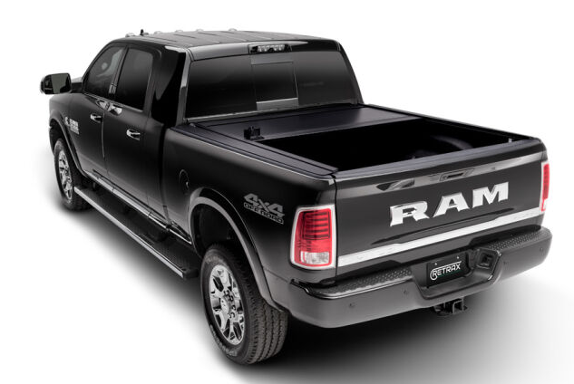

Retrax One MX (polycarbonate series): : estimated amount is $1550
-One-piece sheet of polycarbonate - Made for a perfect fit for the exact truck needed
-Flush with the bed of the truck - Warranty: check with company; it may be a 1 year warranty

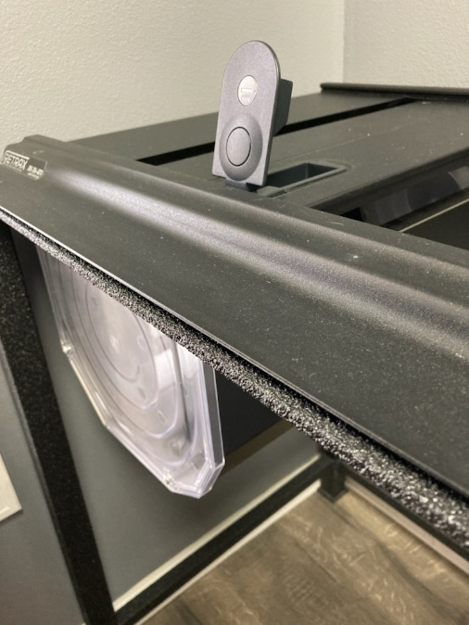
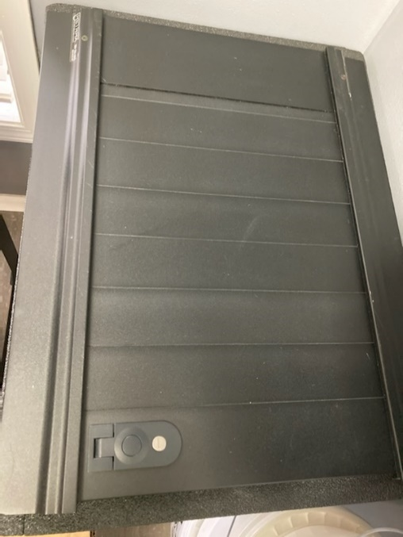
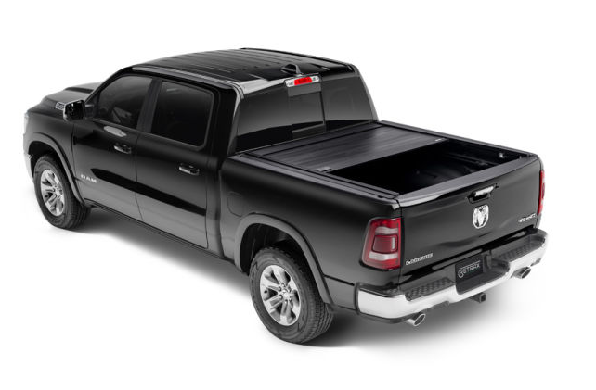

Retrax Pro MX (aluminum series):
estimated amount is $2200
-Material: heavy duty aluminum -Low profile design to be flush with truck bed -Has a matte finish
-Warranty: check with company but it may be lifetime warranty for the original owner only; not transferrable

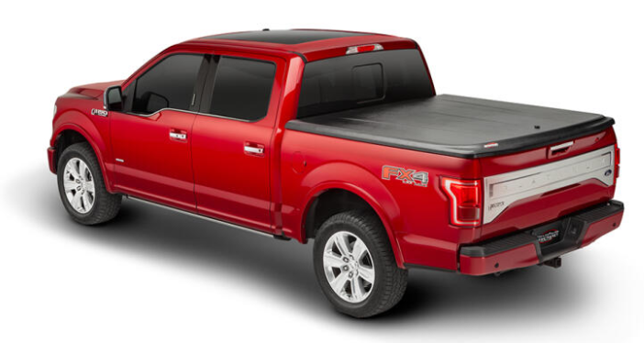
Undercover SE- black: estimated price is $1100
-Comes in all black color
-Is one solid piece that can be pushed up and down for access
-It has a twist lock
-Warranty: check with the company but it may be 3 years for the structure and 1 year for the hardware
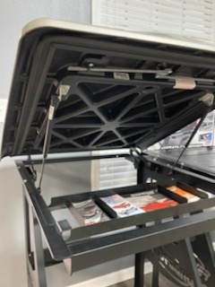
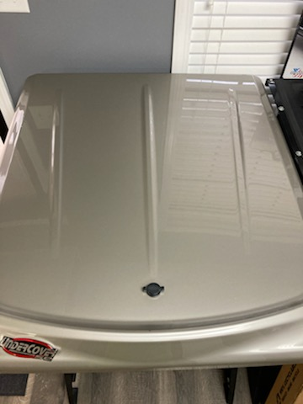
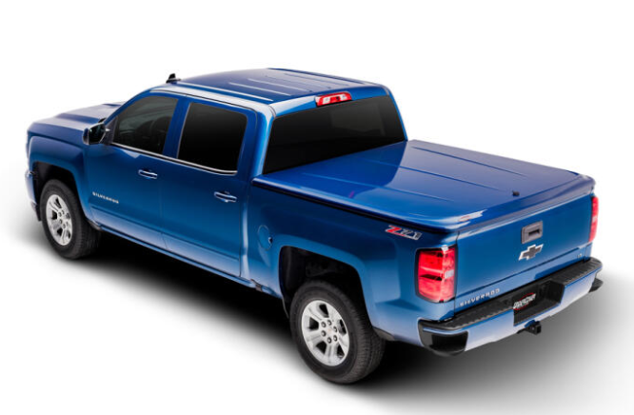

Undercover SE- Lux color matched: estimated price is $1700
It is the same as the Undercover SE, but this one has a smooth, glossy finish to match the color of the truck
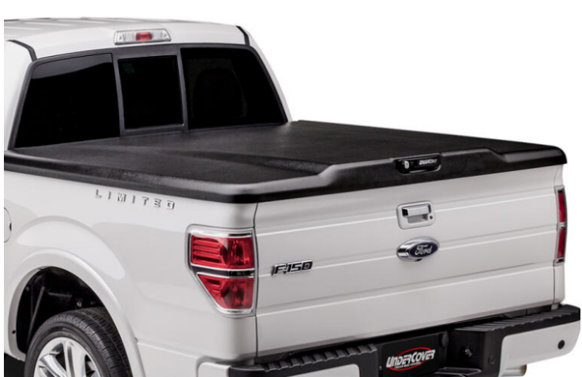
Undercover Elite- black: estimated cost is $1200
- All undercover bed covers are made the same. The only difference is the color and the style
- The Elite has one hump in the very middle of the cover

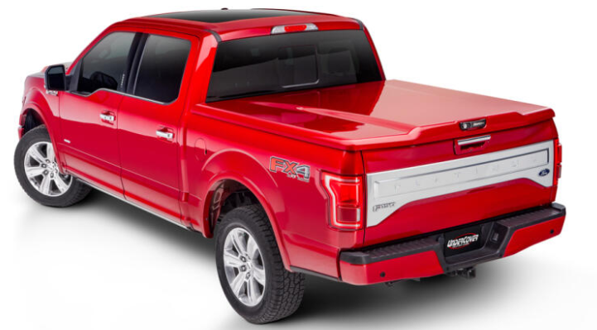
Undercover Elite- Lux color matched: estimated cost is $1800
- This is the same as the Elite above, but it is made to match the color of the truck
- It is one hard cover that goes up and down

*All undercover bed covers should not be left up while driving

Links:
BAKflip- https://bakflip.com/p/bakflip-mx4-tonneau-cover/v/ram/truck-1500/2022/
Retrax- https://retrax.com/products
Undercover- https://www.undercoverinfo.com/

