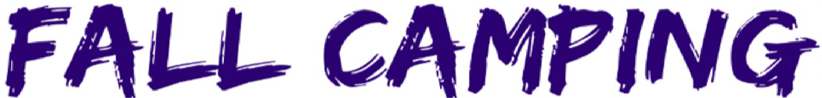

FOR A CURE 2022

Price List
Campsite Registration: $50.00 Per Night

Car Show Registration: $20.00 Pre-Registration
$25.00 Day Of Registration

Chili Cook Off: $50.00 Per Team

Cornhole Tournament: $50.00 Registration Fee

Craft Booth Vendors : $75.00 Per Booth

Food Booth: $50.00 Booth Fee

Kid Zone: (For Kids Under The Age Of 16)
$5 Day Pass
$10 Weekend Pass

