Join Us For A Fun Filled Camping Weekend
Where All Proceeds Benefit Local Charities
October 14-16, 2022
Kemper Williams Park In Patterson

If You Are Interested Or Want More Information, Please Contact 985-262-8757 Or Email camping4acure@gmail.com
Or visit Protekyourrv.com under the events section

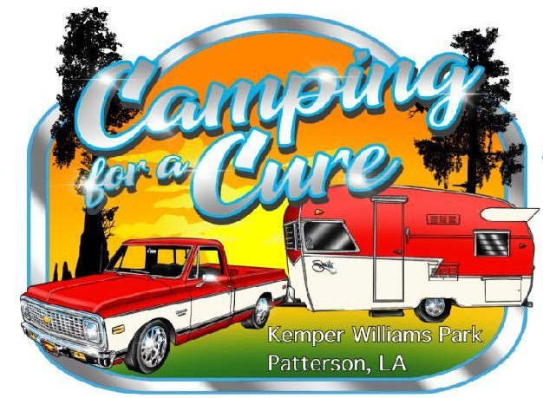
Things To Do:
- Car Show On Saturday
- Cornhole Tournament On Saturday
- Craft Show On Saturday
- Food Booth On Friday And Saturday
- Chili Cook Off On Saturday
- Kid Zone All Weekend
- Music, Contest, Hayrides, And More!
Donations to the cause will be accepted as well. If you want to come fill out a registration form, you can see us at 3274 West Main Street Gray, LA 70359

