**PRO-TEK LIFETIME ROOF COMPATABILITY/INFORMATION**

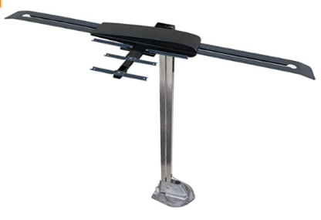Some types of antennas may not be compatible with our Lifetime Roof. For example, the Winegard Antenna to the right.

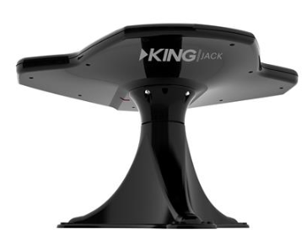If you would like to get the Lifetime Roof done, the antenna will have to be changed over to the King Jack Antenna, like the one to the left. We will replace it with either stationery or a rotational one, based off of the type your unit has now.

Information About The King Jack Antenna:

* Comes in colors of white or black
* Wider reception range.
  + Less directional than traditional RV antennas to provide broader reception coverage
* Effortless antenna rotation (if applicable)
  + Easily rotate antenna with two fingers with 360 degree rotation for no dead spots
* Greatly improved UHF reception
* Over-the-air Broadcast TV antenna with aerial mount/signal finder

Lifetime Roof:

* Skylight will be sprayed over as the color of the roof either white, tan, black, or grey
* All fixtures on the roof will be sprayed, either black or white
* Only the base of the antenna is sprayed (the same color as the roof); the fixture colors are usually the color of the antenna because we don’t spray the entire antenna
* The ladder is sprayed on to the roof
* The roof takes 2-3 weeks once started on
* Preparation: For a rubber roof we tear off the old roof and take off old fixtures to inspect the roof decking; for fiberglass roofs we have to sand a prep differently.

Pro-Tek LLC Is Not Liable For

5th Wheel Lube Plate Damage

Please remove before dropping unit off

Thank You!