PRO-TEK LIFETIME ROOF COMPATABILITY/INFORMATION

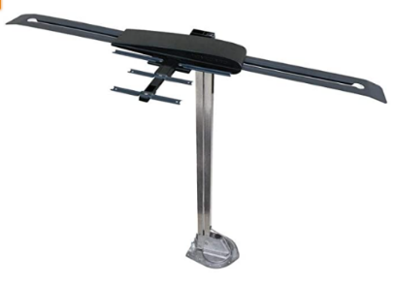
If you have a Winegard Antenna, like one to the right,
it will not be compatible with our Lifetime Roof.
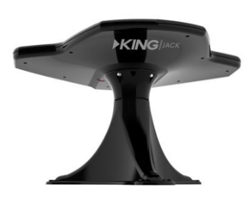
If you would like to get the Lifetime Roof done, the antenna will have to be changed over to the King Jack Antenna, like the one to the left.

Information About The King Jack Antenna:
- Comes in colors of white or black
- Wider reception range.
  - Less directional than traditional RV antennas to provide broader reception coverage
- Effortless antenna rotation
  - Easily rotate antenna with two fingers with 360 degree rotation for no dead spots
- Greatly improved UHF reception
- Over-the-air Broadcast TV antenna with aerial mount/signal finder
- Has the option of getting Omni-Directional as well
Lifetime Roof:
- Skylight will be sprayed over as the color of the roof either white, tan, black, or grey
- All fixtures on the roof will be sprayed over, either black or white
- Only the base of the antenna is sprayed; the fixture colors are usually the color of the antenna because we don’t spray the entire antenna
- The ladder is sprayed on to the roof
- The roof takes 2-3 weeks once started on
- Before roof is sprayed on to the roof decking, the rubber roof is completely taken off
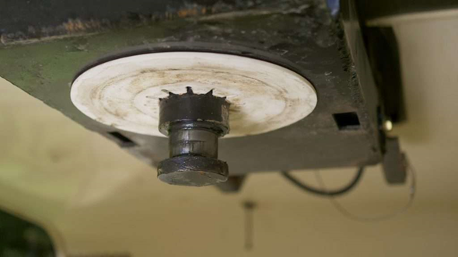
Pro-Tek LLC Is Not Liable For 5th Wheel Lube Plate Damage
Please remove before dropping unit off. Thank you!

