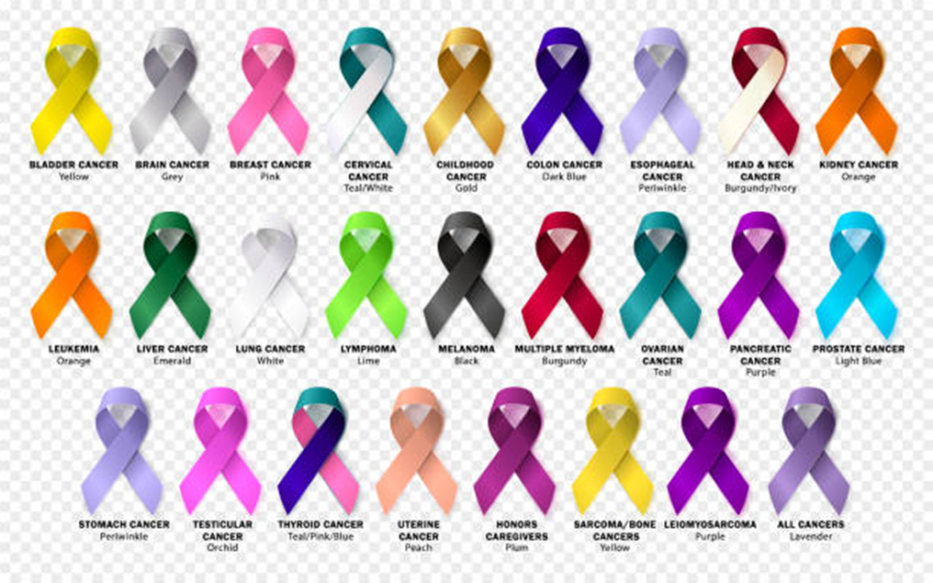
Camping For A Cure
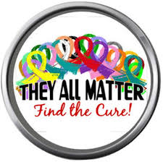

Sponsorship Opportunities

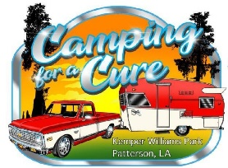

Dear Friend and Community Leader,

You can be an everyday hero in the fight against cancer.
Partner with us as a sponsor for the Camping For A Cure event taking place on October 14th⁻ 16th, 2022 at Kemper Williams Park in Patterson, La.

Why support Camping For A Cure?
It is estimated that nearly 1.9 million new cases of cancer will be diagnosed in 2021. Prostate cancer is the most common cancer among males (26%), followed by lung (12%) and colorectal (8%) cancers. Among females, breast (30%), lung (13%), and colorectal (8%) cancers are the most common. Help us to get one step closer to bringing those percentages down by becoming a sponsor.

Build your brand’s goodwill by supporting a cause everyone can stand behind.
Our event participants and volunteers are passionate about the cause. Goodwill goes a long way, 91% of global consumers will likely switch to a brand that is associated with a good cause. 72% of consumers would recommend a brand that supports a good cause over one that does not. Come on and join in on that goodwill.

Camping For A Cure aims to help with funding to support local charities in the fight to end cancer.
The funds raised from Camping For A Cure allows local charities to fund cancer research, to save lives, celebrate lives, and contribute to the fight for a world without cancer. Last year despite only having 2 weeks to prepare for the event due to changing COVID regulations we had our biggest turnout to date.

For more information please call (985) 262-8757 or email us at camping4acure@gmail.com and we can discuss the Camping For A Cure sponsorship opportunities and benefits with you.

Become a Camping For A Cure sponsor to show our community that you are a voice for those fighting, living with, or winning their battle with cancer.

Tax ID#85-3173559

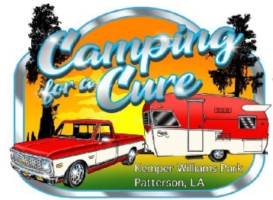
Camping For A Cure Sponsorship Levels

Event Sign Level Sponsorship | Donate $100 | Benefits Include:
- Name displayed on the Camping For A Cure Facebook page and logo on the event tee-shirt
Hayride Level Sponsorship | Donate $250 | Benefits Include:
- Name displayed on the Camping For A Cure Facebook page, logo on the event tee-shirt, and recognition on local radio station promotions
Event Level Sponsorship | Donate $500 | Benefits Include:
- Logo displayed on all event flyers, name displayed on the Camping For A Cure Facebook page, logo on the event tee-shirt, and recognition on local radio station promotions
Band Level Sponsorship | Donate $600 | Benefits Include:
- Company banner on the stage (if provided), Logo displayed on all event flyers, name displayed on the Camping For A Cure Facebook page, logo on the event tee-shirt, and recognition on local radio station promotions
Silver Level Sponsorship | Donate $800 | Benefits Include:
- Logo displayed prominently on the event tee-shirt and all event flyers, name displayed on the Camping For A Cure Facebook page, and recognition on local radio station promotions
Gold Level Sponsorship | Donate $1000 | Benefits Include:
- One free camping spot for the weekend of the event, Logo displayed prominently on the event tee-shirt and all event flyers, name displayed on the Camping For A Cure Facebook page, and recognition on local radio station promotions
Corporate Level Sponsorship | Donate $1500 | Benefits Include:
- Given the opportunity to speak and promote their company at the event, One free camping spot for the weekend of the event, Logo displayed prominently on the event tee-shirt and all event flyers, Company banner on the stage (if provided), name displayed on the Camping For A Cure Facebook page, and recognition on local radio station promotions
In-Kind Sponsorship | Donate a Product or Service
An in-kind sponsorship can be a product or service that is donated to the event. The value must be greater than or equal to the minimum sponsor level cash amount to qualify for the sponsorship level benefits. A fair market value must be calculated to determine the level of sponsorship it will be placed at.

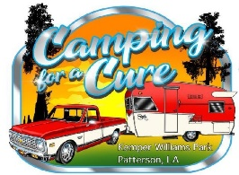
Camping For A Cure Sponsorship Agreement
Please Print

Name/Company:
Mailing Address:
City: State: Zip:
Contact Name:
Phone: Email:
Company Website Address:
Please select one of two sponsorship options:
In-Kind Sponsorship:
Product:
Or Service:
Fair Market Value* of Product or Service:
$
*Value must be greater than or equal to the minimum sponsor level cash amount to qualify for sponsorship level benefits
Cash Sponsorship:
- Corporate Level Sponsorship | Donate $1500
- Gold Level Sponsorship | Donate $1000
- Silver Level Sponsorship | Donate $800
- Band Level Sponsorship | Donate $600
- Event Level Sponsorship | Donate $500
- Hayride Level Sponsorship | Donate $250
- Event Sign Sponsorship | Donate $100

OR

Additional Options:
Unable to sponsor, but please accept this donation: $
We authorize, Camping for A Cure to include our corporate name and logo on all “Camping For A Cure” materials consistent with our sponsorship selection and publication dates.
Authorized Signature: Date:
Donation Payment Via: Check Enclosed Cash at Drop off Location Venmo Payment (See below)
Venmo payments should be sent to @CampingForACure with the word “sponsorship” in the message.
Drop off/mailing location is at Pro-Tek, LLC 3274 West Main Street Gray, Louisiana 70359
Completed & signed agreement with logo is due by September 1st, 2022
Please email your agreement & logo (EPS, PS,PDF, JPEG, or PNG) to camping4acure@gmail.com

Thank you for your generous support!

