come grow with us!
Enrollment Packet Table of Contents
Payment Contract
Enrollment Application with emergency contact list and release form
Student Discipline Policy
Discipline Policy Agreement
Alternate Nutrition Plan Agreement
Child Health and Development Questionnaire
Florida Department of Health Food Program Application
Release for Emergency Care (Notarized)
Flu brochure
Holiday Participation Notice
Notice of Non-Smoking Policy
Tuition Express Form
Know Your Child Care Facility Brochure
First Day of School Checklist
Notice of Sick Policy
Menu
Daily classroom schedule
Parent Handbook (visit www.greendayearlylearning.com click "about us" and Parent Hand Book)
- Email, address and phone number to school
- Sick policy and attendance limitations
- Explanation of new student/parents orientation
- Philosophy and how it is reflected in the learning environment
- Guidelines for parent involvement and volunteers
- How we provide ongoing communication between teacher/parents
- Behavior expectations
- Guidelines for disenrolling
- Clear statement of open-door policy
- Hours of operations, holidays and closings
- Information regarding meals
- Statement outlining provider's policy on TV and videos
- Requirement that all children be signed in and out
- Statement that says we prohibit the release of a child to an individual who appears intoxicated or otherwise impaired
- Policy stating providers responsibility to report suspected abuse and neglect
- Policy stating that we do not discriminate against anyone (adult, child, staff or parents) on the basis of sex, age, religion, national origin, color, race, marital status, physical or mental disability or veteran status.
- A policy that states the provider includes children with special needs and makes accommodations as required by the Americans with Disabilities Act
- Guidance and discipline Policy
✓

Basic Guidelines
- Tuition is due on Monday of each week. A $10 late fee will apply to tuition paid after Wednesday. Please be aware that your child will not be permitted to attend if your account is more than two payments past due
- Sick policy: your child should stay home if he/she is vomiting, has diarrhea, a rash, persistent cough, fever over 101 degrees, obvious contagious conditions, head lice or pink eye. This policy is consistent with Florida DCF guidelines and is intended to keep our children safe
- Missed days for illness or other reasons are not credited back. Extended absences are handled on a case-by-case basis
- 2019 Holidays in which center will be closed:
  - New Year’s day Jan 01
  - Memorial Day May 27
  - Independence Day July 4
  - Labor Day Sept 2
  - Thanksgiving Nov 28-29
  - Christmas Dec 25-26
- Each family receives one week of vacation per year
- VPK classroom days follow the OCPS classroom schedule. VPK all day (Wrap) weekly tuition covers the non VPK days. You are responsible for paying for non-VPK days if you choose not to attend on those OCPS school off days
- Green Day provides lunch. If you chose to provide your child’s lunch it must come in a small lunch container with your child’s name printed on the container. Due to limited space in the refrigerator please bring enough food and drinks for one day.
- Children should arrive to school no later than 9:30am.

445 Gaston Foster Road
Orlando, FL 32807

Payment Contract
Name: ___________________________________ DOB: ___________ Enrollment Date:
_____________
Responsible Parent/Guardian: ___________________________
S.S. #: ________________________ Driver’s License #:______________________
- Thank you for selecting Green Day Early Learning Center as your child’s care provider. The initial registration fee is $50. Thereafter, VPK / four-year-old students have an annual supply fee of $15 due in August. WEEKLY child care payment is $ ___________ and is due on Friday for the upcoming week or on Monday at the latest for the week of service. A late fee of $10.00 will be assessed on Tuesday to those who have not paid in full for the week of service. If your account is not cleared by Wednesday, GREEN DAY reserves the right to terminate services. The fee for NSF check is $35.00. After the second returned check, we will accept cash only. We would appreciate your cooperation in keeping your child’s tuition current.
- School hours of operation are from 6:30 a.m. to 6:00 p.m. Parents picking up their child after 6:30 p.m. will be charged $10 for the first fifteen minutes and a $1.00 per minute, per child after 6:15 p.m.
- Under NO circumstances will any child be released to any person, unless specifically authorized in writing by the legal parent/guardian. If there is ANY uncertainty regarding identity, your child will NOT be released. GREEN DAY reserves the right to request identification from any person on the premises.
- Your child may be photographed or taped during activities at the center and also by a professional photographer during the year. These pictures/videos may be displayed in the center and in company brochures.
- Each child who is enrolled for 52 weeks is allowed one weeks’ vacation. If not taken during the appropriate time your vacation will not roll over to the following year. It renews every year on the month you enrolled.
- To comply with state requirements, all applicable enrollment forms and immunization/physical records must be completed and furnished before your child attends Green Day Early Learning Center.
Registration and child care fees are non-refundable.
By signing this contract you agree to the above terms.

___________________________________ ___________________________________
Parent/Guardian Date Director Date

State of Florida
Department of Children and Families
CHILD CARE APPLICATION FOR ENROLLMENT
Student Information: Date of Birth: _______ Sex: _______ Date of Enrollment:___________________ Nickname
Full Name:_______________________________________________________________________________________________
' Last First Middle
Child's Physical Address:____________________________________________________________ Primary Hours of Care: From ___________To ______
Days of the Week in Care: M T W Th F Sa Su
Meals Typically Served While in Care: Br AM Snack Lunch PM Snack Sup Eve Snack Child Lives With: ______________________________
Family Information:  Mother's Name: ________________________________________________  Address: ______________________________________________________  Home Phone: __________________________________________________  Employer: _____________________________________________________  Address: ______________________________________________________  Work Phone: _____________________ Cell:_______________________ | Father's Name: ___________________________________________  Address: ________________________________________________  Home Phone: ____________________________________________  Employer: _______________________________________________  Address: ________________________________________________
Work Phone: ___________________ Cell:________________ Custody: Mother ________ Father ________ Both ________ Other ________
Medical Information:
I hereby grant permission for the staff of this facility to contact the following medical personnel to obtain emergency medical care if warranted.
Doctor: ______________________________ Address: ____________________________________ Phone _________________
Doctor: ______________________________ Address: ____________________________________ Phone: ________________ Dentist: ______________________________ Address: ___________________________________ Phone: ________________
Hospital Preference: ___________________________________________________________________________________________________________
Please list allergies, special medical or dietary needs, or other areas of concern: _____________________________________________________________ Contacts:
Child will be released only to the custodial parent or legal guardian and the persons listed below. The following people will also be contacted and are authorized to remove the child from the facility in case of illness, accident or emergency, if for some reason, the custodial parent or legal guardian cannot be reached:
Name Address Work# Home#
Name Address Work# Home#
Name Address Work# Home#
Name Address Work# Home#
CF-FSP 5219, Child Care Application For Enrollment, March 2009, 65C-22.006(3)(c)1., 65C-22.008(3)(u)3. and 65C-20.011(2)(a). F.A.C. Page 1 of 2
Helpful Information About Child:
________________________________________________________________________________
________________________________________________________________________________
________________________________________________________________________________
- Section 65C-22.006(2), F.A.C., requires a current physical examination (Form 3040) and immunization record (Form 680 or 681) within 30 days of enrollment.
- Section 402.3125(5), F.S., requires that parents receive a copy of the Child Care Facility Brochure, "Know Your Child Care Facility”
(CF/PI 175-24), or
Section 65C-20.11(2)(c)(1), F.A.C., requires that parent(s) receive a copy of the family day care home brochure, “Selecting A Family Day Care Home Provider” (CF/PI 175-28).
- Section 65C-22.006(3)(c)2., F.A.C., requires that parents are notified in writing of the disciplinary practices used by the child care facility, or
Section 65C-20.010(6)(c), F.A.C., requires that a written a copy of the family day care provider’s discipline policy be available for review by the parent(s).
Your signature below indicates that you have received the above items and that the information on this enrollment form is complete and accurate.
_________________________________________________
Signature of Parent/Guardian Date _____________________
CF-FSP 5219, Child Care Application For Enrollment, March 2009, 65C-22.006(3)(c)1., 65C-22.008(3)(u)3. and 65C-20.011(2)(a). F.A.C. Page 2 of 2

Student Discipline Policy
Green Day Early Learning Center is committed to providing students and families with quality childcare in a safe and loving environment. Our children will be taught age appropriate rules and encouraged to make positive choices regarding their behavior.
Our goal is to promote resiliency through the development of attachment, self-control and initiative. Resiliency is defined in Merriam-Webster’s collegiate dictionary (9th ed.) as the ability to recover from or adjust easily to misfortune or change. With the increase of resiliency, a decrease in behavioral concerns occurs. By using positive redirection and promoting self-discipline, it is our goal to have every child achieve positive growth in all areas. We must work together to guide each child toward personal success.
Our teachers are expected to:
- Set limits of behavior expectations that are developmentally appropriate.
- Praise and encourage children’s positive behavior as well as model appropriate actions, attitudes and responses throughout date to day interactions with children and other staff members.
- Demonstrate what behavior is appropriate and give developmentally appropriate explanations for why behavior is expected. Focus on what the child CAN DO, not what the child cannot do.
- Provide age appropriate alternatives for children who choose not to participate in an activity.
- Focus on students’ actions rather than personality. Make each child feel worthwhile and respected.
- Teach children to solve conflicts and problems independently, and allow each child involved in a conflict to express “their side” of the situation before a consensus is made.
- Maintain a calm but firm tone when disciplining. Use words and tones that respect and reassure the student.
- Be consistent with consequences and disciplinary interactions that are both logical and intrinsic.
- Be proactive in preventing behavioral concerns in the classroom by taking into account the needs and abilities of each individual child.
All staff is prohibited to:
- Use corporal or physical punishment • Associate punishment with: o Food o Naps
o Bathroom/Diapering
- Use time-out as a form of discipline

Discipline Policy Agreement
The goal of discipline is to help the student gain self-control through learning and making positive choices rather than forcing the child to adult standards.
I, ________________________________________ have read, understand, and am in agreement with Primary Prep Academy Guidance and Discipline Guidelines. As a parent I will strive to reinforce the above discipline policies at home.
I understand that use of harsh words, harsh tones, or inappropriate handling of a child in any manner is not condone by Green Day Early Learning Center and that all employees of Green Day Early Learning Center have received and signed the above discipline policy.
_____________________________ Parent/ Guardian Signature
_____________________________
Director Signature

Alternate Nutrition Plan Agreement
Name of Child ______________________________________ Age _______________
Indicate special dietary requirements: ___________________________________________________
_____________________________________________________________________________________
_____________________________________________________________________________________
Specific Allergies: _____________________________________________________________________
_____________________________________________________________________________________
_____________________________________________________________________________________
I understand and approve the use of the Alternate Nutrition Plan. I agree to provide the following meals and or snacks to meet my child's nutritional dietary needs:
Mark (P) for Parent Provides, or (C) for Center Provides

AM Snack Lunch PM Snack
_________________________________ _______________________ Signature of Parent/Guardian Date
I agree to provide the parent/Guardian with a suggested meal pattern/menu and will discuss any problems which might develop in the use of the Alternate Nutrition Plan.
_________________________________ _______________________
Signature of Director Date

CHILD HEALTH AND DEVELOPMENT QUESTIONNAIRE
(To be completed by parent or guardian)
Child's Full Name: _____________________________________ Age: ____ Date: ___________
Name of Parent or Guardian completing form: ______________________________________________
As a supplement to the attached Student Physical Examination, please answer the questions on this form.
We feel this information will help us be more effective in working with your child.
CHILDHOOD DISEASES CHILD HAS HAD:
o Chicken Pox Date: ___________ o Measles ____ 3 Day (Rubella) Date: ___________
____ 10 Day (Rubella) Date: ___________ o Scarlet Fever Date: ___________ o Rheumatic Fever Date: ___________ o Mumps Date: ___________ o Strep Throat Date: ___________
Is your child taking over the counter or prescribed medications regularly at home? ___Yes ___ No
If yes, which ones? ________________________________________________________________
Is your child taking vitamins regularly at home? ___ Yes ___ No
Please list any known allergic reactions: _______________________________________________
________________________________________________________________________________
Does your child complain of feeling ill often? ___ Yes ___ No
If yes, what does your child complain of? ______________________________________________
________________________________________________________________________________
Have you ever suspected your child of having seizures (fits)? ___ Yes ___ No
Describe your child's appetite: _______________________________________________________
Does your child dislike any foods? ___ Yes ___ No
If yes, which foods? ________________________________________________________________
What does your child usually eat for breakfast before arriving at school? ______________________
How easily does your child fall asleep? _________________________________________________
What is the usual bedtime? ______________ Wake up time? _______________
What is the usual naptime? ______________ Wake up time? _______________ Is your child completely potty-trained? ___ Yes ___ No
Does your child remain dry all night? ___ Yes ___ No
When did your child begin to walk alone? _______________________________________________
Are other adults (non family) able to understand your child's speech? ___ Yes ___ No
Does your child have a regular playmate of their same age, older or younger? ___ Yes ___ No
What is your child's favorite toy or activity at home? ______________________________________
Does your child have temper tantrums? ________________________________________________
Does your child bite their nails? ___ Yes ___No Twist their hair? ___ Yes ___ No
If you could describe your child in one word, what would it be? _____________________________
Please list your child's strong points (happy, curious, etc.) __________________________________
Please list anything else, medical or otherwise that we need to know? _________________________

CHILD CARE FOOD PROGRAM FREE AND REDUCED-PRICE MEAL APPLICATION
Green Day ELC 1010 W Oak Ridge Rr, Orlando, FL 32807
Child’s Name: __________________________________ Center Name & Address: ________________________________________________________________________________
Please read the instructions and accompanying Parent Letter before completing this form. If you need assistance completing this form, call: (__407 ____) _801 __ __ – 5727

STEP 1: Complete the following table for all INFANTS and CHILDREN through age 18 that reside in the household, even if not related. (include child listed at top of form)……….…
Child’s Name (Last Name, First Name) | Date of Birth | Attends this center? (circle) | Foster Child? (circle) | Migrant? (circle) | Homeless/Runaway? (circle)
 |  | Yes No | Yes No | Yes No | Yes No
 |  | Yes No | Yes No | Yes No | Yes No
 |  | Yes No | Yes No | Yes No | Yes No
STEP 2: Do any household members (children or adults) receive Food Assistance Program (FAP/SNAP) or Temporary Assistance for Needy Families (TANF) benefits?.............
If NO, go to STEP 3. If YES, enter one of the following case numbers, then go to STEP 4.
FAP/SNAP Case Number: ___ ___ ___ ___ ___ ___ ___ ___ ___ ___ or TANF Case Number: ___ ___ ___ ___ ___ ___ ___ ___ ___ ___
STEP 3: Household income and adult household member information (see reverse side for what types of income to report) (skip this step if you listed a case # in STEP 2)….........n A. Children’s Income – sometimes children earn or receive income. Enter the total income received by all children listed in STEP 1, then check how often the income is received.
Total children’s income: $ | How often received? (check only one): □ Weekly □ Bi-Weekly □ Twice a Month □ Monthly □ Annually
B. Adult Household Members and Income – list all adult household members (age 19 and up) even if they do not receive income. For each adult, list the total gross income (before taxes & deductions) from each source in whole dollars only (no cents) and how often it is received (i.e., weekly, bi-weekly, twice a month, monthly, or annually). For an adult that does not receive income from any source, write “none” or “0.” If you enter “none” or “0” or leave any income fields blank, you are certifying that there is no income to report.
Adult Household Member’s Name (Last Name, First Name) |  | Earnings from Work ($ Amount / How often?) | Public Assistance/Child Support/Alimony ($ Amount / How often?) | Pensions/Retirement/All Other Income ($ Amount / How often?)
 | $ | / | $ / | $ /
 | $ | / | $ / | $ /
 | $ | / | $ / | $ /
Total Household Members (children and adults): _______ Last four digits of Social Security Number (SSN) of adult household member: ___ ___ ___ ___ If no SSN, write “none.”
STEP 4: Contact information and adult signature……………………………………………………………………………………………………………………………………………….…………...…
By signing below, I am certifying (promising) that all information on this application is true and that all income is reported. I understand that this information is being given in connection with the receipt of federal funds and that institution officials may verify (check) the information. I am aware that if I purposely give false information, I may be prosecuted under applicable state and federal laws.
Home address (if available): ________________________________________________________________________________ Daytime phone #: (_______) ________ – __________
Street Address, City, State, Zip Code
Signature of adult household member: _______________________________________ Printed name: ____________________________________ Date signed: ________________
OPTIONAL: Child’s ethnic and racial identities We are required to ask for information about your child’s ethnicity and race. This information is important and helps make sure that we are fully serving the community.
Responding to this section is optional and does not affect your child’s eligibility for free or reduced-price meals. Ethnicity (check one): ___ Hispanic or Latino ___ Not Hispanic or Latino
Race (check one or more): ___ American Indian or Alaskan Native ___ Asian ___ Black or African American ___ Native Hawaiian or Other Pacific Islander ___ White
FOR CONTRACTOR USE ONLY:………………………………………………………………………………………………………………………………………………………………...…….……….XX
Categorical Eligibility: □ FAP/SNAP or TANF Household □ Foster Child Total Household Size: _______ Total Household Income: $______________
Eligibility Determination: □ Free □ Reduced-Price □ Non-needy How Often Income is Received (Frequency): □ Weekly □ Biweekly □ Twice a Month □ Monthly □ Annually
NOTE: If different income frequencies are listed, convert all income to an annual amount. Annual Income Conversion: Weekly x 52, Biweekly x 26, Twice a Month x 24, Monthly x 12
Reason for Non-needy Status: □ Income too High □ Incomplete Application □ Other Reason: ______________________________________________________________________________________
Determining Official’s Signature: ______________________________________ Date: _______________ Second Party Check Signature: __________________________________ Date: ____________
Revised 6/2016 Page 1 of 2 I-009-11
INSTRUCTIONS for completing the Free and Reduced-Price Meal Application (use a pen and print all information other than signature)……………………….…………………………
IF ANY MEMBER OF YOUR HOUSEHOLD RECEIVES FOOD ASSISTANCE PROGRAM (FAP/SNAP) OR TEMPORARY ASSISTANCE FOR NEEDY FAMILIES (TANF) BENEFITS,
FOLLOW THESE INSTRUCTIONS: STEP 1: List all children age 18 and under that are supported with the household’s income, even if they are not related to you. Be sure to include the child listed at the top of the form. If there is not enough space to list all children, use a second form and attach the forms together. List the date of birth of each child. In the next three columns, circle Yes or No to answer each question for each child listed. STEP 2: Enter either the FAP/SNAP or TANF case number in the designated space. The case number will be on your letter of eligibility; it is not the number on your EBT card. STEP 3: Skip this step. STEP 4: Enter your address and phone # (if available). An adult household member must sign the form. Print the name of the person who signed the form, then enter the date signed.
IF YOU ARE APPLYING FOR A FOSTER CHILD, FOLLOW THESE INSTRUCTIONS: With appropriate documentation, foster children are automatically eligible for free meals regardless of the income of the household where they reside. You have the option to provide the child care center with official documentation from the foster care agency or court that placed the child in the household, rather than completing this application. Should you choose to complete this application, and you are applying only for a foster child(ren), then only complete STEPS 1 and 4. If you are applying for foster and non-foster children, complete STEPS 1, 3, and 4. If completing STEP 3, do not include payments to the household for the care of the foster child(ren). See the instructions listed below for the applicable steps.
ALL OTHER HOUSEHOLDS, FOLLOW THESE INSTRUCTIONS: STEP 1: List all children age 18 and under that are supported with the household’s income, even if they are not related to you. Be sure to include the child listed at the top of the form. If there is not enough space to list all children, use a second form and attach the forms together. List the date of birth of each child. In the next three columns, circle Yes or No to answer each question for each child listed. STEP 2: Skip this step. STEP 3: A. Enter the total income received by all children listed in STEP 1, then check how often the income is received. B. List all adults age 19 and older that are supported with the household’s income, even if they are not related to you and even if they receive no income. If there is not enough space to list all adults, use a second form and attach the forms together. For each adult, list the amount of income he/she regularly receives before taxes or anything else is taken out and how often the income is received (frequency) in the appropriate columns. If self-employed, list net income. See examples below for sources of income to report. For any adult with no income, write “none” or “0.” Any income fields that are blank will also be counted as a zero (0). Enter the total number of household members (all children and adults), then list the last four digits of the social security number (SSN) of the adult completing/signing the application (or write NONE if he/she has no SSN). STEP 4: Enter your address and phone # (if available). An adult household member must sign the form. Print the name of the person who signed the form, then enter the date signed.
Sources of Income for Children |  |  | Sources of Income for Adults
Earnings from work | A child has a regular full or part-time job where they earn a salary or wages | Earnings from Work | Public Assistance/ Alimony/Child Support | Pensions/Retirement/All Other Income
Social Security  - Disability Payments  - Survivor’s Benefits | - A child is blind or disabled and receives Social Security benefits  - A parent is disabled, retired, or deceased, and their child receives Social Security benefits | - Salary, wages, cash  bonuses  - Net income from self- employment (farm or business)  If you are in the U.S. Military:  - Basic pay and cash bonuses (do NOT include combat pay, FSSA or privatized housing allowances)  - Allowances for off-base housing, food and clothing | - Unemployment benefits • Worker’s compensation  - Supplemental Security  Income (SSI)  - Cash assistance from  State or local government  - Alimony payments  - Child support payments  - Veteran’s benefits  - Strike benefits | - Social Security (including railroad retirement and black lung benefits) • Private pensions or disability benefits  - Regular income from trusts or estates  - Annuities  - Investment income  - Earned interest  - Rental income  - Regular cash payments from outside household
Income from person outside the household | A friend or extended family member regularly gives a child spending money
Income from any other source | A child receives regular income from a private pension fund, annuity, or trust
The Richard B. Russell National School Lunch Act requires that, unless you list a current Food Assistance Program (FAP/SNAP) or Temporary Assistance for Needy Families (TANF) case number or are applying for a foster child, you must include the last four digits of the Social Security Number (SSN) of the adult household member signing the application or indicate that the signer does not have a SSN. Providing the last four digits of a SSN is not mandatory, but if this information is not given or an indication is not made that the signer does not have a SSN, the application cannot be approved. The information provided on this form may be verified through program reviews, audits, and investigations and may include contacting employers to determine income, contacting a welfare office to verify receipt of FAP/SNAP or TANF benefits, contacting the state employment security office to determine the amount of benefits received, and checking any documentation produced by the household to prove the amount of income received. These verification efforts may result in a loss or reduction of benefits, administrative claims, or legal actions if incorrect information is reported. We may share your eligibility information with education, health, and nutrition programs to help them evaluate, fund, or determine benefits for their programs; auditors for program reviews; and law enforcement officials to help them investigate violations of program rules.
This institution is an equal opportunity provider. Please refer to the accompanying Parent Letter to read the full Nondiscrimination Statement.
Revised 6/2016 Page 2 of 2 I-009-11

Florida Department of Health

Child Care Food Program
Child Participation Form
Name of Child: _________________________ Name of Facility: ____________________________
Dear Parent:
Please fill out the following information so that your child may participate in the Child Care Food Program, which reimburses child care providers for serving nutritious, well-balanced meals to children in child care.
If child care hours are the same every day, please complete this chart.
Day | Normal Hours in Care | Meals Normally Received While in Care
Mon – Fri | a.m. a.m.  _____ p.m. to _______ p.m. | Breakfast ◻ AM Snack ◻ Lunch ◻ PM Snack ◻ Supper ◻ Eve Snack ◻

OR
If child care hours are not the same every day, please complete this chart.
Monday | a.m. a.m.  _____ p.m. to _______ p.m. | Breakfast ◻ AM Snack ◻ Lunch ◻ PM Snack ◻ Supper ◻ Eve Snack ◻
Tuesday | a.m. a.m.  _____ p.m. to _______ p.m. | Breakfast ◻ AM Snack ◻ Lunch ◻ PM Snack ◻ Supper ◻ Eve Snack ◻
Wednesday | a.m. a.m.  _____ p.m. to _______ p.m. | Breakfast ◻ AM Snack ◻ Lunch ◻ PM Snack ◻ Supper ◻ Eve Snack ◻
Thursday | a.m. a.m.  _____ p.m. to _______ p.m. | Breakfast ◻ AM Snack ◻ Lunch ◻ PM Snack ◻ Supper ◻ Eve Snack ◻
Friday | a.m. a.m.  _____ p.m. to _______ p.m. | Breakfast ◻ AM Snack ◻ Lunch ◻ PM Snack ◻ Supper ◻ Eve Snack ◻
Saturday | a.m. a.m.  _____ p.m. to _______ p.m. | Breakfast ◻ AM Snack ◻ Lunch ◻ PM Snack ◻ Supper ◻ Eve Snack ◻
Sunday | a.m. a.m.  _____ p.m. to _______ p.m. | Breakfast ◻ AM Snack ◻ Lunch ◻ PM Snack ◻ Supper ◻ Eve Snack ◻
◻ Check here if your child has no regularly scheduled hours of care
Signature of Parent/Guardian: ________________________________ Date: ________________
Printed Name: ____________________________________ Phone Number: __________________ I-108-01

RELEASE FOR EMERGENCY CARE
To whom it may concern,
I hereby give my consent to any emergency facility and physical to administer necessary treatment to my child _________________________________________.
Name of Child
In the event of any emergency at which time I cannot be reached, I give consent for my child to be transported by ambulance to the nearest hospital.
_________________________________________ ____________________________
Physician's Name Phone
Preferred hospital: _____________________________________________________________
Allergies:_____________________________________________________________________
Date of last DPT or Tetanus: _______________________
Insurance company covering the child: __________________________________________
________________________________________ | __________________________
Policy Number | Date
________________________________________ | __________________________
Signature of Parent or Guardian | Date
This form is to be notarized
State of: _______________________ County of: __________________
On the _________________ day of _______________, 20____, before me
came ________________________________________, to me known to be the individual described in and who executed the foregoing instrument and acknowledged that (s)he executed the same.
_________________________________ Notary Public

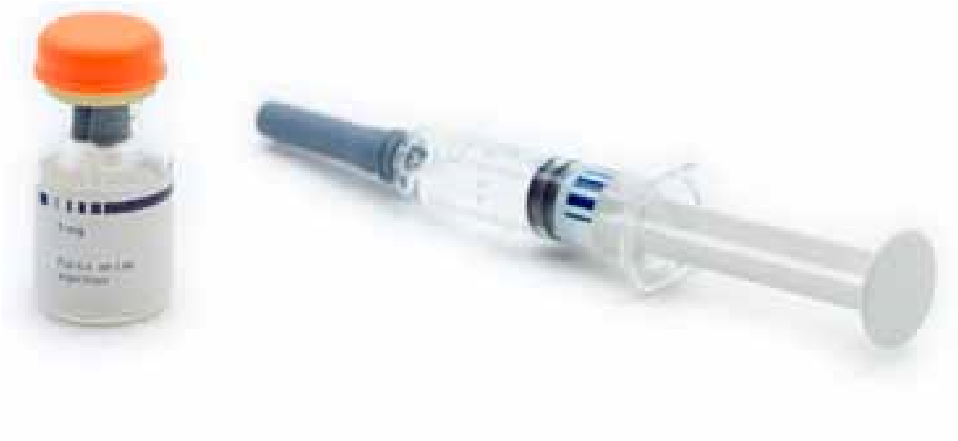
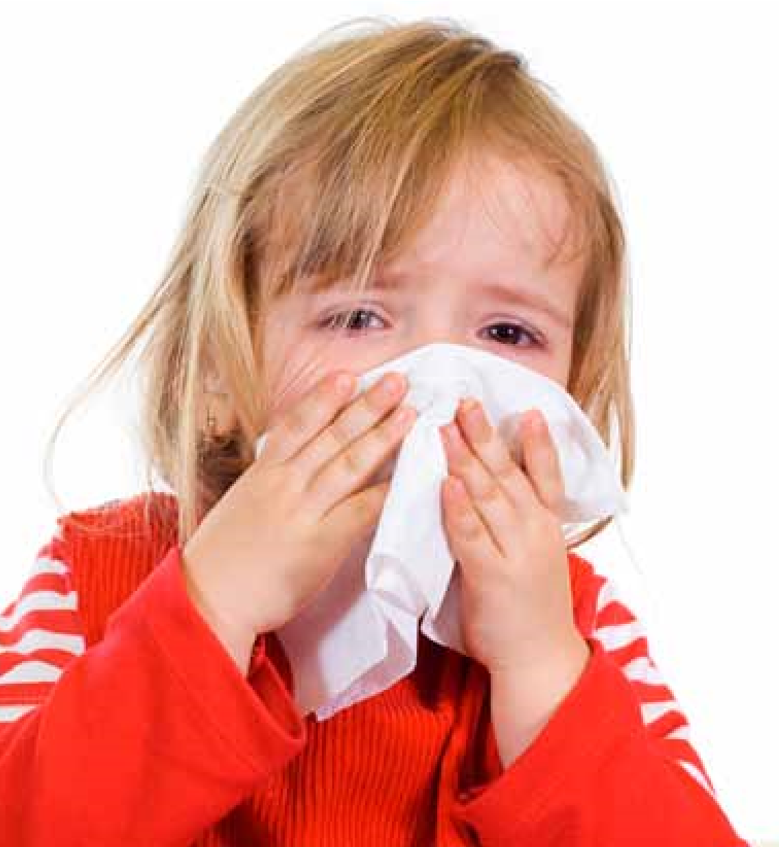
During the 2009 legislative session, a new law was passed that requires child care facilities, family day care homes and large family child care homes provide parents with information detailing the causes, symptoms, and transmission of the influenza virus (the flu) every year during August and September.
My signature below verifies receipt of the brochure on Influenza Virus, The Flu, A Guide to Parents:
Name: ________________________________
Child’s Name: ________________________
Date Received: _______________________
Signature: ____________________________
Please complete and return this portion of the brochure to your child care provider, in order for them to maintain it in their records.
What should I do if my child gets sick?
Consult your doctor and make sure your child gets plenty of rest and drinks a lot of fluids. Never give aspirin or medicine that has aspirin in it to children or teenagers who may have the flu.
CAll oR TAke youR ChIlD To A DoCToR RIGhT AWAy IF youR ChIlD:
- Has a high fever or fever that lasts a long time
- Has trouble breathing or breathes fast
- Has skin that looks blue
- Is not drinking enough
- Seems confused, will not wake up, does not want to be held, or has seizures (uncontrolled shaking)
- Gets better but then worse again
- Has other conditions (like heart or lung disease, diabetes) that get worse
how can I protect my child from the flu?
A flu vaccine is the best way to protect against the flu. Because the flu virus changes year to year, annual vaccination against the flu is recommended. The CDC recommends that all children from the ages of 6 months up to their 19th birthday receive a flu vaccine every fall or winter (children receiving a vaccine for the first time require two doses). You also can protect your child by receiving a flu vaccine yourself.
What can I do to prevent the spread of germs?
The main way that the flu spreads is in respiratory droplets from coughing and sneezing. This can happen when droplets from a cough or sneeze of an infected person are propelled through the air and infect someone nearby. Though much less frequent, the flu may also spread through indirect contact with contaminated hands and articles soiled with nose and throat secretions. To prevent the spread of germs:
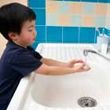
- Wash hands often with soap and water.
- Cover mouth/nose during coughs and sneezes. If you don’t have a tissue, cough or sneeze into your upper sleeve, not your hands.
- Limit contact with people who show signs of illness.
- Keep hands away from the face. Germs are often spread when a person touches something that is contaminated with germs and then touches his or her eyes, nose, or mouth.
When should my child stay home from child care?
A person may be contagious and able to spread the virus from 1 day before showing symptoms to up to 5 days after getting sick. The time frame could be longer in children and in people who don’t fight disease well (people with weakened immune systems). When sick, your child should stay at home to rest and to avoid giving the flu to other children and should not return to child care or other group setting until his or her temperature has been normal and has been sign and symptom free for a period of 24 hours.

For additional helpful information about the dangers of the flu and how to protect your child, visit: http://www.cdc.gov/flu/ or http://www.immunizeflorida.org/

What is the influenza (flu) virus?
Influenza (“the flu”) is caused by a virus which infects the nose, throat, and lungs. According to the US Center for Disease Control and Prevention (CDC), the flu is more dangerous than the common cold for children. Unlike the common cold, the flu can cause severe illness and life threatening complications in many people. Children under 5 who have the flu commonly need medical care. Severe flu complications are most common in children younger than 2 years old. Flu season can begin as early as October and last as late as May.
or the flu?
Most people with the flu feel tired and have fever, headache, dry cough, sore throat, runny or stuffy nose, and sore muscles. Some people, especially children, may also have stomach problems and diarrhea. Because the flu and colds have similar symptoms, it can be difficult to tell the difference between them based on symptoms alone. In general, the flu is worse than the common cold, and symptoms such as fever, body aches, extreme tiredness, and dry cough are more common and intense. People with colds are more likely to have a runny or stuffy nose. Colds generally do not result in serious health problems, such as pneumonia, bacterial infections, or hospitalizations.
I
NF
lue
N
zA V
IR
u
S
“The Flu”
A Guide
for Parents
how can I tell if my child has a cold,
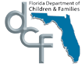
For additional information, please visit www.myflorida.com/childcare or contact your local licensing office below:
CF/PI 175-70, June 2009
This brochure was created by the Department of Children and Families in consultation with the Department of Health.

Holiday Participation Notice
We often schedule instructional activities around holidays. Additionally, most classrooms schedule snacks around holiday events. We encourage you to celebrate your child's birthday by bringing in small, store-made cupcakes to be served during snack time as well.
We want to be sensitive to the individual needs of our students and their families. We recognize that some families may object to holiday activities. We will arrange for these students to have an alternative activity. If you do not wish for your child to participate in holiday activities, please indicate on the slip below and return it to the school along with your enrollment forms. We encourage you to keep in touch with your child's teacher regarding scheduled classroom activities.

Yes, my child can participate in all holiday activities ________.
No, I do not want my child to participate in holiday activities ________.
Our family celebrates special holidays and I would like to have them observed in their classroom as well. The holidays are __________________________________________________.

Child's Name: ___________________________________________________________
__________________________________________ _________________
Parent's Signature Date

Comments: _____________________________________________________________

_______________________________________________________________________

_______________________________________________________________________

_______________________________________________________________________.

Green Day Early Learning Center • 1010 West Oak Ridge Rd • Orlando, FL 32809 • 407-801-5727

Notification of Non-Smoking Policy
In compliance with state law, and for the well-being of our children, the use of all tobacco products and e-cigarettes is prohibited on the Green Day Learning Center campus, and within 1,000 feet of campus, at all times. Violators will be asked to leave campus immediately.

---------------------------------------------------------------------------------------
I acknowledge receipt of a copy of this policy and agree to comply where required.

_____________________ _________________________ _______________
Printed Name Signature Date

Notification of Non-Smoking Policy
In compliance with state law, and for the well-being of our children, the use of all tobacco products and e-cigarettes is prohibited on the Green Day Learning Center campus, and within 1,000 feet of campus, at all times. Violators will be asked to leave campus immediately.

---------------------------------------------------------------------------------------
I acknowledge receipt of a copy of this policy and agree to comply where required.

_____________________ _________________________ _______________
Printed Name Signature Date
We are excited to offer the safety, convenience and ease of Tuition Express®—a payment processing system that allows secure, on-time tuition and fee payments to be made from either your bank account or credit card.

ELECTRONIC FUNDS TRANSFER AUTHORIZATION FOR BANK ACCOUNT and CREDIT CARD
I (we) hereby authorize (business name) ____________________________________________ to initiate credit card charges to
the below-referenced credit card account (Section A) OR, initiate debit entries to my (our) checking or savings account, indicated below (Section B). To properly affect the cancellation of this agreement, I (we) are required to give 10 days written notice. Credit union members: please contact your credit union to verify account and routing numbers for automatic payments. Check with the center for accepted credit card types.
COMPLETE ONE SECTION ONLY
SECTION A (Credit Card)
_______________________________________________________________________________________________________
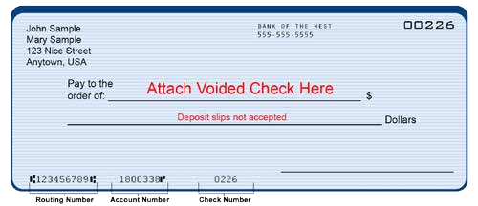
Cardholder Name Phone #

State

Zip
City

Address
_______________________________________________________________________________________________________
Bank or Credit Union Name

Bank or Credit Union Address

City

State
Zip

_______________________________________________________________________________________________________
Routing Transit Number (see sample below)

Account Number (see sample below)
_______________________________________________________________________________________________________

Authorized Signature
Date

For Official Use Only
Date Received
________________________
Employee Signature
________________________
A service of
Checking
Savings
Copyright Procare Software 1/19/2015
Automated Payment Processing
Safe – Convenient – Easy
_______________________________________________________________________________________________________
Cardholder Address City State Zip

_______________________________________________________________________________________________________
Account Number Expiration Date
_______________________________________________________________________________________________________
Cardholder Signature Date
SECTION B (Bank Account)
_______________________________________________________________________________________________________
Your Name Phone #
_______________________________________________________________________________________________________

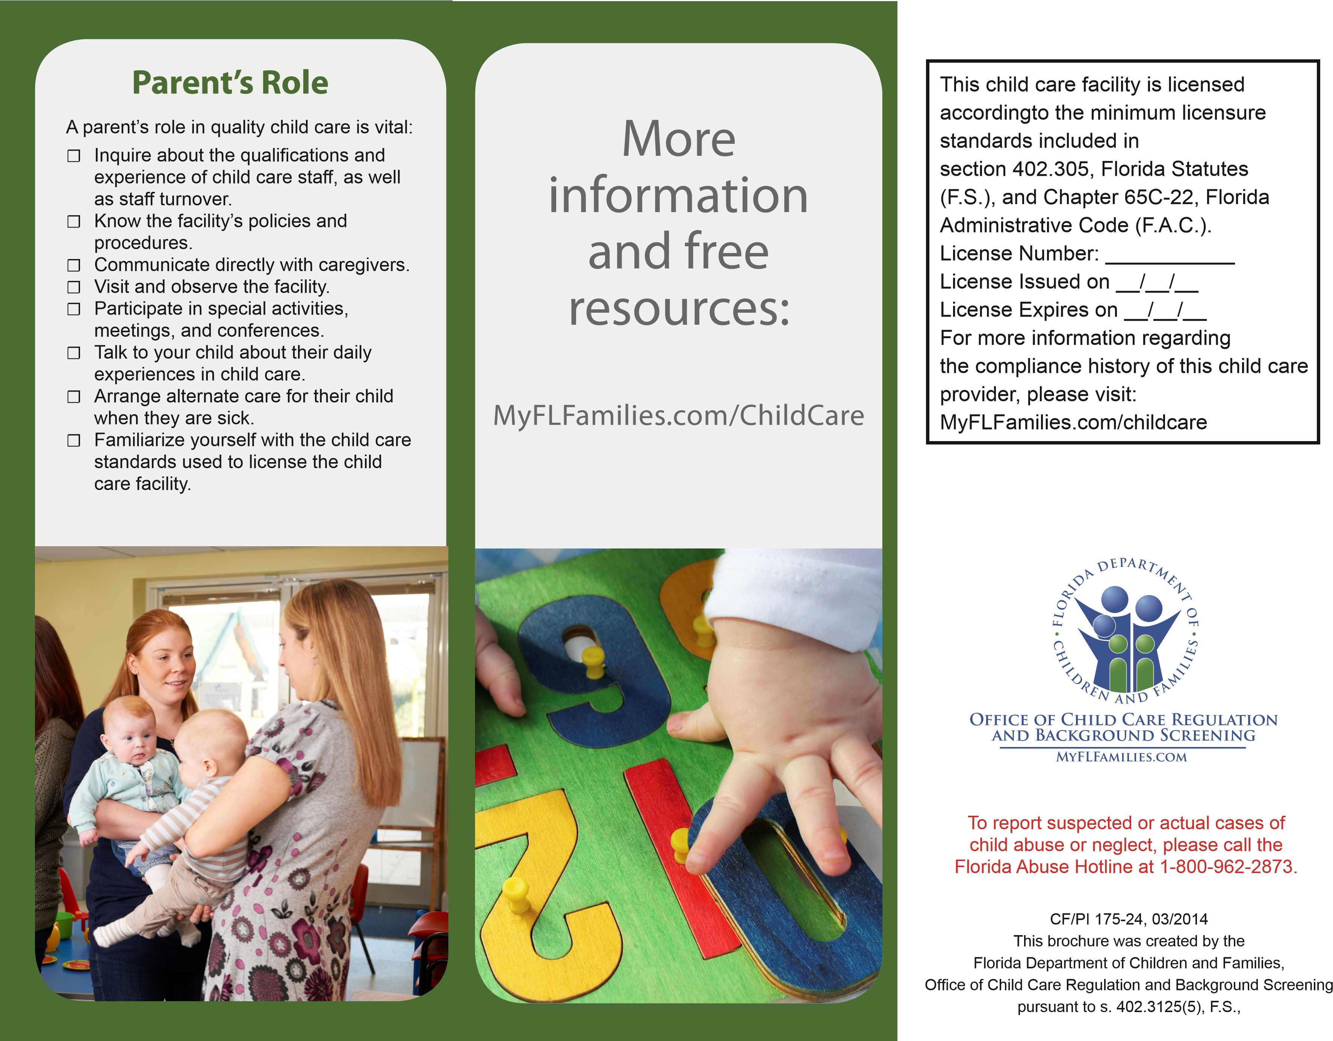
Know Your
Child Care
Facility
MyFLFamilies.com/ChildCare
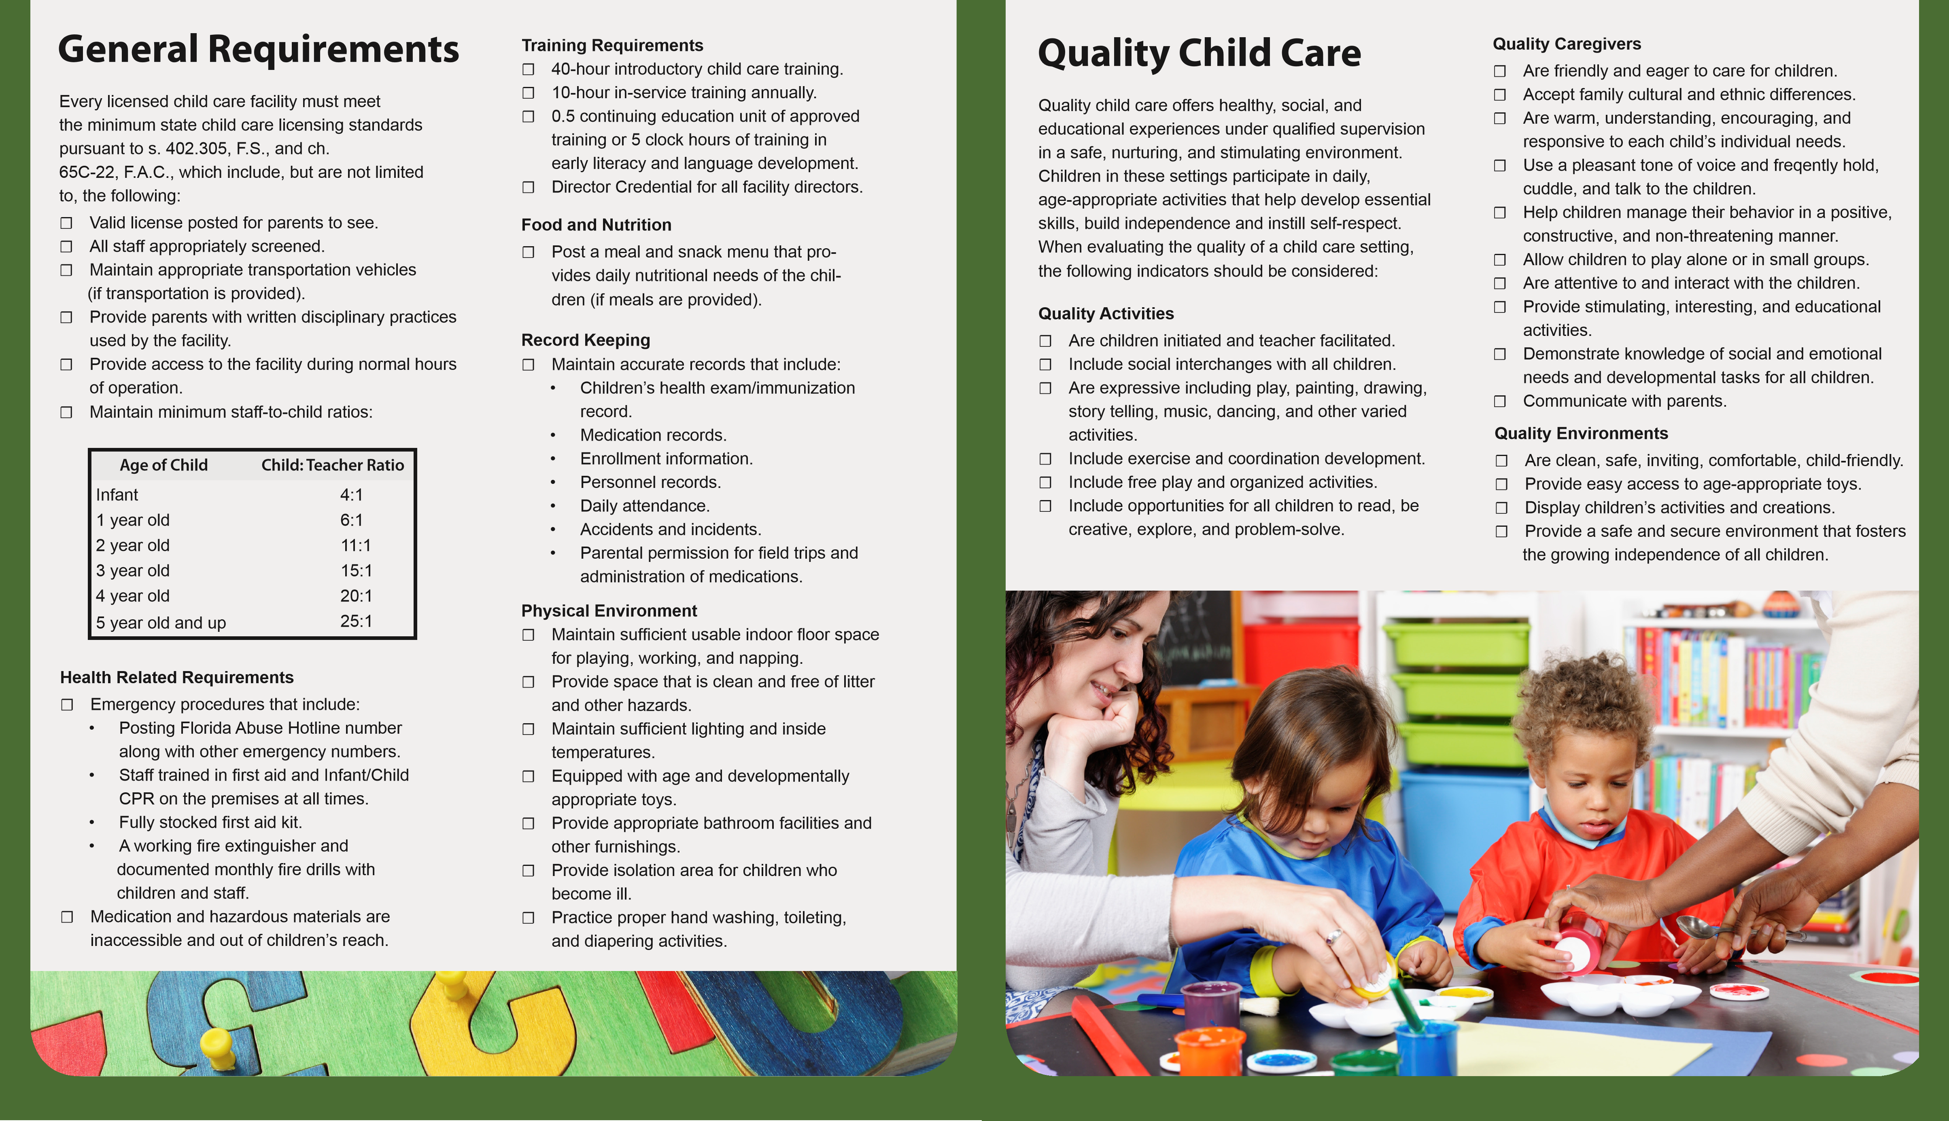

Notice of Sick Child
Name: __________________________________ Date: _____________________ Symptoms: ________________________________________________________
__________________________________________________________________
__________________________________________________________________
Who was notified? __________________________ Time: __________________
_______________________________ |  | ___________________
Director/Supervisor |  | Date
_______________________________ |  | ___________________
Parent/Guardian |  | Date
I understand that my child may return to school, symptom-free in 24 hours unless we are provided with a doctor's note.

Notice of Sick Child
Name: __________________________________ Date: _____________________ Symptoms: ________________________________________________________
__________________________________________________________________
__________________________________________________________________
Who was notified? __________________________ Time: __________________
_______________________________ |  | ___________________
Director/Supervisor |  | Date
_______________________________ |  | ___________________
Parent/Guardian |  | Date
I understand that my child may return to school, symptom-free in 24 hours unless we are provided with a doctor's note.

First Day of School Checklist & Student Orientation
Enrollment Packet
 Enrollment Application
 Tuition Express Form
 Student Discipline Policy
 Signed, Know Your Child Care Facility Brochure
 Payment Contract
 Holiday Participation Notice
 Physical
 Immunization Form (Florida)
 Alternate Nutrition Plan
 Health and Development Questionnaire
 Release for Emergency Care
 Food Program Application
General
 At least 2 full changes of clothes, including one pair of shoes in a large, labeled with first and last name, freezer storage bag (Please replace as needed and when seasons change)
 Crib sheet, labeled with child's first and last name
 Blanket, labeled with child's first and last name (Crib sheets and blankets are sent home every Friday to be laundered)
 One's only - Bottle or Sippy Cup labeled with child's first and last name (one's only). Sippy Cups and Bottles must be taken home EVERY DAY.
 Three's and Four's only - Green folder for homework and notices
On your child's first day, it's natural to want to stay with them and help them feel comfortable. We invite you to hug them tight, wish them well and watch them for a little through the windows in the hallway. This helps ensure an easy, stress-free transition for them and their classmates. We have an open-door policy and you are more than welcome to come by any time and take a peek!

