Economical Ultrapure Water Machine

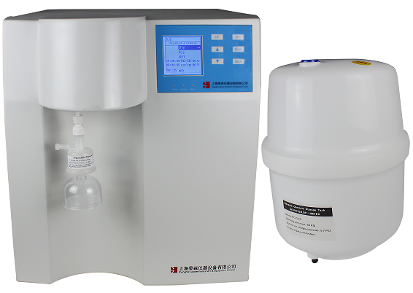

CR/CM- 系列超纯水机是由上海杲森仪器独立研发生产的经济型超纯水机，系统高度智能、操作简单、体积小巧、维护简便。
CR/CM- series ultrapure water machine is a high-end ultrapure water production instrument. It features highly intelligent system, simple operation, compact volume and convenient maintenance.
特点与优势
Features and advantages
- 全自动微电脑控制系统，多级菜单式操作，触摸按键设计160*160高清晰显示屏，模块化控制系统。
1. Full-automatic microcomputer control system, multi-level menu operation, 160*160 HD display screen for touch buttons, and modularized control system.
- 中英文菜单可自由切换，方便不同的客户使用。
2. Chinese and English menus can be switched freely to facilitate different clients’ operation.
- Gaosens操作系统具有定时取水模块：1、可以在0-9999min区间内自由选择取水时间；2、可以10min、30min、60min、120min四个量程定量取水。
3. Gaosens operation system has timing module for water usage: 1. Water usage time can be selected from 0 to 9999min freely. 2. Timed water usage can be carried out at four ranges including 10min, 30min, 60min and 120min.
- Gaosens操作系统具有定量取水模块：1、可以在0-9999ml区间内自由选择取水量；2、可以500ml、1000ml、2000ml、5000ml四个量程定量取水。
4. Gaosens operation system has quantitative module for water usage: 1. Water usage time can be selected from 0 to 9999ml freely. 2. Quantitative water usage can be conducted at four ranges including 500ml, 1000ml, 2000ml and 5000ml.
- Gaosens操作系统具有定质取水模块，可根据客户需求在0.1-18.25内自由设定取水。
5. Gaosens operation system has quality module for water usage: it can set water usage from 0.1 to 18.25 freely as required.
- 纯水存储选用压力罐存储，可根据客户需求选用不同容量的压力罐。
6. Pure water storage pressure tank storage, according to customer demand for different capacity of the pressure tank
- 系统自带内存，可以随时查看运行及报警数据。
7. The system is furnished with memory for reviewing operation and alarm data at any time.
- 系统自带万年历时钟，便于对耗材及服务的设置。
8. The system is furnished with calendar clock for setting consumables and services.
- 超纯水循环系统可自由选择自动和手动，保持系统的低细菌污染水平。
9. Ultrapure water circulation system can select automatic and manual modes freely to keep the system at low bacteria pollution.
- 工厂、客户二级密码，系统设置均有密码保护，防止它人未经授权更改和使用。
10. Besides secondary passwords for plant and client, the system setup has password protection to prevent unauthorized change and usage by others.
- 原装进口水源初级过滤系统，增加机器使用寿命。
11. With original imported primary filtering system for water source, service life of the machine is prolonged.
- 缺水、水满报警，源水、RO反渗透水、DI去离子水/UP超纯水超标报警。
12. Alarms for water deficiency and water full; out-of-limit alarms for source water, RO (reverse osmosis) water and DI (deionization) water/UP (ultrapure) water.
- RO膜防垢程序冲洗程序分为自动和手动两种，方便用户及时清理并延长了RO膜的使用寿命。
13. RO membrane anti-scale and flushing programs are divided into two types (automatic and manual types) to facilitate client’s timely cleaning and prolong service life of RO membrane.
技术指标
Technical indexes
型 号  Model |  | CR/CM-L | CR/CM-T | CR/CM-N | CR/CM-B
产水量（L/H）  Water yield (L/H) |  | 5/10/20/30/40/60 | 5/10/20/30/40/60 | 5/10/20/30/40/60 | 5/10/20/30/40/60
源 水  Source water |  | CR:市政自来水，源水压力：1.0~5.0kg/cm2、源水温度：5~40℃  CM:去离子水、反渗透水 源水温度：4~40℃  CR: city water, source water pressure: 1.0~5.0kg/cm2; source water temperature: 5 to 40℃  CM: deionization water, RO water source water temperature: 4 to 40℃
产水水质Water yield quality | RO | 源水电导率*2%（二级反渗透电导率<5us/cm）@25℃  Source water conductivity *2% (Level-II RO conductivity <5us/cm) @25℃
产水水质Water yield quality | 纯水  Pure water | 电导率<0.2us/cm  Conductivity <0.2us/cm
产水水质Water yield quality | UP | 18.25 MΩ•cm
产水水质Water yield quality | TOC | <3ppb | 1-3ppb | <10ppb | <20ppb
产水水质Water yield quality | 微生物  Microorganism | <1cfu/ml | <1cfu/ml | <1cfu/ml | <1cfu/ml
产水水质Water yield quality | 内毒素  Endotoxin | <0.001EU/ml | <0.02EU/ml | <0.005EU/ml-- | ---
产水水质Water yield quality | RNA酶  RNA enzyme | <0.01ng/ml | --- | --- | ---
产水水质Water yield quality | DNA酶  DNA enzyme | <0.04pg/ml | --- | --- | ---
终端过滤器  Terminal filter |  | 选配0.2/ 0.1/ 0.05/ 0.01um终端过滤器  Optional: 0.2/ 0.1/ 0.05/ 0.01um terminal filter |  |  | ---
应用领域  Application fields |  | 电泳、内毒素分析、细胞免疫化学、核酸与蛋白质分离、单克隆抗体研究等其它实验领域  Experiment fields such as electrophoresis, endotoxin analysis, cell immunity chemistry, nucleic acid and protein separation, monoclonal antibody research | 石墨炉原子吸收（GFAAS）、气质联用（GC-MS）、高效液相色谱（HPLC）、等离子质谱（ICP-MS）、离子质谱（IC）、TOC分析、固相萃取（SPE）  Graphite furnace atomic absorption spectrometry (GFAAS), gas chromatography and mass spectrum combination (GC-MS), high performance liquid chromatography (HPLC), inductive coupling plasma mass spectrum (ICP-MS), ion mass spectrum (IC), TOC analysis, solid-phase extraction (SPE) | 哺乳动物组织细胞培养、微生物分析、分子生物学研究、植物组织细胞培养  Cultivation of mammal tissue cell, analysis of microorganism, research of molecular biology and cultivation of plant tissue cell | 原子吸收光谱（AAS）、原子荧光、普通化学、电感耦合等离子光谱仪（ICP-AES）  Atomic absorption spectrum (AAS), atomic fluorescence, normal chemistry, inductive coupling plasma spectrograph (ICP-AES)
电源  Power supply |  | 220V 50HZ 功率：80~120W  220V 50HZ Power: 80 to 120W
外形  Appearance |  | 560*458*395mm喷塑机箱，不会腐蚀、生锈，符合GLP规范  560*458*395mm plastic-sprayed case free of corrosion and rust, conforming to GLP specification
备注：B：基础型 N：分子生物型 T:痕量有机型 L:生命科学型
Remark: B: Basic type; N: Molecular biology type: T: Trace organic type; L: Life science type

