To be able to judge whether a log entry shows good reflection, you need to have an understanding of what reflection is and the different levels describing the depth of reflection.
It is a skill which we all do to varying depths and the role of the ES and CS is to help the trainee develop or enhance what they already have.

Why do we go on and on about reflection?
- Because effective learning won’t happen unless you reflect.
- Reflecting on or during some experience in light of known theoretical concepts or previous learning should lead to new insights into different aspects of that situation.
- So we see that the outcome of reflection is learning (Meziros, 1981).

The proper definition
Kemmis (1985) the process of reflection is more than a process that focuses 'on the head'. It is a positive active process that reviews, analyses and evaluates experiences, draws on theoretical concepts or previous learning and so provides an action plan for future experiences.
Johns (1995) adds that reflection is a personal process enables the practitioner to assess understand and learn through their experiences. This results in some change for the individual in their perspective of a situation or creates new learning for the individual.

Types of reflection
Do not confuse this with levels of reflection. Levels of reflection refers to how deeply one reflects. Types of reflection is different.
Schön (1987) in his work identifies two types of reflection; these are reflection-in-action (thinking on your feet) and reflection-on-action (retrospective thinking). He suggests that reflection is used by practitioners when they encounter situations that are unique, and when individuals may not be able to apply known theories or techniques previously learnt through formal education.
Encourage a trainee to use both TYPES of reflection. Most trainees write reflection-on action. In other words, they write about situations which went either particularly well or badly to see what they might continue to do and what they might change. Encourage them to write about reflection in action – writing about the reflective process happening in their heads DURING the situation (like one which they have never encountered before and had to therefore think on their feet).

The key qualities and skills and individual needs to do proper reflection
Gillings (2000) states that commitment to self-enquiry and readiness to change practice are important if the individual is to get the most out of the process.
Qualities needed (Richardson & Maltby 1995, Gillings 2000)
These are the sorts of attitudes you want to instil in your trainee:
- Open minded’ness
- Commitment to self enquiry
- Motivation and
- Readiness to change practice

Skills needed (Richardson & Maltby 1995)
You need to analyse the trainee’s log entry in these terms. I call them the ISCE criteria.

- Information – describing what happened or what was observed in enough detail.
- Self Awareness - being open and honest about performance but also writing about own feelings and/or that of others
- Critical Thinking – analysing the bigger and smaller pictures, problem solving, describing own thought processes
- Evaluation – pooling the above three things together (synthesis) and describing what needs to be learned, why and how.

Levels or depths of reflection – ISCE levels
That brings us nicely onto the different depths of reflection. Take a look at this table for a minutes. Hit the pause button below now.
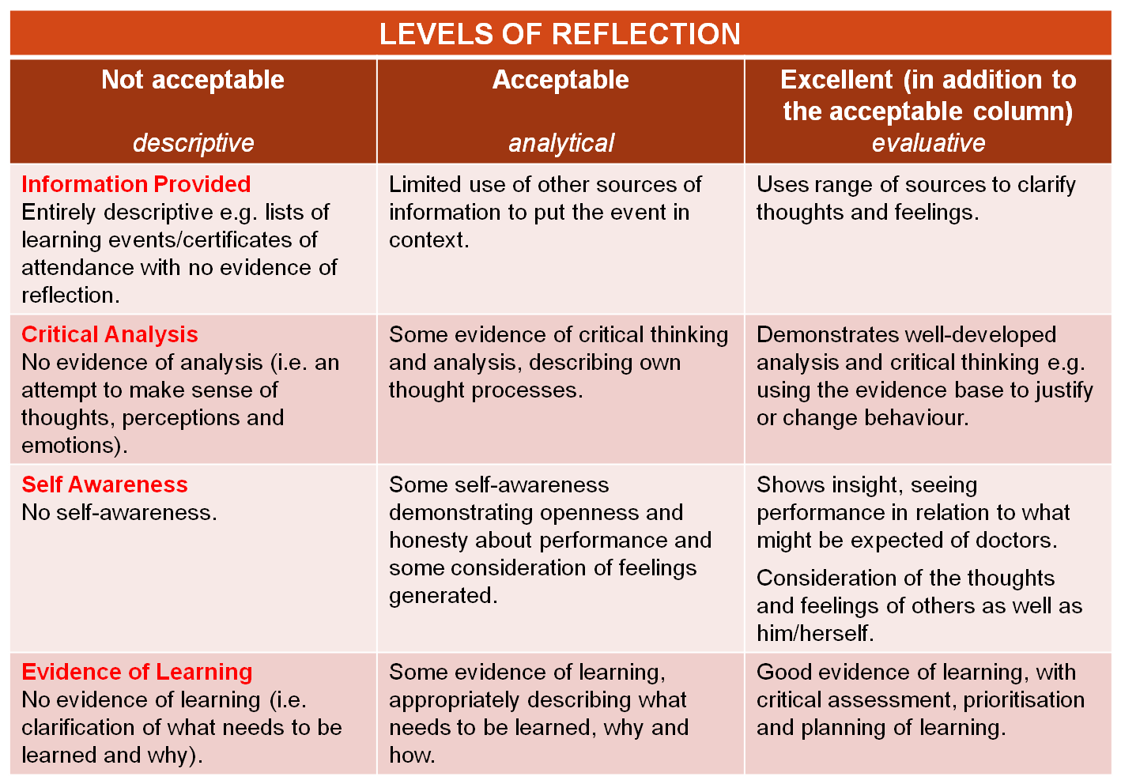
So, when trying to figure out how reflective a log entry is, think of four things – the ISCE levels.
- Information provided
- Critical Analysis
- Self Awareness
- Evidence for Learning
Have you read a trainee’s log entry and thought it was a bit dire? And that’s putting it nicely? Did you struggle in terms of trying to identify why it was dire? Well, usually it’s because the trainee has written endless descriptive notes on what happened without any further analysis or evaluation. By applying the ISCE criteria, you should now be able to see that they fit into the first column.

I won’t detail what makes a really good deeply reflective log entry because the descriptors under the ‘excellent’ column in the table above say it all.

How do I get my trainee to reflect more deeply?
A handy tip for you might be to print this little table and keep it with you when reading log entries. Share it with the trainee and get them to assess their own level of reflection on a few of their own log entries. They’re more likely to learn in this way.
Another thing you might do is to pick a log entry that you think could have been more reflective and get them to apply Kolb’s experiential learning cycle (1984) in a clockwise direction. Why not print a copy of Kolb’s cycle for them so they get used to this method of thinking. Hopefully, that should result in new things that they could have done which they will now consider in the future. Get them to see the value of doing this methodically.
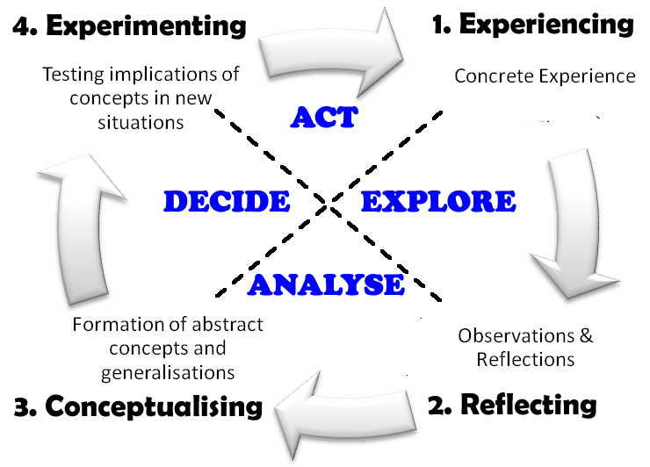
- CONCRETE EXPERIENCE is about something that has happened to you or that you have done.
- REFLECTION is concerned with reviewing the event or experience and exploring what you did and how you and others felt about it.
- ABSTRACT CONCEPTUALISATION is all about developing an understanding of what happened by seeking more information or bringing in theoretical concepts or previous learning to form new ideas about ways of doing things in the future.
- ACTIVE EXPERIMENTATION is about trying these newly formed ideas.
When reflecting-on-action, the first step in the process is the description of the incident. Therefore, you might want to encourage your trainee to keep a reflective diary in which they record details of incidents that either troubled or pleased them (as memory cannot be relied upon for the detail of events). Encourage them to record details as soon after the event as possible.
Why not encourage the unreflective trainee to sum up each day with a reflective comment in his/her diary, spending only a few minutes doing it. You may also set them an example by keeping a reflective diary of your own professional practice or indeed your experiences as a Educational or Clinical Supervisor, thus demonstrating that learning is always ongoing!
And remember, the more you can coach your trainee to do reflection properly, the more you move them from ignorance to understanding. And that means that they soon continue at a much swifter pace, requiring less input from you, and as a result, your work as ES/CS becomes easier. Bliss!

My trainee doesn’t like writing it all down. He says he does it all in his head anyway!
Loads of trainees say that they do it in their head, but remember, reflection is an active process rather than about passive thinking. The problem with thinking ‘in your head’ is that people often rush through the reflective process. Writing it down encourages them to slow their pace. Slowing down promotes a better description, better critical analysis, better self awareness and therefore better evaluation (or learning) – Richardson & Maltby 1995, Zubbrizarreta 1999 and Tryssenaar 1995 (is that enough evidence for you?)

Time for reflection
As and ES or CS, don’t forget that you’re a role model (whether you like it or not). McClure (2005) says how important the time for reflection is – and that applies to you too; you need to make time during training and day to day practice to encourage the trainee (and yourself) to reflect. In that way, reflection becomes a part of your and the trainee’s way of working. It’s an integral part of practice and trainees need time to develop the skill. You can’t rush it and must be a dynamic part of working life (i.e. avoid saying ‘let’s reflect on that later’ – do it when it’s hot!).
References
- Mezirow J (1981) A critical theory of adult learning and education. Adult Education 32(1):3-24.
- Richardson & Maltby, 1995 Reflection on practice: enhancing student learning, Journal for Advanced Nursing, 22, 235-42
- Gillings B ( 2000) In Burns S and Bulman C (2000) (eds) Reflective Practice in Nursing: The Growth of the Professional Practitioner, Ch 5, Pages 106-121. Oxford, Blackwell Science
- Zubrizarreta J (1999) Teaching portfolios: an effective strategy for faculty development in occupational therapy. American Journal of Occupational Therapy. 53(1):51-55.
- Tryssenaar J (1999) Interactive journals: an educational strategy to promote reflection. American Journal of Occupational Therapy. 49(7):695-702.
- McClure P (2005) Reflection on Practice. http://www.practicebasedlearning.org/resources/materials/docs/reflectiononpractice.pdf

