Workshop Minutes
15/5/18
Apologies
Nick B
Chuan C
May C
Amir A
Mareeni R
Anna P
Present
Mel S
Steph C
Will B
Milan G
Paul U
Mark H
Haoili J
Fiona P
Meena K
Juliet B
Michael L
Jim B
Jo H
Alex K
Niifio A
Leo H
Helen D
Jonathon T
James M
Emily W
Agenda
Home visits
Ensuring Educational and Clinical Safety
COGPED
- The number of home visits undertaken should be related to educational and not service delivery needs.
- The trainer is responsible for assessing the suitability of the visit for a Trainee in terms of learning needs, clinical competence (patient safety) and personal safety.
- The trainer is responsible for ensuring arrangements to brief the Trainee before, making suitable arrangements for clinical supervision during and debriefing after the visit.
Things to consider
- Emergency vs routine (FHV) visits
- Who allocates visits, inc triage of visit requests
- Equipment, inc phone
- Safety (consider disability, transport, access, gender)
- Supervision before, during and after visit – why are we visiting? Now what?
- Learner readiness
- Patient consent
- Handover/continuity
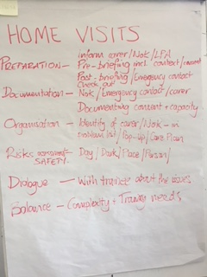
Educational Supervisor notes
When we use them
Best practice
Sharing with learner
Helping panel reach decision
Business
- Welcome new Trainers
- CSA
- Recruitment
- Website
- ‘Escalations of Concern’
- Indemnity
  - Block paid
  - Check your learner has it and has declared in GP post
- VTS Residential 6th - 8th June
- Summer drink 4-7; 214 Richmond Rd E8 3QN 14th August
- TWS Residential 5pm-5pm 9th-10th November
- Next meeting 17th July 1:30-3pm
Alex Kelly updated us on OOH – requirements for current ST3s and situation with CHUHSE

