Workshop minutes 21.07.2020; New Portfolio and WPBA

Main points: Mobile app; linking to ESR, messaging service

3 Clinical Case Reviews per month.

SEA not mandatory unless sufficient for Form R/ referral to GMC etc

New capability areas: 13 total, it’s the learners’ responsibility to link up to 3 capability areas for each case review

Leadership activity for all ST3s in the first 6 months and the MSF is for the following 6 months.

ST1/2 will have to do a QI project

CAT: Clinical Assessment Tool

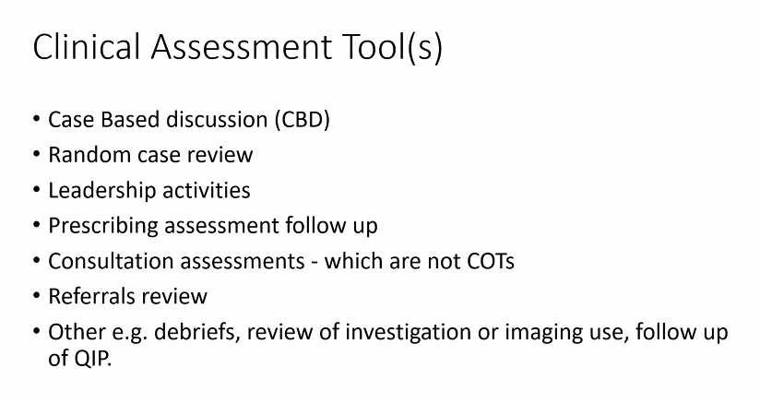

MiMid year review

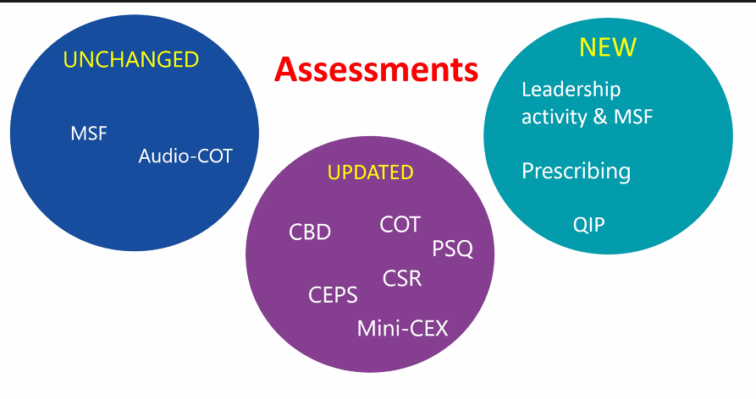

Mid Year Review: may be very light for an absolutely fine review; otherwise will need a ESR level review

Summary of changes:

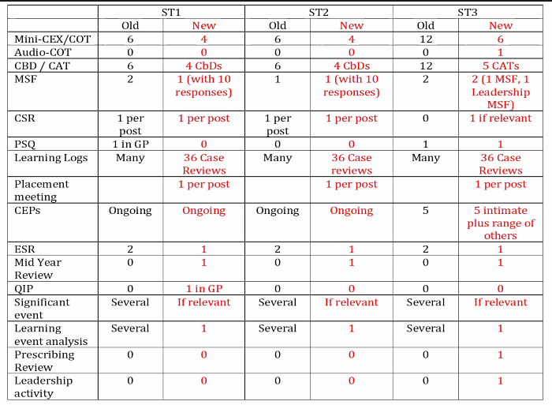

Questions:

Will chat function be private? Probably not

What kinds of leadership activity will be counted? To be covered in November

Induction and Coronavirus:

Risk assessment: trainee’s level of risk/ comfort/ views

Co-working safely

Doctors’ bag

How to ensure sufficient clinical contact/ experience

Rhythm/ cadence of a normal surgery when consulting by phone

Note: We can ask for an extension if we don’t think they’ve had enough experience

Next session:

August 18th ST1 from 2, everyone else from 5-7pm

September 15th: Audio COT Callibration; Fairhealth – GP training and inequalities.

November Residential: Maddingly Hall: Educating for uncertainty