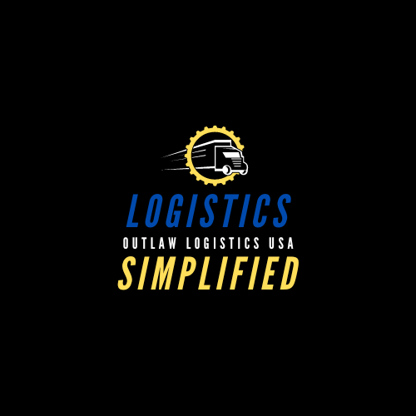

**Outlaw Logistics USA** is looking for Straight Truck (Box Truck) Drivers with a valid government issued driver’s license (State standard license/non-CDL) to transport palletized freight from Amazon to various distribution centers. Maximum expected distance covered within a day is 300 miles. Drivers must be available to train for 3 days prior to initial start date.

**We are seeking a Warehouse Route Driver (Non-CDL) to join our Outlaw Logistics USA team in Waldorf, MD.**

The Truck Driver is responsible for delivering products to/from customers, company/warehouse locations, and company suppliers with a 26-foot box truck (No CDL required). Responsible for ensuring that deliveries are prepared to meet customer requirements in the most efficient manner, and materials are correct and free of damage.

* Ensuring the safety of the motor vehicle and all deliveries
* Weekly Pay
* Compensation ranges from $150.00 to $300 daily
* Paid weekly bonus incentives for keeping an 100% on time delivery
* Full-time position as a 1099 Independent Contractor
* First Shift: Morning/Afternoon 7am-3pm
* Second Shift: Evening/Night 7pm-3am
* Must be able to work 5 days per week
* Must have a valid driver’s license (CDL not required)
* Must be 21 years or older
* Must be VERY PUNCTUAL!

Job Description

* Inspects company vehicle for visual and operating defects. Responsible for completing a daily inspection report
* Keeps company vehicle clean, serviced, and maintained. Alerts supervisor of repair and/or service needed
* Must follow Department of Transportation (DOT), local and state driving laws and regulations
* Loads or unloads vehicle; and ensures all material for each order is correct (quantity and type of material), and that material is free of damage before departure
* May assist in preparing orders for delivery
* Ensures all appropriate documentation is thoroughly completed at the time of delivery, including delivery receipt is signed by the customer, packing list and branch/warehouse manifest
* Picks up material returns from customers. Responsible for inspecting the condition of the material and verifies quantities and catalog numbers
* Picks up material from company suppliers
* May be required to support other Warehouse duties such as preparing and filling orders and/or receiving, stocking, staging, and shipping material
* Other duties as assigned

The information in this job description is intended to describe the essential job functions required of those assigned. It is not intended to be an exhaustive list of all responsibilities, duties, knowledge, skills, and abilities needed to perform the job. Please note that management retains the right to assign or reassign duties and responsibilities to this job at any time. The ability to competently perform all the essential duties of the position, with or without reasonable accommodation, demonstrated commitment to effective customer service delivery, integrity, and the ability to work productively as a team member are fundamental requirements of all positions at Outlaw Logistics USA.

What You'll Need

* 2+ years of experience, preferred, not required
* Must have a valid Driver’s License
* Must be at least 21 years of age
* Must pass a pre-employment and annual review of their Motor Vehicle Record
* Must obtain verification of non-expired medical certificate within 30 days of hire
* Must not have had their drivers’ license suspended for traffic accidents/violations within the past 3 years
* Must not have any moving violations within the past 3 years
* Must not have any at fault accidents in the past 3 years

Knowledge, Skills, and Abilities

* Ability to handle loads with a combine weight not to exceed 26,000 GVW
* Ability to handle moderate issues and problems
* Strong knowledge of safety regulations, and be familiar with traffic and driver laws
* Willingness to adhere to assigned routes, schedules, safety procedures, and transportation laws
* Excellent organizational and time management skills. Ability to meet deadlines!
* Excellent customer service skills
* Good attention to detail
* Ability to work overtime as needed

To apply for this position, please email us at [contactus@outlawlogisticsusa.com](mailto:contactus@outlawlogisticsusa.com).

In the subject line please put: New Driver Applicant