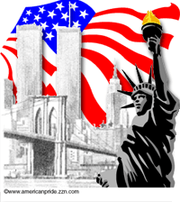
A MEMORIAL DAY PLEDGE

“I PLEDGE”- a promise made by 4,435 Americans who gave their lives for our independence in the Revolutionary War.

“ALLEGIANCE”- attested to by the 2,260 battle deaths suffered in the War of 1812.

“TO THE FLAG”- 1,000 served under it and died for it during our Indian Wars.

“OF THE UNITED STATES OF AMERICA”- from 1846 to 1848, 1,733 Americans gave their lives in the Mexican War.

“AND TO THE REPUBLIC”- divided at the Mason Dixon line during our own Civil War… over 500,000 Americans, some with blue uniforms, some with grey, perished.

“FOR WHICH IT STANDS”- 2,446 Americans stood… and died in the Spanish American War.

“ONE NATION”- our nation, joined in the war to end all wars, WW I from which 116,516 American never returned from “over there”.

“UNDER GOD”- 305,399 Americans died in the Atlantic and Pacific Theaters of
WW II

“INDIVISABLE”- Korea is still divided despite the efforts of 36,516 Americans who shed their life’s blood there.

“WITH LIBERTY” Viet Nam’s liberty battle cost 58,198 of my classmates lives.

“AND JUSTICE”- 383 Gulf War American casualties.

“FOR ALL”- including 3,400 who perished in the Iraq War as of (time, today).

It’s not about war or politics. It’s about the sacrifice these people made… life.

