Table of Honor

I would like to draw your attention to the small, round table in the front of the room. It is set for our brothers and sisters who have answered their final call and are no longer with us on this earth. The origin of the Table of Honor comes from the military, but it has been adapted to fit many other organizations. For the Fire Service, the symbolism remains almost identical, with only minimal variation.

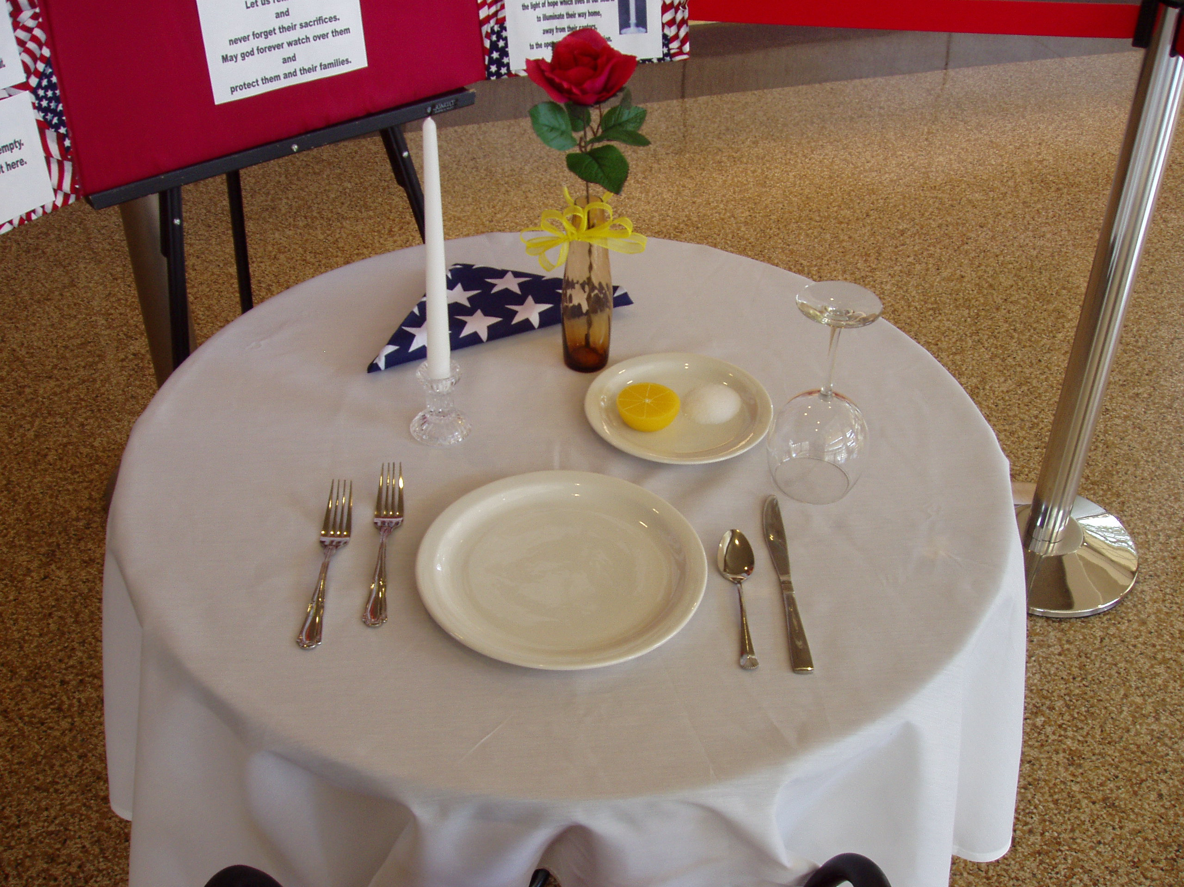

As the Honor Guard places a fire helmet on the empty plate, I would like to ask you to consider their sacrifices, followed by a moment of silent prayer.
(Seating the audience is optional)

Please be seated…..I would like to take a moment and explain the meaning of the items on this special table.

The TABLE is small symbolizing the frailty of human life and set for one, symbolizing the loneliness we feel without them. It is round to show our everlasting concern and our unending love for our fallen comrade.

The TABLECLOTH is white symbolizing the purity of their motives and willingness to respond when answering the call to duty.

The SINGLE RED ROSE, displayed in a vase, reminds us of the life of each of the missing, and their loved ones left behind. They will always be a part of our family.

The PURPLE RIBBON tied so prominently on the vase, represents our strength in healing.

A SLICE OF LEMON is on the bread plate to remind us of their bitter fate.

There is SALT upon the bread plate too, symbolic of the river of tears shed by families and loved ones.

The GLASS is inverted - to symbolize their inability to share this evening's toast.

The CHAIR is empty … they are not here. Our lives are incomplete because they cannot sit with us tonight.

The CANDLE is reminiscent of the light of hope which lives in our hearts to illuminate their memory.

The FOLDED AMERICAN FLAG and the BIBLE represents those who gave the ultimate sacrifice for their community and country which was founded as one nation under God.

(Have audience rise if they are seated.)

In honoring them … each of them … all of them … we stand silently and face their table … the table where they should be sitting with us tonight. We stand silently in their absence.

Please raise your glass in a toast. To our Fallen Heroes; we will never forget your ultimate sacrifice.

Materials Needed:
- Small, round table – cocktail size
- One chair
- White tablecloth
- Folded American Flag
- Bible
- Table setting to include; plate, utensils, glass, napkin and bread plate
- Bud vase
- Single red rose
- Purple ribbon
- Slice of Lemon
- Small pile of salt (1-2 tablespoons?)
- Fire Helmet
- Candle

Modify and adjust the ceremony to fit your agency. As always, it is what you make it and most anything done in a dignified and military manner is usually acceptable. Keep the Flag Code in mind and it is hard to go wrong.

