**Washington State Fire Service Line of Duty Death Guidelines and Procedures**

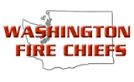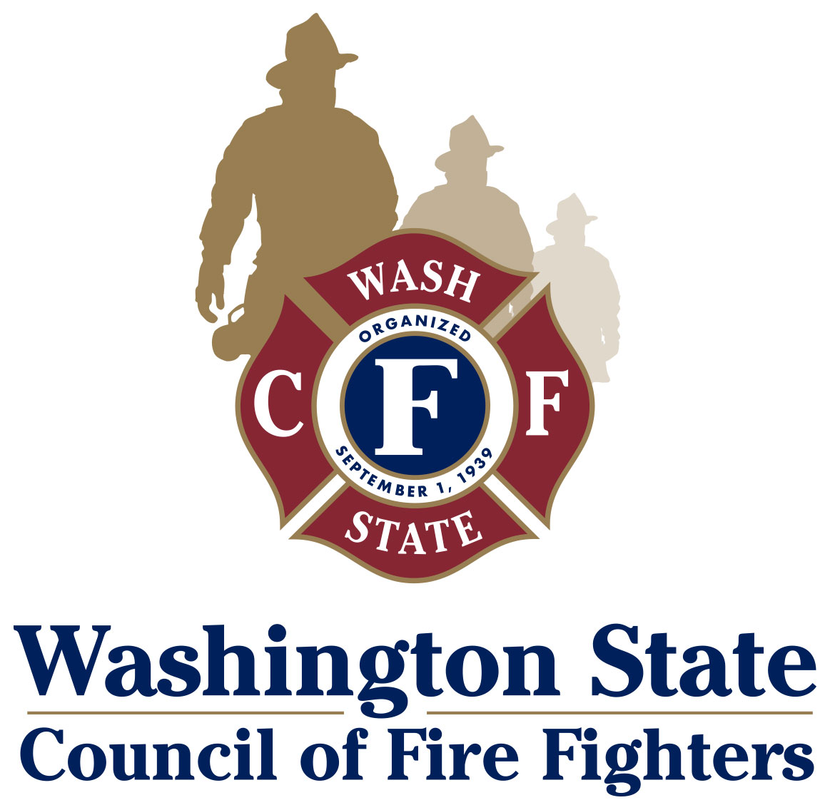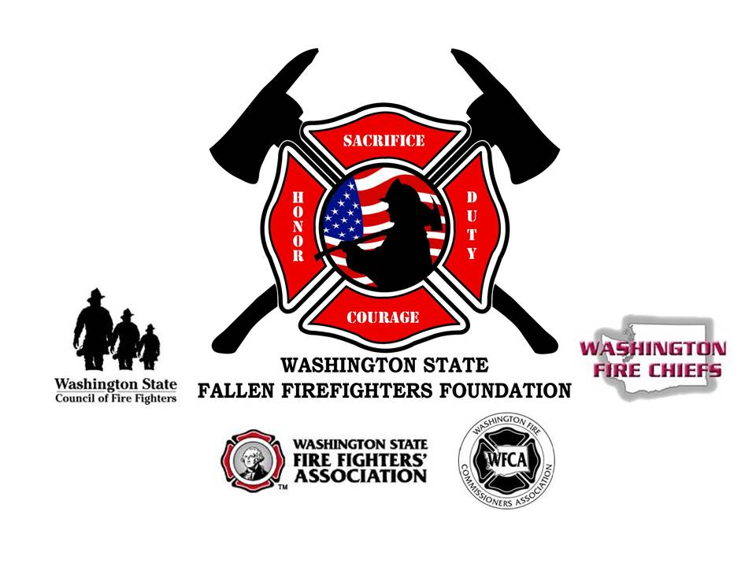**Line of Duty Death of a Member**

### Level I: Line-of-Duty Death (LODD)

The death occurs while in the line-of-duty or from a job-related medical injury covered by RCW 51.32.185. The funeral service may include all honors and assistance.

Contents

Page 3: Notification Procedures after the Death of a Firefighter

Page 5: Purpose and Scope of the LODD Guidelines

Page 6: Implementation of the Line of Duty Death Procedures

Page 7: Level of Honor At-A-Glance

Page 8: Level I: Line of Duty Death

Page 10: Level I LODD: Suggested Order of Service

Page 12: Medical/Cancer LODD

Part 1: Preparing for the death of the Firefighter

Part 2: Time of Death

Part 3: Funeral/Memorial Service Planning

Appendix 1, 2, and 3

Page 21: Medical/Cancer LODD Determination Quick Sheet and RCW 51.32.185

Page 25: Protocols

Flag Display

Badge Shrouding

Dress Code

Hand Salute

Page 26: Suggested wording for Key Portions of the Service

Pre-Service Protocol Instructions

Flag Presentation

Honors Introduction

Bell Ceremony

Last Alarm Radio Call

Firefighters Prayer

Page 31: Chiefs “Need to Do” Check List

Page 32: LODD Resources

**\*\*\*\*If your department has suffered the death of a firefighter form a work related incident the following, time sensitive notifications must be made.\*\*\*\***

***Within 8 hours of the death of a firefighter*** the Washington State Department of Labor and Industries must be notified at 1-800-423-7233 to be in compliance with WAC 296-800-32005andWAC 296.305.01501 *[(c). Within eight hours after the fatality or probable fatality of any firefighter or employee from a work-related incident or the inpatient hospitalization of any employee as a result of a work-related incident, the employer of any employees so affected, shall orally report the fatality/hospitalization by telephone (1-800-423-7233) or in person, to the nearest office of the department.]*

***Within 48 hours of the death of a firefighter*** the Washington State Fire Marshal’s Office must be verbally notified at 1-360-753-0523. The WSP FIRE FATALITY REPORT FORM must be completed by the Fire Chief.

***Within 90 days of the death of a Volunteer Firefighter*** the Board of Volunteer Firefighters must have the Accident Report Card submitted <http://bvff.wa.gov/AccidentReportCard.aspx>

**Please notify the appropriate organizations of the death**

**Washington State Association of Fire Chiefs**

*\*For Career and Volunteer Fighters*

[www.wsafc.org](http://www.wsafc.org)

605 11th Ave, SE, Suite 211

Olympia, WA. 98501

360-352-0161

360-586-5868 (fax)

[wfc@washingtonfirechiefs.org](mailto:wfc@washingtonfirechiefs.org) (e-mail)

**Washington State Council of Fire Fighters**

*\*For Career Firefighters*

[www.wscff.org](http://www.wscff.org)

1069 Adams Street Southeast  
Olympia, WA 98501  
360-943-3030  
360-943-2333 (fax)

800-572-5762

**Washington State Fire Fighters' Association**

*\*For Volunteer Firefighter*

[www.wsffa.org](http://www.wsffa.org)

PMB 117  
1910 E. 4th Ave.  
Olympia, WA 98506-4632  
Phone or Fax: 800-340-8023

**Board for Volunteer Firefighters**

*\*For Volunteer Firefighter*

[www.bvff.wa.gov](http://www.bvff.wa.gov)

PO Box 114, Olympia, WA 98507  
360-753-7318   
877-753-7318   
360-586-1987 (fax)

**Washington State Local Assistant State Team (LAST)**

<https://www.firehero.org/resources/department-resources/programs/local-assistance-state-team/>

Pat Ellis – 253-856-5826/ [info@wsfff.org](mailto:info@wsfff.org)

Pat Pawlak – 206-949-3039/ [ppawlak@pugetsoundfire.org](mailto:ppawlak@pugetsoundfire.org)

Randy Johnson – 509-467-4500/ [randyj@scfd4.org](mailto:randyj@scfd4.org)

**Law Enforcement Officers’ and Fire Fighters’ Retirement System**

*\*For Career Firefighters*  
Department of Retirement Systems  
P.O. Box 48380 (Mailing Address)  
Olympia, WA 98504-8380  
360-664-7000  
800-547-6657

[www.drs.wa.gov](http://www.drs.wa.gov)

**DRS Point of Contact: (Current as of Dec 2016)**

Tammy Harman, LEOFF Plan 2 Ombudsman

306-586-2324

[tammy.harman@leffo.wa.gov](mailto:tammy.harman@leffo.wa.gov)

**National Organization Notifications for all fire service work related Firefighter deaths**

**Public Safety Officers Benefit (PSOB)**

[www.psob.gov](http://www.psob.gov)

*\*All claims are processed on line, please ask WA State LAST for assistance with filing the claim*

**U.S. Fire Administration**

<http://apps.usfa.fema.gov/firefighter-fatalities/fatalityData/notification1>

**National Fallen Firefighters Foundation**P.O. Drawer 498  
Emmitsburg, MD 21727  
LODD 24hr Hot Line 886-736-5868  
301-447-1365   
301-447-1645 fax  
[www.firehero.org](http://www.firehero.org)

*\*For comprehensive list of State Benefits:*

<http://www.firehero.org/resources/family-resources/benefits/local/wa/>

**Purpose and Scope of the LODD Guidelines**

The purpose of this policy is to provide a best practice guideline for Washington State Fire Departments, Fire Districts and EMS Agencies to follow in the event of a death or serious injury in the line-of-duty. This guideline describes the activities, roles and responsibilities for fire service funeral protocols including Levels of Honor, planning, roles and responsibilities of a planning team and best practice guidelines for funeral procedures as well as conducting notifications, assisting and supporting family members, and interaction with the news media. In this way, Fire Service Agencies in the State of Washington can be uniform in their procedures in rendering the appropriate honors for a fallen member.

This model guideline is a collaborative effort of the following:

Washington Fire Chiefs (WFC)

Washington Fire Commissioners Association (WFCA)

Washington State Council of Firefighters (IAFF)

Washington State Fire Fighters' Association (WSFFA)

National Fallen Firefighters Foundation through the Taking Care of Our Own and Local Assistance State Team (LAST) Programs

### Objectives

1. Provide a uniform procedure to handle the death or serious injury of a member, while on duty, off duty, or retired.
2. To assist the agency and families affected by the death of a member, ensuring that the proper level of honors is offered by the Fire Service or EMS Agency.
3. To provide clear instructions to key individuals in fulfilling their responsibilities during the LODD process.
4. To ensure a unified commitment to assist the Fire Service or EMS Agency and the family of the fallen member regardless of rank, volunteer or career status or affiliation.

This document is intended to be a model policy to show best practices that can be used by individual Fire Service and EMS Agencies to fit their particular circumstances. It is recognized that the varying sizes and configurations of Agencies precludes the guideline from being a *one size fits all* solution and will need to reflect local policy. Additionally, this is a voluntary guideline, and Agencies may choose to use some, none or all of this guideline at their sole discretion. For questions of concerns please contact Pat Ellis at [info@wsfff.org](mailto:info@wsfff.org) or at 206-372-2663 (cell).

Implementation of the Line of Duty Death Procedures

The overriding philosophy of the fire service is that the first priority following a serious injury or line-of-duty death – after caring for the members – is the swift and compassionate notification of the injured or deceased member’s family and the extension of assistance and support to them.

As soon as is possible, the Chief should appoint an Incident Commander (IC), and a meeting should be held to assign or affirm the assignments within the Incident Command System (ICS) structure. The Appendices provide detailed roles and responsibilities for further reference. If there is a question as to whether or not the death is to be considered an LODD, please refer to the LODD Quick Determination Sheet in this document.

A briefing/planning meeting should be scheduled at least once a day until the conclusion of the Memorial Service and should include all section chiefs and other appropriate personnel. A final meeting for discussion of lessons learned and debriefing should be held no later than 48 hours after the conclusion of the Memorial Service.

The IC is responsible for the overall management of the activities that take place after the death of a member. This function is completely separate from the activity and command structure involved in the actual incident that caused the death.

It is vitally important that the wishes of the fallen member be followed according to the Personal Information Packet. The family will be presented the options available based on the classification of service, and their desires override all others. If the family wishes the help of the Agency, the sections of this document will lead the Agency and the family through the steps to properly honor the fallen member’s life. If the family does not want the assistance of the Agency, the Agency will then do whatever they can to support the family and take care of the needs of the personnel affected by the loss.

The WA State LAST team is available to assist the agency and the family upon request. This resource is extremely valuable and brings LODD-specific knowledge and expertise to assist in planning and executing the service and ensuring that the family and the affected department are properly cared for. The team works for the Agency and acts in a support role. The Public Safety Officer Benefit (PSOB) is a key for survivors, and the LAST team can assist with this process. Planning these services is a very detail-orientated process, the services of the LAST Team is invaluable. Please contact Pat Ellis [pellis@pugetsoundfire.org](mailto:pellis@pugetsoundfire.org) or [info@wsfff.org](mailto:info@wsfff.org), Pat Pawlak [ppawlak@pugetsoundfire.org](mailto:ppawlak@pugetsoundfire.org), Brian Hurley [bhurley@iaff.org](mailto:bhurley@iaff.org) or Randy Johnson at [randyj@scfd4.org](mailto:randyj@scfd4.org) for assistance or more information.

The Fire Chief may wish to consult with other fire departments that may have had recent experience with funeral planning. The National Fallen Firefighters Foundation offers the Chief-to-Chief Network, which pairs the Fire Chief who has just lost a member with a Chief who has experienced a loss in the past. The Foundation can be contacted at 301-447-1365 for more information.

**Level of Honor At-A-Glance**

**Level I – LODD**

* Badge Shrouds/Flag Lowering – Time Protocol
* Honor Watch
* Station Bunting
* Fire Engine Caisson
* Multi-Agency Vehicle Procession to the ceremony
* Vehicle Bunting on all department vehicles
* Crossed Ladders with American Flag
* Home Agency and Honor Guard Cordon of Honor
* Massed Band/Bagpipers and Drum Corps
* Honor Detail Pallbearers
* Color Guard to post and retire the colors
* Honor Guard
* WA State Flag presented by the Governor
* Walk of Honor Certificate by Washington State Association of Fire Chiefs
* IAFF Medal of Valor Presentation if IAFF member
* Washington State Firefighters’ Association Presidents Coin if Volunteer
* American Flag Presentation – Presentation Protocol
* Honor Flags
* Bell Ceremony – 21 Salute
* Bugler for Taps
* Last Alarm Radio Call
* Amazing Grace

### 

### Level I: Line-of-Duty Death (LODD)

The death occurs while in the line-of-duty or from a job-related medical injury covered by RCW 51.32.185. The funeral service may include all honors and assistance which include the following;

* Badge Shrouds
  + Worn from time of death until 30 days after the funeral/memorial ceremony
* American Flags lowered to half-staff in compliance with local flag lowering policies
  + Lowered at time of death until sunset day of the service
* Honor Watch (Recommended for a combat type death only)
  + Active duty firefighter remains with the fallen firefighter from time of death until the service
* Station Bunting
  + From time of death until after the service
* Fire Engine Caisson
* Multi-Agency Vehicle Procession to the ceremony
* Vehicle Bunting on all department vehicles
* Crossed Ladders with American Flag
* Multi Agency Member Cordon of Honor upon arrival at service venue
* Home Agency Member and Honor Guard Cordon of Honor at the start of the service
* Massed Band/Bagpipers and Drum Corps
  + Mass Band will lead vehicle procession, lead the remains to the ceremony, play at the beginning of the ceremony, and play Amazing Grace at the end of the ceremony
* Honor Detail Pallbearers
  + Remains will be posted by Honor Guard until the start of the service
* Viewing of remains before the ceremony if in a casket
* Color Guard to post and retire the colors
* Honor Guard
* Fire Service Honors
  + Washington State Flag presented by the Governor
  + Walk of Honor Certificate by Washington State Association of Fire Chiefs
  + IAFF Medal of Valor Presentation if IAFF member
  + Washington State Firefighters’ Association Presidents Coin if Volunteer
  + American Flag Presentation
    - Casket: Flag is draped over the casket and is folded and presented to the family
    - Urn: Flag is tri-folded, unfolded and refolded then presented to the family
  + Honor Flags
    - American Flags flown over the station the firefighter worked
  + Bell Ceremony
  + Bugler for Taps
  + Last Alarm Radio Call
  + Amazing Grace

**Honors Considerations**

**Military**

Military Honors include a presentation of the American Flag and Taps by a military honor guard and should be rendered graveside. If there is no graveside service, these honors can be rendered at the funeral/memorial. If the fallen firefighter is receiving a flag for their military service they may also receive a flag for their fire service. It is suggested that the fire service flag be an Honor Flag or a tri-folded fallen firefighter memorial flag.

**Procession to the Service Location**

The procession to the service location will be open to all Fire and Police agencies that wish to participate. The firefighter may be transported in a department vehicle/apparatus to the location of the service. Police Escort must be pre-arranged with the local law enforcement jurisdiction. This type of procession needs to be well coordinated.

**Crossed Ladders:**

Crossed Ladders should be set up in such a way that the only vehicles that pass under the flag are those of the Family Escort and/or Apparatus Procession. All other vehicles are not to pass under the flag.

**Level I LODD: Suggested Order of Service**

**Arrival at Service Location**

The family should arrive at the service location at least one (1) hour prior to the start of the service. If the department has the resources, a large American Flag can be hung by a single ladder truck or by crossed ladders, two ladder trucks with ladders crossed. Department members and other uniformed personnel should be in formal ranks to receive the family and the urn/casket. All uniformed personnel will salute as family moves from the vehicles to the building.

* Family Vehicles enter under Crossed Ladders and are escorted by Honor Guard and Massed Band
* Family Escorted to Family Room
* For an Urn
  + Urn can be escorted to the Family Room, the front of service area, or can be left on apparatus until service start time. No matter where the Urn is placed, it needs to be posted by Honor Guard until the time of the service.
* For a Casket
  + Casket is left on apparatus until service start time or carried in to the service area and placed in the front. This would be done for a walk through (Viewing). The casket will be posted by Honor Guard, whether it is left on the apparatus or placed in the front of the service area.

**Start of Service**

* Cordon of Honor formed 15 minutes prior to service start time
  + Cordon of Honor includes all Uniformed Personnel
* Service Announcements
  + Instructions to audience regarding saluting protocols
* Entrance of Family
  + Escorted and Seated by Honor Guard
  + Procession Order
    - Piper
    - Honor Guard
    - Chaplain
    - Urn/Casket (if not already in place)
    - Family
    - Honor Guard
  + Cordon of Honor Called to Attention and Salute as family passes through
* Cordon of Honor Dismissed to their seats
  + If there is an Urn/Casket Watch Detail in place, they will dismiss with the Color Guard. Urn/Casket Watch concludes at the start of the service
* Posting of the Colors – Color Guard
* Memorial Emblems Placed by Honor Guard
  + Firefighters Bunker Gear and Helmet
* Invocation/Welcome – Chaplain or Family Clergy
* Chief’s Welcome
* Remembrances
  + Family/Friends Speakers/Music/Eulogy
* Slide Show
* Honors
  + Military (See Military Considerations)
    - Presentation of Flag and Taps
  + Washington State Flag presented by the Governor
  + Walk of Honor Certificate by Washington State Association of Fire Chiefs
  + IAFF Medal of Valor Presentation if IAFF member
  + Fire Department
    - Any departmental memorial tokens for the family such as a plaque or challenge coin
    - Presentation of American Flag (non-military)
      * For non-military the flag is pre-folded and not unfolded during ceremony (More than 1 flag may be presented to family members)
  + Bugler for Taps
  + American Flag Presentation
    - Casket: Flag is draped over the casket and is folded and presented to the family
    - Urn: Flag is tri-folded, unfolded and refolded then presented to the family
  + Honor Flags
    - American Flags flown over the station the firefighter worked
  + Bell Ceremony
  + Amazing Grace
  + Last Alarm Radio Call
* Closing Comments
* Benediction
* Retiring of the Colors – Color Guard
* Family Dismissal by Honor Guard
* Fallen Firefighter’s Fire Department Members Dismissal
* Audience Dismissal

This service should last no longer than 90 mins.

**Medical/Cancer LODD**

A medical/cancer LODD can be given all of the same honors as a combat LODD but best practice suggests that these honors be scaled back to fit the situation and location of the service. Medical LODD services are not attended to the scale of a combat LODD service therefore the venue will be smaller. Honor Guard Details and Massed Band attendance will be smaller and available as needed.

**Suggested Medical LODD Honors**

* Badge Shrouds
  + Worn from time of death until 30 days after the funeral/memorial ceremony
* Fire Engine Caisson
* Home Agency only Vehicle Procession to the ceremony
* Vehicle Bunting on Caisson only
* Crossed Ladders with American Flag
* Multi-Agency Member Cordon of Honor upon arrival at service venue
* Home Agency Member Cordon of Honor at the start of the service
* Massed Band/Bagpipers and Drum Corps
  + Mass Band will lead vehicle procession, lead the remains to the ceremony, play at the beginning of the ceremony, and play Amazing Grace at the end of the ceremony
* Honor Detail Pallbearers
  + Remains will be posted by Honor Guard until the start of the service
* Viewing of remains before the ceremony if in a casket
* Color Guard to post and retire the colors
* Honor Guard
* Fire Service Honors
  + Washington State Flag presented by the Governor
  + Walk of Honor Certificate by Washington State Association of Fire Chiefs
  + IAFF Medal of Valor Presentation if IAFF member
  + American Flag Presentation
    - Casket: Flag is draped over the casket and is folded and presented to the family
    - Urn: Flag is tri-folded, unfolded and refolded then presented to the family
  + Honor Flags
    - American Flags flown over the station the firefighter worked
  + Bell Ceremony
  + Bugler for Taps
  + Last Alarm Radio Call
  + Amazing Grace

**LODD Level I – Medical/Cancer Outline**

Content:

* Introduction
* Part 1: Preparing for the death of the firefighter
  + Key Roles and Assignments
  + The Pre-Planning Process
  + Department Response
  + Funeral Home Arrangements
  + Vigil
* Part 2: Time of Death
  + Transport to Funeral Home
* Part 3: Funeral/Memorial Service Planning
  + Procession to the Service Location
  + Arrival at Service Location
  + Start of Service
  + After Service Reception
  + Graveside Considerations
* Appendix
  + #1: Family Liaison
  + #2: Department Liaison
  + #3: Funeral Home Liaison

Planning the funeral/memorial service for a member of the fire service whose cancer is presumptive under RCW51.32.185 needs to be done with tremendous care and compassion for both the family and the fire department. Emotions can be very high, and the desire is to give the highest honors possible. The goal of any fire service-related service is to honor the fallen firefighter, the family, the department and the community; therefore, care must be taken to render the appropriate honors for the situation.

Pre-planning for this type of situation can lower the levels of stress for the family and the department members. It is important that plans be in place and the department be ready to respond as the death may be imminent. Pre-authorization to use department vehicles and/or apparatus for transporting the fallen firefighter, funeral home arrangements and planning will be vital.

This section is a short overview of the best practices, recommended procedures, and honors for a medical/cancer related LODD. It is broken down into three parts: preparation for the firefighter’s death, actions taken at time of death, and planning the funeral/memorial service. For more resources and guidance, please contact the Washington State LAST Team Coordinators, Pat Ellis [pellis@pugetsoundfire.org](mailto:pellis@pugetsoundfire.org) or [info@wsfff.org](mailto:info@wsfff.org), Pat Pawlak [ppawlak@pugetsoundfire.org](mailto:ppawlak@pugetsoundfire.org), Brian Hurley [b.hurley@me.com](mailto:b.hurley@me.com) or Randy Johnson at [randyj@scfd4.org](mailto:randyj@scfd4.org).

**Part 1: Preparing for the death of the firefighter**

**Key Roles and Assignments:**

These are the main assignments and considerations for the pre-planning processes. A detailed checklist for each position can be found in the appendix of this document

**Family Liaison:** This person works closely with the family and is the point of contact between the family and the department. They need to be someone with whom the family is very familiar and comfortable with.

**Department Liaison:** This person keeps the fire department members informed on the condition of the firefighter. They will make sure pre-authorizations are taken care of and arrangements for Honor Guard and department personnel at the time of death are attended to.

**Funeral Home Liaison:** The family needs to select a funeral home that will handle the fallen firefighter and the family’s wishes. Having this conversation with the family can be difficult, timing is very important. Once the family has selected a funeral home, the Funeral Home Liaison should contact the funeral home and begin the prearrangement process.

**The Pre-Planning Process:**

The purpose of the pre-planning process is to make sure all the details and plans are in place for when the firefighter passes; it is not a predictor or indicator of the firefighter’s death. The fire department should form a very small group to begin the planning process. This group should include the Family Liaison, the Department Liaison, the Funeral Home Liaison, and any key department members (such as the chaplain and possibly the firefighter’s crew or close work friends) who will be involved in the care and transport of the firefighter. The following is a brief outline of these procedures. In the appendix is a checklist of responsibilities and actions for each of the coordinators.

**Department Preparation:**

Once the firefighter passes, the body should be transported from the place of death to the funeral home in a department Aid Unit. Since the time of death cannot be predicted, this Aid Unit will need to be ready to go at a moment’s notice. The Department Liaison will make arrangements for this to happen and have a crew ready to be deployed for this duty. Any department members involved in the transporting and receiving the firefighter at the funeral home should be notified of the plan so that they can be ready to respond. If the firefighter lives too far out of the department’s response area, plans should be made with the local jurisdiction to assist with the transportation process.

**Funeral Home:**

As difficult as this conversation might be, if it is possible, have the family choose the funeral home prior to the firefighter’s passing. This will relieve the family of the stress involved in making that decision after death occurs and will allow for the department to make arrangements with the funeral home regarding transportation. Cremation, burial, viewing and other disposition issues can be discussed after the time of death. It is important to not push the family and to go at their pace. Once this decision has been made, the Funeral Home Liaison will make contact with the funeral home to start that process.

**Vigil:**

Within a few days of the firefighter’s passing, a 24-hour vigil can be set up so the firefighter and their family are never alone. Since the time of death cannot be accurately predicted, having a firefighter present to help with comfort and care needs as well as immediate notifications is extremely helpful. The Department Liaison will put a schedule together and will notify the members of the department of the opportunity to fill the schedule.

**Part 2: Time of Death:**

It is important to note that when the death occurs, you need to allow the family time to mourn and be with their loved one. Slow down, go at the family’s pace, and do not rush this process.

All legal death notification procedures must be followed. If the firefighter is in hospice care, notify hospice; if in the hospital, notify the charge nurse; if at home, call 911. After these notifications are done, contact the Family Liaison, the Department Liaison, and the Funeral Home Liaison. The firefighter should be covered with the American Flag. The Department Liaison will activate the transportation plan and notify the department members. The Funeral Home Liaison will contact the funeral home. The Family Liaison will remain with the family.

**Transport to Funeral Home:**

An Aid Unit will transport the firefighter to the funeral home, accompanied by crew or Honor Guard. The fallen firefighter should be wrapped in a white sheet and transferred to the gurney, secured and covered with the American Flag. All members of the department at the place of death will render honors in form of a salute as the body is moved from the house. Upon arrival at the funeral home, a cordon of honor should be formed and honors, in the form of a salute, shall be rendered as the firefighter is moved from the Aid Unit into the funeral home. Once inside, the funeral director will assist with transferring the firefighter from the department gurney to the funeral home gurney. The firefighter shall remain draped with the American Flag at all times. At this point the funeral director will take possession of the firefighter, and then everyone will be dismissed. For this level of death an honor watch is not recommended.

The family will need to work with the funeral home to make arrangements for the disposition of the firefighter. The Family and Department Liaisons should remain in those positions, while the Funeral Home Liaison might or might not be needed again.

**Part 3: Funeral/Memorial Service Planning**

**Best Practice Service Procedures for a Cancer/Medical LODD:**

A line of duty death from cancer or other medical issue is considered a local area level death. While it is recognized as an LODD and therefore allowed Full Fire Service Honors, best practice suggests that these honors be scaled back to fit the situation and location of the service. Since medical LODD services are not attended to the scale of a combat LODD service, the venue will be smaller. Honor Guard Details and Massed Band attendance will be smaller and available as needed. **Please note that if this death is not covered by the RCW that it would be considered a Level II, Non-Line of Duty Death and should be receive the appropriate honors.**

The goal of this type of service is to honor the firefighter, honor the family, honor the department and honor the community. The following is an outline of what the funeral/memorial service could look like. For detailed service planning, please contact the Washington LAST Team.

**Suggested Order of Service**

See Suggested Order of Service on page 10.

**Procession to the Service Location**

For this type of service, there would be no multi-department procession. The firefighter may be transported in a department vehicle/apparatus to the location of the service in a small procession consisting of a department apparatus and family vehicles, with the remaining department apparatus on static display at the service site, if possible. Police Escort must be pre-arranged with the local law enforcement jurisdiction.

**After-Service Reception**

Depending on the service location, size, and time of day, the reception can be planned according to the wishes of the family and department.

**Graveside Service Considerations**

Since the funeral is a formal event, it is suggested that the graveside service be a more intimate event for the family and close friends. It can be formal, with Honor Guard and Pipes and Drums, if the family desires. As there are many different ways the graveside service can be handled, please contact one of the Washington LAST Team Coordinators for details and service outline.

**Appendix #1**

**Family Liaison:** This person works closely with the family and is the point of contact between the family and the department. The Family Liaison needs to be someone with whom the family is very familiar and comfortable.

* Establish communication lines with the family
* Explain the process, the department’s involvement, and who is involved
* Pass on the family’s wishes to the Department Liaison
* Set up a meeting with the Funeral Home Liaison and the Family to discuss funeral home arrangements
* Keep the Department Liaison up-dated so the vigil can start when appropriate
* Identify the needs of the family that the department can meet, and pass that information on to the Department Liaison
* Secure a clean, white sheet for the time of death
* Secure an American Casket Flag for the time of death

**Appendix #2:**

**Department Liaison:** This person keeps the fire department members informed on the condition of the firefighter. They will make sure the pre-authorizations are taken care of as well as arrangements for Honor Guard or department personal at the time of death.

* Secure pre-authorization for a department Aid Unit to be used to transport the firefighter to the funeral home from the place of death
* Identify who will be the transportation crew and make arrangements for them to be ready at a moment’s notice
* Set up a Vigil Schedule when the time of death is close
* Keep the department up-dated on the firefighter’s condition in accordance with the family’s wishes
* At time of death, notify the department members of the death and the arrival time at the funeral home

**Appendix #3**

**Funeral Home Liaison:** The family needs to select a funeral home that will handle the deceased firefighter and the family’s wishes. Having this conversation with the family can be difficult, and the timing is very important. Once the family has selected a funeral home, the Funeral Home Liaison should contact it and begin the prearrangement process.

When the firefighter passes, the funeral home will need to be contacted. The funeral director will meet the Aid Unit transporting the firefighter at the funeral home. Upon arrival at the funeral home, the firefighter will be taken into a viewing room or other part of the funeral home, **not the preparation room**, for the gurney transfer.

* Make contact with funeral home
* Explain the situation and the department’s involvement with the family
* Set up a plan with the funeral director for when the firefighter passes
* Look at the area and determine the best route to the funeral home and where the Aid Unit will park when it arrives.
* Draw up plans and have them ready in the Aid Unit for the driver
* Know where the firefighter will be taken upon arrival
* Contact the funeral home at time of death to set the plan in to motion

**LODD Determination Quick Sheet**

LODD Determination Meeting for Medical Related Deaths for IAFF Firefighters

**Overview**

When the WA State Council of Firefighters has been given notification that a firefighter has received a terminal cancer diagnosis, there will be a meeting with the IAFF 7th District Representative, the President of the Local, a representative of the Department’s Administration and a member of the WA State LAST Team. The purpose of this meeting is to determine if the cancer diagnosis is presumptive under the RCW 51.32.185 using the attached check sheet.

If it is determined that the cancer is presumptive, the planning process for a Line of Duty Death Fire Service Funeral that is consistent with the State LODD Funeral Policy will begin. The department will be offered the services of the LAST Team, State Honor Guard and Massed Band resource for assistance in planning and performing the LODD Fire Service Funeral.

If the cancer diagnosis is not determined to be line of duty, the department will be given a funeral service outline that is consistent with the State LODD Funeral Policy for a non-LODD funeral. The department will be offered the services of the LAST Team to provide assistance as needed as well as State Honor Guard and Massed Band resources as available.

If it is determined at a later date that the cancer diagnosis is presumptive a ceremony will be planned to render the proper LODD honors. These honors would include the IAFF Medal of Honor, a letter of condolence from the WA State Governor, a Washington State Flag, and recognition from the Washington State Association of Fire Chiefs.

**LODD Determination Process**

**Step 1:** Notification received by the State Council

**Step 2:** State Council Representative will set up a meeting or conference call with the IAFF 7th District Representative, the President of the Local, a representative of the Department’s Administration and a member of the WA State LAST Team within 24 hours of notification.

**Step 3:** The LODD Determination Quick Sheet will be gone over and services offered in accordance with its recommendations.

**LODD Determination Quick Sheet**

* Did the firefighter die on scene of a working incident?
* Did the firefighter die as a result of a cancer or other medical related issue?

**RCW Determination Check List**

* Did the Firefighter die of a respiratory or heart problems within 72 hours of exposure to smoke, fumes, or toxic substances? _______
* Did the Firefighter die of respiratory or heart problems experienced within 24 hours of strenuous physical exertion due to firefighting activities? ________
* Is there any evidence of (may include, but is not limited to) the use of tobacco products, physical fitness and weight, lifestyle, hereditary factors, or exposure from other employment or non-employment activities? ______
* Did the Firefighter die after a diagnosis of the following infectious diseases?
  + Human Immunodeficiency Virus/Acquired Immunodeficiency Syndrome
  + Hepatitis
  + Meningococcal Meningitis
  + Mycobacterium Tuberculosis
* Did the Firefighter die after a diagnosis of one of the following cancers?
  + Prostate Cancer diagnosed prior to the age of fifty
  + Primary Brain Cancer
  + Malignant Melanoma
  + Leukemia
  + Non-Hodgkin's Lymphoma
  + Bladder Cancer
  + Ureter Cancer
  + Colorectal Cancer
  + Multiple Myeloma
  + Testicular Cancer
  + Kidney Cancer
* Did this cancer develop or manifest itself after the firefighter had served at least ten years and was given a qualifying medical examination upon becoming a firefighter that showed no evidence of cancer? _____
* Retired Firefighter:
  + When did the firefighter retire? _____
  + Is this date within 60 months of the cancer diagnosis? _____

**RCW 51.32.185**

|  |  |
| --- | --- |
| Occupational diseases — Presumption of occupational disease for firefighters — Limitations — Exception — Rules. |  |

(1) In the case of firefighters as defined in *RCW [41.26.030](http://apps.leg.wa.gov/rcw/default.aspx?cite=41.26.030)(4) (a), (b), and (c) who are covered under Title [51](http://apps.leg.wa.gov/rcw/default.aspx?cite=51) RCW and firefighters, including supervisors, employed on a full-time, fully compensated basis as a firefighter of a private sector employer's fire department that includes over fifty such firefighters, there shall exist a prima facie presumption that: (a) Respiratory disease; (b) any heart problems, experienced within seventy-two hours of exposure to smoke, fumes, or toxic substances, or experienced within twenty-four hours of strenuous physical exertion due to firefighting activities; (c) cancer; and (d) infectious diseases are occupational diseases under RCW [51.08.140](http://apps.leg.wa.gov/rcw/default.aspx?cite=51.08.140). This presumption of occupational disease may be rebutted by a preponderance of the evidence. Such evidence may include, but is not limited to, use of tobacco products, physical fitness and weight, lifestyle, hereditary factors, and exposure from other employment or non-employment activities.  
  
     (2) The presumptions established in subsection (1) of this section shall be extended to an applicable member following termination of service for a period of three calendar months for each year of requisite service, but may not extend more than sixty months following the last date of employment.  
  
     (3) The presumption established in subsection (1)(c) of this section shall only apply to any active or former firefighter who has cancer that develops or manifests itself after the firefighter has served at least ten years and who was given a qualifying medical examination upon becoming a firefighter that showed no evidence of cancer. The presumption within subsection (1)(c) of this section shall only apply to prostate cancer diagnosed prior to the age of fifty, primary brain cancer, malignant melanoma, leukemia, non-Hodgkin's lymphoma, bladder cancer, ureter cancer, colorectal cancer, multiple myeloma, testicular cancer, and kidney cancer.  
  
     (4) The presumption established in subsection (1)(d) of this section shall be extended to any firefighter who has contracted any of the following infectious diseases: Human immunodeficiency virus/acquired immunodeficiency syndrome, all strains of hepatitis, meningococcal meningitis, or mycobacterium tuberculosis.  
  
     (5) Beginning July 1, 2003, this section does not apply to a firefighter who develops a heart or lung condition and who is a regular user of tobacco products or who has a history of tobacco use. The department, using existing medical research, shall define in rule the extent of tobacco use that shall exclude a firefighter from the provisions of this section.  
  
     (6) For purposes of this section, "firefighting activities" means fire suppression, fire prevention, emergency medical services, rescue operations, hazardous materials response, aircraft rescue, and training and other assigned duties related to emergency response.

(7)(a) When a determination involving the presumption established in this section is appealed to the board of industrial insurance appeals and the final decision allows the claim for benefits, the board of industrial insurance appeals shall order that all reasonable costs of the appeal, including attorney fees and witness fees, be paid to the firefighter or his or her beneficiary by the opposing party.  
  
     (b) When a determination involving the presumption established in this section is appealed to any court and the final decision allows the claim for benefits, the court shall order that all reasonable costs of the appeal, including attorney fees and witness fees, be paid to the firefighter or his or her beneficiary by the opposing party.  
  
     (c) When reasonable costs of the appeal must be paid by the department under this section in a state fund case, the costs shall be paid from the accident fund and charged to the costs of the claim.

### Protocols

Upon completion of notifications, the Fire Chief will issue the Memorial Orders, comprised of flag protocol and badge shrouding instructions.

**Flag Display:**

The following shall guide display of flags:

American Flags at all City/Department facilities in compliance with local flag lowering policies may be lowered to half-staff from time of announcement until 24 hours after conclusion of the services.

Badges will be shrouded from time of announcement until 30 days after conclusion of services.

**Considerations:**

Flag display and badge shroud recommendations shall be for the specified time. According to US Flag Code, the American Flag can be ordered to half-staff by the President and/or the State Governor. The Governor’s office has indicated that flag display is a local policy issue and will generally not order flags lowered across the State.

Flags are often lowered for longer duration in the locality where the LODD occurred and are lowered across the state only on the day of the services if directed by the Governor’s Office. Memorial flags can be flown in place of lowering the American Flag at the local authority’s direction.

### Dress Code:

All uniformed members, including off duty attendees, are to wear Class “A” uniforms. Hats shall be worn while outdoors (except during prayers), and removed indoors. If a Class “A” uniform has not been issued the highest level of issued uniform shall be worn.

Exceptions: Honor Guard and Pallbearers/Body Bearers shall remain covered at all times.

**Hand Salute Protocol:**

In order to be consistent and uniformed, hand salutes will be rendered by uniformed personnel regardless of cover. Those in civilian attire will render a salute in the same manner by placing their hand over their heart.

The hand salute is a three-count movement. The command is “Present, Arms.” On the command of execution (“Arms”), raise the right hand to the head dress. With the tip of the forefinger, touch the rim of the visor slightly to the right of the right eye. The fingers and thumb are extended and joined, palm down. The outer edge of the hand is barely canted downward so that neither the palm nor the back of the hand is visible from the front. The upper arm is horizontal, with the elbow inclined slightly forward and the hand and wrist straight.

Order arms from this salute in a three-count movement. The command is “Order, Arms.” On the command of execution “Arms,” return the hand to the side, resuming the position of attention.

When uncovered or when wearing a head dress without a visor, the hand salute is executed in the same manner as previously described, except the tip of the forefinger touches the forehead near the eyebrow and slightly to the right of the right eye.

**Suggested Wording for Key Portions of the Service**

The following is suggested wording for different parts of the service. This wording can and should be modified to fit the service location and audience.

**Pre-Service Protocol Instructions**

Thank you for coming today to help us honor the life of (Rank and Name). In today’s service there will be a time of memories and stories about (Name) and there will be a time when we will be honoring (Name) service to the (Department) and to the citizens of not only the (Name of City or Area) community, but so many other agencies and lives that (Name) had his finger prints on.

There will be times today when we will ask you to stand and you will hear the honor guard give the command for “All uniformed personnel to Present Arms.” If you are in uniform, we ask that you would give a 3 second up salute and hold it until you hear the command to “Order Arms”.

If you hear the command for the “Honor Guard to Present Arms”, only the honor guard will be rendering a salute at that time.

For those of you here today not in uniform we would like to ask you to join us in rendering honors to (Name) by placing your hand over your heart when you hear the command for “All Uniformed Personnel, Present Arms.”

Again, thank you for joining with us today as we honor (Name) life. Will you please stand for the (Presentation of the Colors) or (The entrance of the Family)?

**Flag Presentation**

(Name of person receiving Flag), on behalf of the ________ Fire Department and the citizens of the ________ community I present you this flag in honor of your (relationship) ____ years of service as firefighter. I want you to know that we miss (name) and that he/she will forever be in our hearts and that we will not forget the bravery and the courage he showed through his/her entire career. Please accept this flag and know that it represents the selfless devotion in which (name) served.

Presenter will stand and Salute Flag

**Honors Introduction**

To be used to introduce the Honors portion of the service.

It’s been said that the fire service is a family, and it’s true in so many ways. We stand together through thick and thin, always ready to help each other and it doesn’t matter who you work for. A firefighter can go into any fire house across the country and is immediately accepted, not as a friend or a guest, but as a brother or a sister.

Today we mourn the loss of a brother. (Rank and Name) served his department with distinction, he took pride in his profession and he worked hard.

Today is a time for that the brotherhood of firefighters to come together, to honor and remember, and to stand together.

As firefighters, every day we face dangers on many fronts, we are strong, brave, some would say even fearless. Rarely, if ever, will anyone see our tears.

But today is different, today we share an emptiness because of (Name’s) death. Today many of us don’t feel strong or brave. And today is a day that it’s ok to grieve the loss of a brother and we let others see our tears.

As firefighters experience death in our communities, on the 911 calls that we respond to and we have learned to cope with what we see. But dealing with (Name) death is different, it’s personal, death has come to one of us and so today we have put on our finest, we have polished and shined our apparatus, we have formed a Cordon of Honor and placed emblems of memorial on the stage. You see, this is how we cope with losing a loved one, a brother we fought fires with, answer aid calls at all hours of the night day with. A brother we laughed with and cried with.

And so today we honor (Department Name) (Rank and Name).

These honors today will include a presentation of the American Flag that has been carefully folded. It is given to (Name) family in honor of his service to the fire service.

The bell will sound the Last Alarm and Amazing Grace will be played and with that we will have rendered the honors that (Rank and Name) deserves for his life of service.

Will the Honor Detail please come forward?

**Bell Ceremony**

The fire service of today is ever changing, but yet is steeped in traditions 200 years old. One such tradition is the sounding of the bell.

In the past, as firefighters began their tour of duty, it was the bell that signaled the beginning of that day’s shift. Through the day and night, each alarm was sounded by a bell, it summoned these brave souls to fight fires and save lives often times placing their own lives in jeopardy for the good of their fellow man. When the fire was out and the alarm had come to an end, it was the bell that signaled to all, the completion of that call.

When a firefighter died, it was the mournful toll of the bell that solemnly announced that passing.

We utilize these traditions as symbols which reflect honor and respect on those who have given so much and who have served so well. To symbolize the devotion that these brave souls had for their duty – a special signal of 21 bells, three rings, seven times each, represents the end of our fellow firefighter’s duties, and that they would be returning to quarters, out of service.

And so, to (Rank and Name), who has selflessly devoted his life for the good of his fellow man.

His task completed, his duties well done. To our brother, his last alarm, he’s going home.

**Last Alarm Radio Call**

**Suggested Wording for the Last Alarm Radio Call**

*This radio call can be adapted and changed any way the department deems necessary to fit the situation.

**It is highly recommended that the dispatch center pre-records the radio transition to be played at the service and that it is not dispatched live over the air. There are a lot of opportunities for error when being transmitted live.

**Suggested Word without Tones**

“(Rank and Last Name)…”

“(Rank and First and Last Name)…”

“(Department, Rank, First and Last Name)…”

“(Department, Rank, First and Last Name), no response…”

“(Rank and Last Name) started his/her fire service career with the ____ Fire Department in ______. (Rank and Last Name) started with the _______ Fire Department on _____ and was appointed to the position of _________ on ____. On (Date of Death) (Rank and Last Name) died (while on duty – or – in the line of duty). The _______ Fire Department would like to thank (Rank and Last Name) for ___ year’s faithful service to the citizens of _________ and to the ________ Fire Department. (Rank and Last Name) you will be missed and will forever be in our hearts.

(Department, Rank, First and Last Name) is now Out of Service, never forgotten,”

**Suggested Word with Tones**

Tones Played

“It is with heavy hearts that the _______ Fire Department says a final good bye to (Rank, First and Last Name). (Rank and Last Name) served the _______ Fire Department with pride and dedication for ___ years. His/Her commitment to the citizens of __________ will never be forgotten. It has been said that a firefighter never dies, they just burn in the hearts of those they saved. (Rank and Name) will live forever in our hearts and will always be a part of who we are.

(Department, Rank, First and Last Name) is now out of service, never forgotten.”

**Firefighter's Prayer**

- Author Unknown

When I am called to duty, God,

wherever flames may rage,

give me strength to save a life,

whatever be its age.

Help me embrace a little child

before it is too late,

or save an older person from

the horror of that fate.

Enable me to be alert,

and hear the weakest shout,

quickly and efficiently

to put the fire out.

I want to fill my calling,

to give the best in me,

to guard my friend and neighbor,

and protect his property.

And if according to Your will

I must answer death's call,

bless with your protecting hand,

my family one and all.

**Chief's “Need to Do” Basic Check List**

* Family Notification
* Department Notification
* Legal Notifications (Time Sensitive)
  + State Fire Marshal
  + WSCFF (State Council) or Board for Volunteers
  + Washington State Association of Fire Chiefs
  + L&I
  + City/County Officials
* Assemble Command Staff (with IAFF Local Rep)
  + Agree to check egos and issues at the door
  + Craft a common message so everyone is giving out the same information
* Set up a meeting with LAST (and IAFF Local Rep)
  + Pat Ellis 206-372-2663/Pat Pawlak 206-949-3039
  + Discus Needs and Resources
  + Assign Funeral Incident Commander
  + Communicate this information to Department
* Assign Liaisons and Coordinators
  + Family Liaison
  + Department Liaison
  + Community Liaison
  + Investigation Liaison
  + Benefits Coordinator
    - Local/State/Federal
* Secure Personal Property
  + Not cleaning out the locker
* Set-up Debriefings
  + Crew/Incident
    - Intimate Personal Sharing (inward)
  + Department
    - Information Sharing (outward)
* Establish Planning Timetable
  + 1st Meeting Date, Time, and Location
* Communicate
  + Debriefing Times and Locations
  + That a planning team is being assembled
* Put Press Release Together

# LODD Resources

**Washington State Fallen Firefighters Foundation**

1069 Adams St SE

Olympia, WA. 98501

Chaplain Pat Ellis

[pellis@pugetsoundfire.org](mailto:pellis@pugetsoundfire.org)

[info@wsfff.org](mailto:info@wsfff.org)

253-856-5826/206-372-2663

**Lighthouse Uniform Company**

Bereavement Uniform Program

532 15th Ave W

Seattle, WA 98119

800-426-5225

206-282-5600

**Wilbert Funeral Services, Inc.**

Wilbert Burial Vault Program

2913 Gardner Rd

Broadview, IL 60155

800-323-7188

<http://www.wilbert.com/commemorating-first-responders/about-the-program/>

**Changes and Revision Notes:**

* January 25, 2017 – Adopted as Written
* October 1st, 2017 – Added Suggested wording for Last Alarm Radio Call
* March 26, 2019 – Fixed email addresses
* March 28, 2019 – Split in to LODD and Non-LODD