**Washington State Fire Service Non-Line of Duty Death Guidelines and Procedures**

Off-Duty or Non-Line of Death of a Member

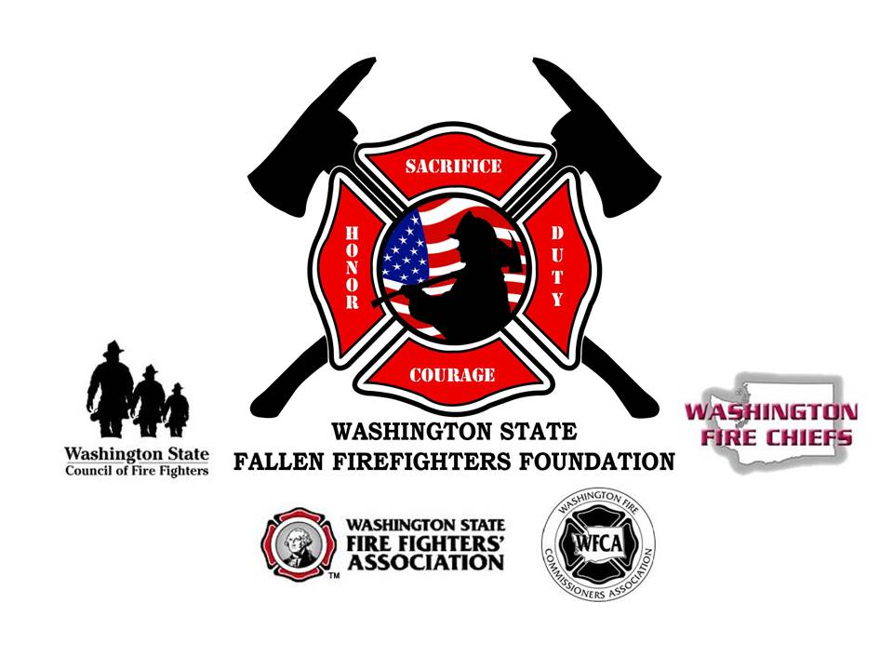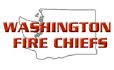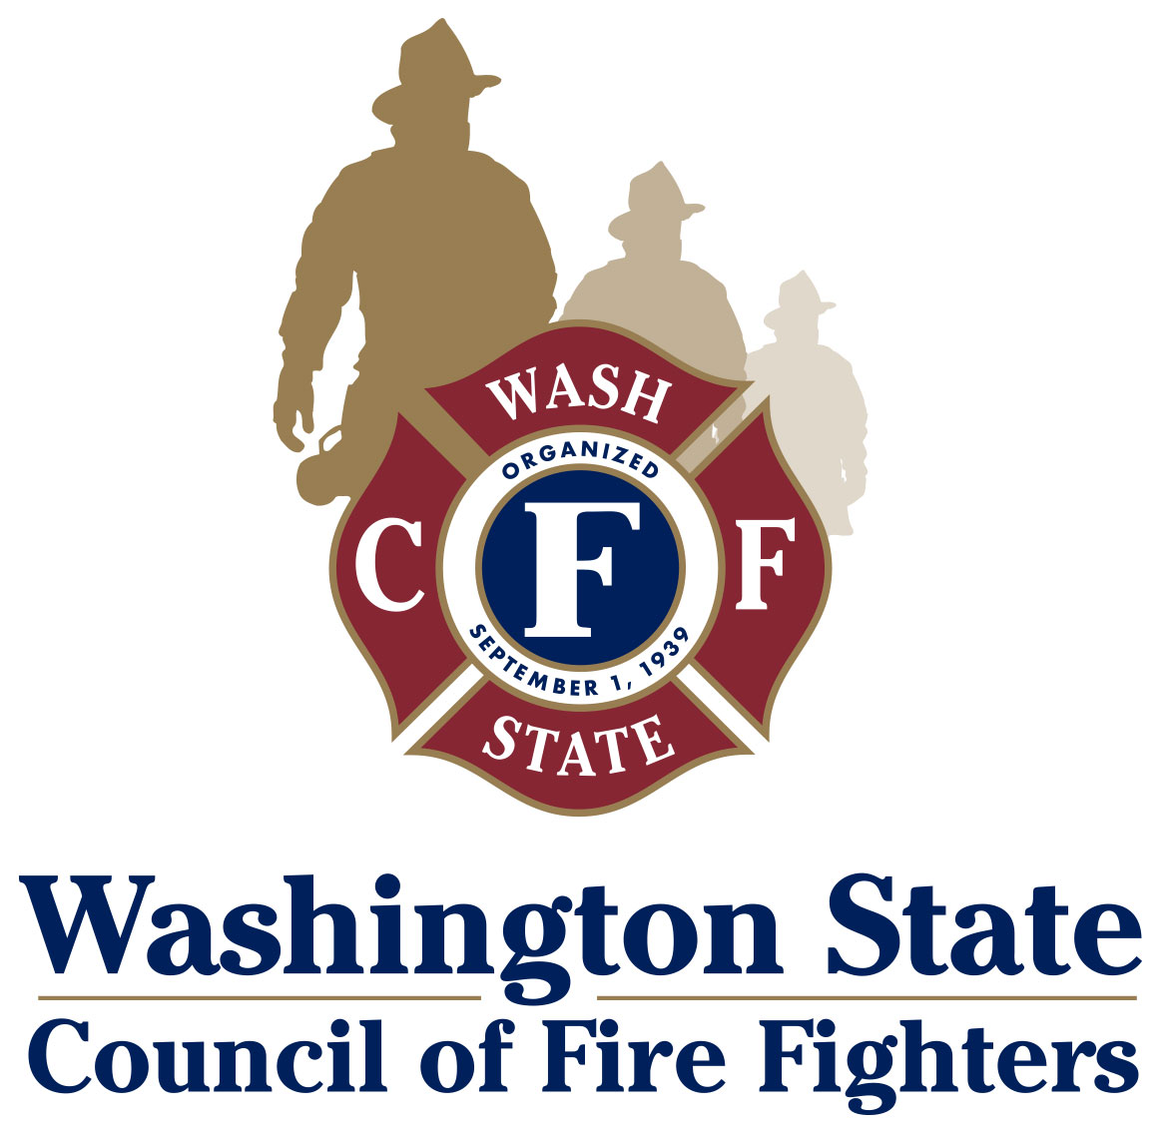

### Non-Line of Duty Death

Death occurs when an active member is off duty and the death is not related to any emergency activities or is a duty related medical death that is not considered presumptive under RCW 51.32.185.

Contents

* Purpose and Scope of the Non-LODD Guidelines
* Implementation of Non-Line of Duty Death Procedures
* Level II: Non-Line of Duty Death
* Funeral/Memorial Service Planning
* Protocol and Suggested Wording
  + Flag Display and Badge Shrouding
  + Dress Code
  + Hand Salute
* Suggested Wording for Key Portions of the Service
  + Pre-Service Protocol Instructions
  + Flag Presentation
  + Honors Introduction
  + Bell Ceremony
  + Firefighters Prayer

**Purpose and Scope of the LODD Guidelines**

The purpose of this policy is to provide a best practice guideline for Washington State Fire Departments, Fire Districts and EMS Agencies to follow in the event of a death or serious injury of a member while off duty or non-line of duty. This guideline describes the activities, roles and responsibilities for fire service funeral protocols including Levels of Honor, planning, roles and responsibilities of a planning team and best practice guidelines for funeral procedures as well as conducting notifications, assisting and supporting family members, and interaction with the news media. In this way, Fire Service Agencies in the State of Washington can be uniform in their procedures in rendering the appropriate honors for a fallen member.

This model guideline is a collaborative effort of the following:

Washington Fire Chiefs (WFC)

Washington Fire Commissioners Association (WFCA)

Washington State Council of Firefighters (IAFF)

Washington State Fire Fighters' Association (WSFFA)

National Fallen Firefighters Foundation through the Taking Care of Our Own and Local Assistance State Team (LAST) Programs

### Objectives

1. Provide a uniform procedure to handle the death or serious injury of a member, while off duty or non-line of duty.
2. To assist the agency and families affected by the death of a member, ensuring that the proper level of honors is offered by the Fire Service or EMS Agency.
3. To provide clear instructions to key individuals in fulfilling their responsibilities during the funeral planning process.
4. To ensure a unified commitment to assist the Fire Service or EMS Agency and the family of the fallen member regardless of rank, volunteer or career status or affiliation.

This document is intended to be a model policy to show best practices that can be used by individual Fire Service and EMS Agencies to fit their particular circumstances. It is recognized that the varying sizes and configurations of Agencies precludes the guideline from being a *one size fits all* solution and will need to reflect local policy. Additionally, this is a voluntary guideline, and Agencies may choose to use some, none or all of this guideline at their sole discretion. For questions of concerns please contact Pat Ellis at [info@wsfff.org](mailto:info@wsfff.org) or [pellis@pugetsoundfire.org](mailto:pellis@pugetsoundfire.org) 206-372-2663 (cell).

Implementation of the Non-Line of Duty Death Procedures

The overriding philosophy of the fire service is that the first priority following a serious injury or death – after caring for the members – is the swift and compassionate notification of the injured or deceased member’s family and the extension of assistance and support to them.

As soon as is possible, the Chief should appoint an Incident Commander (IC), and a meeting should be held to assign or affirm the assignments within the Incident Command System (ICS) structure. The Appendices provide detailed roles and responsibilities for further reference. If there is a question as to whether or not the death is to be considered an LODD, please refer to the LODD Quick Determination Sheet at the end of this document.

A briefing/planning meeting should be scheduled at least once a day until the conclusion of the Memorial Service and should include all section chiefs and other appropriate personnel. A final meeting for discussion of lessons learned and debriefing should be held no later than 48 hours after the conclusion of the Memorial Service.

The IC is responsible for the overall management of the activities that take place after the death of a member. This function is completely separate from the activity and command structure involved in the actual incident that caused the death.

It is vitally important that the wishes of the fallen member be followed according to the Personal Information Packet. The family will be presented the options available and their desires override all others. If the family wishes the help of the Agency, this document will lead the Agency and the family through the steps to properly honor the fallen member’s life. If the family does not want the assistance of the Agency, the Agency will then do whatever they can to support the family and take care of the needs of the personnel affected by the loss.

The WA State LAST team is available to assist the agency and the family upon request. This resource is extremely valuable and brings specific knowledge and expertise to assist in planning and executing the service and ensuring that the family and the affected department are properly cared for. The team works for the Agency and acts in a support role. Planning these services is a very detail-orientated process, the services of the LAST Team is invaluable. Please contact Pat Ellis [pellis@pugetsoundfire.org](mailto:pellis@pugetsoundfire.org) or [info@wsfff.org](mailto:info@wsfff.org), Pat Pawlak [ppawlak@pugetsoundfire.org](mailto:ppawlak@pugetsoundfire.org), Brian Hurley [b.hurley@me.com](mailto:b.hurley@me.com) or Randy Johnson at [randyj@scfd4.org](mailto:randyj@scfd4.org) for assistance or more information.

The Fire Chief may wish to consult with other fire departments that may have had recent experience with funeral planning. The National Fallen Firefighters Foundation offers the Chief-to-Chief Network, which pairs the Fire Chief who has just lost a member with a Chief who has experienced a loss in the past. The Foundation can be contacted at 301-447-1365 for more information.

**Level II: Non-Line-of-Duty Death**

Death occurs when an active member is off duty and the death is not related to any emergency activities, or is a duty-related medical death that is not considered presumptive under RCW 51.32.185

* Badge Shrouds
  + Worn from time of death until 1700hrs the day of the funeral/memorial ceremony
* American Flags lowered to half-staff in compliance with local flag lowering policies
  + Lowered at 0800hrs until sunset day of the service
* Vehicle escort to ceremony to include family, remains and a fire apparatus.
  + Remains are transported in a funeral coach or with the family, depending upon disposition and family wishes
* Fire Service Cordon of Honor upon arrival at service venue
* Home Agency Member Cordon of Honor at the start of the service
* Honor Detail Pallbearers
  + Remains will be posted by Honor Guard until the start of the service
* Viewing of remains before the ceremony if in a casket
* Color Guard to post and retire the colors
* Honor Guard
* Fire Service Honors
  + American Flag Presentation
    - Flag is tri-folded prior to service and present to family
  + Honor Flags
    - American Flags flown over the station the firefighter worked
  + Bell Ceremony
  + Pipes and Drums for Amazing Grace

**Honors Considerations**

**Military**

Military Honors include a presentation of the American Flag and Taps by a military honor guard and should be rendered graveside. If there is no graveside service, these honors can be rendered at the funeral/memorial. If the fallen firefighter is receiving a flag for their military service they may also receive a flag for their fire service. It is suggested that the fire service flag be an Honor Flag or a tri-folded fallen firefighter memorial flag.

**Escort to the Service Location**

For this type of service, there would be no multi-department procession. The family of the fallen firefighter may be escorted to the location of the service in a small procession consisting of a department apparatus, family vehicles and the funeral coach if casket service. The remaining department apparatus would be on static display at the service site, if possible. Police Escort must be pre-arranged with the local law enforcement jurisdiction.

**After Service Reception**

Depending on the service location, size, and time of day, the reception can be planned according to the wishes of the family and department.

**Grave Side Service Considerations**

Since the funeral is a formal event, it is suggested that the graveside service be a more intimate event for the family and close friends. It can be formal, with Honor Guard and Pipes and Drums, if the family desires. As there are many different ways the graveside service can be handled, please contact one of the Washington LAST Team Coordinators for details and service outline.

### 

**Funeral/Memorial Service Planning**

**Best Practice Service Procedures for a Non-LODD**

A non-LODD death is considered a local area level death. Best practice suggests that the honors be scaled back to fit the situation and location of the service. Since non-LODD services are not attended to the scale of a LODD service, the venue will be smaller. Honor Guard Details and Massed Band attendance will be smaller and available as needed.

The goal of this type of service is to honor the firefighter, honor the family, honor the department and honor the community. The following is an outline of what the funeral/memorial service could look like. For detailed service planning, please contact the Washington LAST Team.

**Suggested Order of Service**

**Arrival at Service Location**

The family should arrive at the service location at least one (1) hour prior to the start of the service. Department members and other uniformed personnel should be in formal ranks to receive the family and the urn/casket. All uniformed personnel will salute as family moves from the vehicles to the building.

* Family Escorted to Family Room
* For an Urn
  + Urn can be escorted to the Family Room, the front of service area, or can be left on apparatus until service start time. No matter where the Urn is placed, it needs to be posted by Honor Guard until the time of the service.
* For a Casket
  + Casket is left on apparatus until service start time or carried in to the service area and placed in the front. This would be done for a walk through (Viewing). The casket will be posted by Honor Guard, whether it is left on the apparatus or placed in the front of the service area.

**Start of Service**

* Cordon of Honor formed 15 minutes prior to service start time
  + Cordon of Honor includes only members of the firefighter’s department
  + All other uniformed personal are pre-seated
* Service Announcements
  + Instructions to audience regarding saluting protocols
* Entrance of Family
  + Escorted and Seated by Honor Guard
  + Precession Order
    - Honor Guard
    - Chaplain
    - Urn/Casket (if not already in place)
    - Family
    - Honor Guard
  + Cordon of Honor Called to Attention and Salute as family passes through
* Cordon of Honor Dismissed to their seats
  + Urn/Casket Watch concludes at the start of the service
* Posting of the Colors – Honor Guard
* Memorial Emblems Placed
* Invocation/Welcome – Chaplain or Family Clergy
* Chief’s Welcome
* Remembrances
  + Family/Friends Speakers/Music/Eulogy
* Slide Show
* Honors
  + Military (See Military Considerations)
  + Fire Department
    - Any departmental memorial tokens for the family such as a plaque or challenge coin
  + American Flag Presentation
    - Casket: Flag tri-folded and placed beside the casket and presented to the family
    - Urn: Flag is tri-folded and presented to the family
  + Honor Flags
    - American Flags flown over the station the firefighter worked
  + Bell Ceremony
  + Amazing Grace
* Closing Comments
* Benediction
* Retiring of the Colors – Honor Guard
* Family Dismissal by Honor Guard
* Fallen Firefighter’s Fire Department Members Dismissal
* Audience Dismissal

This service should last no longer than 90 mins.

**Military**

Military Honors include a presentation of the American Flag and Taps by a military honor guard and should be rendered graveside. If there is no graveside service, these honors can be rendered at the funeral/memorial. If the fallen firefighter is receiving a flag for their military service they may also receive a flag for their fire service. It is suggested that the fire service flag be an Honor Flag or a tri-folded fallen firefighter memorial flag.

**After-Service Reception**

Depending on the service location, size, and time of day, the reception can be planned according to the wishes of the family and department.

**Graveside Service Considerations**

Since the funeral is a formal event, it is suggested that the graveside service be a more intimate event for the family and close friends. It can be formal, with Honor Guard and Pipes and Drums, if the family desires. As there are many different ways the graveside service can be handled, please contact one of the Washington LAST Team Coordinators for details and service outline.

**Protocol and Suggested Wording for Services**

**Flag Display and Badge Shrouding:**

Upon completion of notifications, the Fire Chief will issue the Memorial Orders, comprised of flag protocol and badge shrouding instructions.

The following shall guide display of flags:

American Flags at all City/Department facilities may be lowered to half-staff on the day of the services from 0800 until conclusion of the services. (Mayor/Manager approval may be necessary.)

Badges will be shrouded from time of announcement until 1700hrs the day of the funeral/memorial ceremony.

**Considerations:**

Flag display and badge shroud recommendations shall be for the specified time. According to US Flag Code, the American Flag can be ordered to half-staff by the President and/or the State Governor. The Governor’s office has indicated that flag display is a local policy issue and will generally not order flags lowered across the State.

Flags are often lowered for longer duration in the locality where the death occurred and are lowered across the state only on the day of the services if directed by the Governor’s Office. Memorial flags can be flown in place of lowering the American Flag at the local authority’s direction.

### Dress Code:

All uniformed members, including off duty attendees, are to wear Class “A” uniforms. Hats shall be worn while outdoors (except during prayers), and removed indoors. If a Class “A” uniform has not been issued the highest level of issued uniform shall be worn.

Exceptions: Honor Guard and Pallbearers/Body Bearers shall remain covered at all times.

**Hand Salute Protocol:**

In order to be consistent and uniformed, hand salutes will be rendered by uniformed personnel regardless of cover. Those in civilian attire will render a salute in the same manner by placing their hand over their heart.

The hand salute is a three-count movement. The command is “Present, Arms.” On the command of execution (“Arms”), raise the right hand to the head dress. With the tip of the forefinger, touch the rim of the visor slightly to the right of the right eye. The fingers and thumb are extended and joined, palm down. The outer edge of the hand is barely canted downward so that neither the palm nor the back of the hand is visible from the front. The upper arm is horizontal, with the elbow inclined slightly forward and the hand and wrist straight.

Order arms from this salute in a three-count movement. The command is “Order, Arms.” On the command of execution “Arms,” return the hand to the side, resuming the position of attention.

When uncovered or when wearing a head dress without a visor, the hand salute is executed in the same manner as previously described, except the tip of the forefinger touches the forehead near the eyebrow and slightly to the right of the right eye.

**Suggested Wording for Key Portions of the Service**

The following is suggested wording for different parts of the service. This wording can and should be modified to fit the service location and audience.

**Pre-Service Protocol Instructions**

Thank you for coming today to help us honor the life of (Rank and Name). In today’s service there will be a time of memories and stories about (Name) and there will be a time when we will be honoring (Name) service to the (Department) and to the citizens of not only the (Name of City or Area) community, but so many other agencies and lives that (Name) had his finger prints on.

There will be times today when we will ask you to stand and you will hear the honor guard give the command for “All uniformed personnel to Present Arms.” If you are in uniform we ask that you would give a 3 second up salute and hold it until you hear the command to “Order Arms”.

If you hear the command for the “Honor Guard to Present Arms”, only the honor guard will be rendering a salute at that time.

For those of you here today not in uniform we would like to ask you to join us in rendering honors to (Name) by placing your hand over your heart when you hear the command for “All Uniformed Personnel, Present Arms.”

Again, thank you for joining with us today as we honor (Name) life. Will you please stand for the (Presentation of the Colors) or (The entrance of the Family)?

**Flag Presentation**

(Name of person receiving Flag), on behalf of the ________ Fire Department and the citizens of the ________ community I present you this flag in honor of your (relationship) ____ years of service as firefighter. I want you to know that we miss (name) and that he/she will forever be in our hearts and that we will not forget the bravery and the courage he showed through his/her entire career. Please accept this flag and know that it represents the selfless devotion in which (name) served.

Presenter will stand and Salute Flag

** For Non-LODD the flag is pre-folded before the ceremony and is not unfolded and refolded during the ceremony. Taps is not played.

**Honors Introduction**

To be used to introduce the Honors portion of the service.

It’s been said that the fire service is a family, and it’s true in so many ways. We stand together through thick and thin, always ready to help each other and it doesn’t matter who you work for. A firefighter can go into any fire house across the country and is immediately accepted, not as a friend or a guest, but as a brother or a sister.

Today we mourn the loss of a brother. (Rank and Name) served his department with distinction, he took pride in his profession and he worked hard.

Today is a time for that the brotherhood of firefighters to come together, to honor and remember, and to stand together.

As firefighters, every day we face dangers on many fronts, we are strong, brave, some would say even fearless. Rarely, if ever, will anyone see our tears.

But today is different, today we share an emptiness because of (Name’s) death. Today many of us don’t feel strong or brave. And today is a day that it’s ok to grieve the loss of a brother and we let others see our tears.

As firefighters experience death in our communities, on the 911 calls that we respond to and we have learned to cope with what we see. But dealing with (Name) death is different, it’s personal, death has come to one of us and so today we have put on our finest, we have polished and shined our apparatus, we have formed a Cordon of Honor and placed emblems of memorial on the stage. You see, this is how we cope with losing a loved one, a brother we fought fires with, answer aid calls at all hours of the night day with. A brother we laughed with and cried with.

And so today we honor (Department Name) (Rank and Name).

These honors today will include a presentation of the American Flag that has been carefully folded. It is given to (Name) family in honor of his service to the fire service.

The bell will sound the Last Alarm and Amazing Grace will be played and with that we will have rendered the honors that (Rank and Name) deserves for his life of service.

Will the Honor Detail please come forward?

**Bell Ceremony**

The fire service of today is ever changing, but yet is steeped in traditions 200 years old. One such tradition is the sounding of the bell.”

“In the past, as firefighters began their tour of duty, it was the bell that signaled the beginning of that day’s shift. Through the day and night, each alarm was sounded by a bell, it summoned these brave souls to fight fires and save lives often times placing their own lives in jeopardy for the good of their fellow man. When the fire was out and the alarm had come to an end, it was the bell that signaled to all, the completion of that call.

When a firefighter died, it was the mournful toll of the bell that solemnly announced that passing.

We utilize these traditions as symbols which reflect honor and respect on those who have given so much and who have served so well. To symbolize the devotion that these brave souls had for their duty – a special signal of 9 bells, three rings, three times each, represents the end of our fellow firefighters’ duties, and that they would be returning to quarters, out of service.

And so, to (Rank and Name), who has selflessly devoted his life for the good of his fellow man.

His task completed, his duties well done. To our brother, his last alarm, he’s going home.”

**Firefighter's Prayer**

- Author Unknown

When I am called to duty, God,

wherever flames may rage,

give me strength to save a life,

whatever be its age.

Help me embrace a little child

before it is too late,

or save an older person from

the horror of that fate.

Enable me to be alert,

and hear the weakest shout,

quickly and efficiently

to put the fire out.

I want to fill my calling,

to give the best in me,

to guard my friend and neighbor,

and protect his property.

And if according to Your will

I must answer death's call,

bless with your protecting hand,

my family one and all.