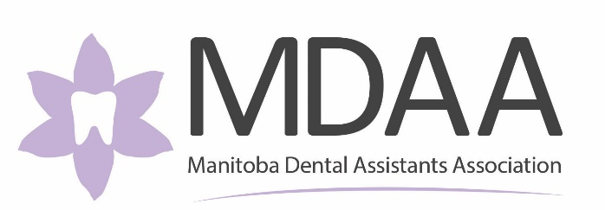

ANNUAL GENERAL MEETING
2025/2026
Thursday, April 18, 2026 – 12:30 pm
Location: RBC Convention Centre & Zoom
AGENDA:

- Call to Order
- Land Acknowledgement

- Establish Quorum

- Adoption of Agenda

- Introductions:

  - Opening Remarks – MDAA Chair
  - Introduction of MDAA Board Members – MDAA Chair
  - Introduction of Guests – MDAA Chair
  - Address from the RDA Representative – Trina Bourgeois
  - Address from the MDA – MDA President
- Approval Credentials Report
- Approval of Rules of Procedure
- Approval of Minutes from 2024/2025 AGM

- Presentation of Audited Financial Statements (2024/2025)

- Approval of Auditor Next Fiscal Year (2025/2026)
- Approval of Projected Budget (2025/2026)

- Annual Reports:

  - President’s Report
  - Executive Director’s Report
  - Continuing Education Committee Report
  - CDAA Board Member for Manitoba Report
  - MDA Truth and Reconciliation Report
  - UM Endowment Fund Advisory Committee Report
  - IPC Report(s)
  - RRC Polytech Report
  - CDI Report
- By-Laws Revisions

- Board of Directors Elections

  - Introduction of 2025/2026 Board of Directors

- Date & Location of 2026/2027 Annual General Meeting

- Adjournment

