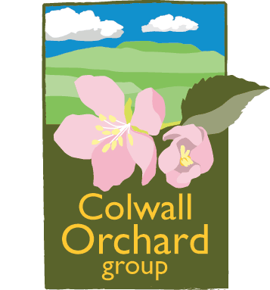
Buying Tree Types from the Nursery

Introduction.
The different terms used by nurseries when you are buying fruit trees can be confusing to the novice. Essentially you can buy either container plants or bare root plants.
Containers: Usually the description will start with the volume of the pot that you are buying, i.e. 12L (12 litres), 7L etc. There will then be a description of the tree form that you are buying, i.e. Bush, Cordon etc. The vast majority of fruit trees that you buy from a garden centre will be containerised, although they may well have been bought in from a nursery as bare root plants and potted up. Trees on vigorous rootstocks are generally not available in containers. Container plants are more expensive (c.200-300% more) than bare roots, partly reflecting the added expense of transplanting, pot, growing medium, watering, pruning etc.
Bush – these two or three year old trees have been headed at 45 cm to produce a clear stem. The central leader will usually be caned and the bush will have a well developed branch framework which will have been pruned in the summer of the year that you buy it. They will usually be on dwarfing or semi-dwarfing rootstocks.
Half-standard - grown in the field for two years then one year in a pot. Headed at 1m with a clear stem and a well shaped head. Usually on a semi-vigorous rootstock to produce the archetypal lawn tree.
Cordons – again grown for two years in the field and one year in the pot. They will have received multiple spur pruning (up to six episodes) to produce a single stem with multiple fruiting spurs already formed. Although these are bought as a vertical tree they are usually planted obliquely at 45°.
Patio trees – designed to be pot grown throughout their lives, these trees are always on very dwarfing rootstocks and have been summer pruned to form a very compact bush.
Step overs – popular at the moment, these are essentially single tier espaliers used for edging lawns and borders. Grown on dwarfing rootstocks on a cane framework, they will have been summer pruned before you buy them to induce early fruiting.
Fans and Espaliers – grown on an ‘A’ frame cane support, these trees will be at least 3 years old. Fans will usually have a minimum of 5 stems and espaliers at least 2 tiers and a central leader. They will have been summer pruned several times to produce fruiting spurs.

Bare Root: Usually only available direct from the grower or from specialist suppliers such as orchard groups. These plants are lifted to order directly from the grower’s nursery beds. All rootstocks are usually available as bare root plants. Bare roots are considerably cheaper than containerised plants but need immediate attention after purchase. A major advantage is that one year old plants can be bought and trained on into any form.
Maidens – these are one year old trees varying from 1 to 2m tall depending on rootstock and variety. Some top fruit varieties produce numbers of feathers (side branches) on the young leader while others produce very few or none. Generally the more dwarfing the rootstock the fewer feathers are produced. Feathered maidens are often used to save a year when pruning to produce espaliers, by using well placed feathers to produce the first tier.
Cordons – a two year tree with a central leader (often caned) which has been spur pruned twice in the growing season to initiate fruiting spur production.
Bush – a maiden tree which has been headed at 75cm and grown on in the second season to produce a well balanced branch framework. All feathers have been removed.
Half-standard – similar to a bush but headed at 1.3m.
Standard – similar to a bush but headed at 2m. The form grown in traditional orchards.
Straight Lead – a two year old, feathered tree with a straight un-pruned stem. Ideal for growing on into a standard or centre leader tree.

Colwall Orchard Group/Tim Dixon
September 2018

