**Fire Risk Assessment for the Apple Packing Shed and the Orchard Room**

**Prepared by:** Helen Stace: 1st March 2017

**Updated:** Helen Stace: 23rd March 2019

**Review by:** 22nd March 2020

**Responsbile Person:** The Responsible Person for the Apple Packing Shed and Orchard Room is Helen Stace

**Description of the premises**

The premises consist of a recently restored timber framed barn with steel and timber cladding. The front section is accessed via a double door, whilst the rear section is fully lined to form an internal space referred to as the Orchard Room. The Orchard Room is accessed by a door into the Apple Packing Shed and a door to the rear. It also has 2 fully opening windows, providing alternative means of escape. The build specification for the Orchard Room was for a 30-minute fire resistance.

NB: The only buildings in the vicinity of the Apple Packing Shed are the composting toilet and the allotment shed. For the purposes of fire safety, these pose minimal risk by virtue of the lack of obvious fire generating sources (having no electricity) and the very fleeting nature of their use.

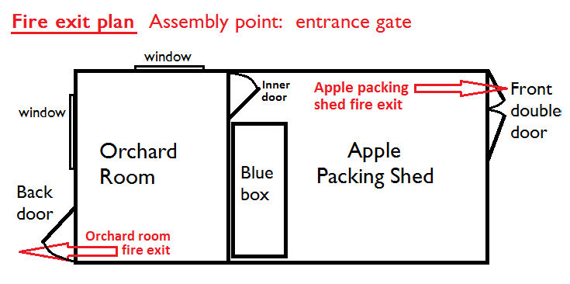

**Use of the premises**

The premises are in use most weeks as the base for the Colwall Orchard Group volunteers and the Colwall Allotment Association members, to carry out COG and CAA activities, hold informal meetings and have refreshments. It is used a few times per month for environmental education (with anywhere between 7 and 30 children, plus teachers/parents) and also for training courses, events and other meetings. At present, the site has limited wheelchair access, so there are no users requiring special measures by virtue of reduced mobility.

There are no known factors of particular risk to firefighters attending a fire at this location.

|  |  |  |  |  |  |  |  |
| --- | --- | --- | --- | --- | --- | --- | --- |
| **RISK** | | **Increasing likelihood →** | | |  | **Level of Risk** | **Action** |
| **1** | **2** | **3** |
| **Inc. severity →** | **1** | **1** | **2** | **3** | 1-2 | Low risk: no further action |
| **2** | **2** | **4** | **6** | 3-4 | Medium risk: ensure compliance with guidance notes and Safe Ways of Working (SWOW) |
| **3** | **3** | **6** | **9** | 6-9 | Risk unacceptable: modify procedures to reduce risk |

**KEY:**

**RISK ASSESSMENT**

|  |  |  |  |  |
| --- | --- | --- | --- | --- |
| **Step1**  *List significant hazards and harm here* | **Step 2**  *Assess risk (likelihood x severity)* | **Step 3**  *Mitigation: List existing controls* | **Step 4**  *Residual risk (likelihood x severity)* | **Step 5**  *Further action needed (by whom and when)* |
| Spread of fire due to the failure of the wood burning stove and chimney. | 3 (1x3) | The stove was fitted in 2016, to current Building Regulations. It has a fully lined chimney. The stove is mounted on a tiled plinth, backed by asbestos boarding. | 1(1x1) | Ensure that the chimney is swept annually, or as needed. |
| Spread of fire from the inappropriate use of the wood burning stove | 6 (2x3) | The stove is only lit and supervised by Trustees of COG, who are familiar with its operation. The fire is fitted with a thermometer to allow users to ensure the burn temperature is kept below 500oC.  Matches and firelighters are stored alongside the plinth to avoid accidental ignition by stray sparks. Fire gloves are provided for users of the stove to prevent burns when lighting and fuelling the fire.  Once the room is warm, the use of further fuel is regulated such that it should have burnt down to ash by the end of the event. The safety of the stove is always checked prior to leaving and locking up the room. | 2(1x2) | Prepare instructions for use of the fire for use by other individuals, as and when required |
| Spread of fire from the cooker | 6 (2x3) | The kitchen area includes a built in domestic oven with integral ceramic hob.  A written user sheet and instructions are attached to the wall above the stove to ensure that the electric switch supplying the hob is not turned off until the warning lights have gone out. | 1 (1x1) | Procure oven gloves for users of the stove/oven |
| Fire due to wiring failure | 6 (2x3) | The wiring was all fitted by a qualified electrician, to current standards. The main risk derives from the possible damage to the wiring by rodents in the Apple Packing Shed section (the Orchard Room is rodent proof). The wiring in the Apple Packing Shed is mounted high on the walls to minimise the risk of rodent damage, whilst the wiring in the Orchard Room is supplied via external trunking, such that damage would be highly visible. | 1 (1x1) | Add visual check of wiring to the annual maintenance plan. |
| Faults in electrical equipment | 6 (2x3) | Electrical equipment in use in the Apple Packing Shed includes domestic appliances such as kettles, vacuums etc., and also larger items such as a desiccator and honey spinner. All electrical items will be PAT tested bi-annually. | 1 (1x1) |  |
| Fire due to the use of flammable materials | 6 (2x3) | COG & CAA volunteers use a number of flammable materials:   * Oil and petrol for fuelling the lawn mowers and strimmers * Paints, teak oil and other decorating materials * Propane gas in gas cookers and the beekeepers blowtorch * Beeswax * Paraffin used during the preparation for the Wassail   Oil, petrol and large propane gas canisters are all stored in a locked flamvault, with only trained volunteers having access.  The small blowtorch gas canister is kept in the secure lock up, and the beekeepers have Safe Ways of Working for use of the blowtorch and for the smoker.  Paints and decorating materials are only used in circumstances analogous to normal domestic use and are stored in small quantities.  Small quantities of wax foundation are stored on the shelving and bee hive kit includes cedar supers and brood boxes with frames of drawn out honeycomb. There is minimal risk of spontaneous ignition, but the beeswax would act as an accelerant in the event of fire. There is little to be done to minimise this risk.  The paraffin poses the greatest risk. It is brought on site in plastic containers, but for the 2 days prior to the Wassail, is stored in an open dustbin, in which the flares are soaked. This is only done by one member of COG, and COG and CAA members are alerted by email re the dangers of paraffin over the 2 days in question. | 1 (1x1) |  |
| Fire generated from outside the Apple Packing Shed | 4 (2x2) | There is a small fire pit situated in the grassland near to the Shed. It is designed to accommodate small fires only and is subject to a Safe Way of Working guidance note which prevents its use in windy conditions that might pose a danger of sparks landing on the shed.  There is a bonfire site approx. 20m from the shed. This is only operational in the winter, for approximately 6 burns per year. The bonfire is only lit by authorised volunteers and is supervised until it has burnt down sufficiently to be safe to leave unattended. Again, it is not used in windy conditions likely to generate sparks that could hit the shed. The grass between the fire pit, bonfire and shed is kept mown and clear of flammable waste.  A small number of rockets are let off on site (usually 2 occasions per year with no more than 3 rockets). The fireworks are supervised by an experience pyrotechnic and the firework stands are angled to launch the rockets away from the Apple Packing Shed and other buildings. | 2 (1x2) |  |
| Smoking | 4 (2x2) | The Orchard Room and Apple Packing Shed are no smoking zones. | 1 (1x1) |  |

**Fire Provisions for users of the Orchard Room and the Apple Packing Shed**

The measures outlined in the above risk assessment bring the risk of fire down to acceptable levels and a range of equipment is provided to minimise the risk to people in the event of a fire.

All users of the Orchard Room are required to designate a safety officer for the duration of their event. Fire Safety and Emergency Procedure instructions have been prepared to inform the safety officers of their duties and relevant procedures.

The following equipment, signs and notices have been provided:

* 1x all-purpose Fire Extinguisher - adjacent to fire exit in the Orchard Room
* 1x fire blanket - wall mounted between the wood burning stove and the kitchen units
* 4x fire plans - on or adjacent to all doors
* 1x fire safety/emergency procedures notice for the attention of leaders of each event - prominently positioned on the worktop
* 2x battery powered light - mounted above the Orchard Room fire exit to identify the exit in the event of electrical failure
* 1x burns kit and 1x first aid kit
* 1x external emergency assembly point

NB: following advice from the fire brigade, fire alarms have not been installed owing to the small size and layout of the space, which means that a fire would be immediately obvious to anyone inside the building.

Fire Drills will be held at least annually to test these procedures, and this Fire Risk Assessment will be reviewed annually.