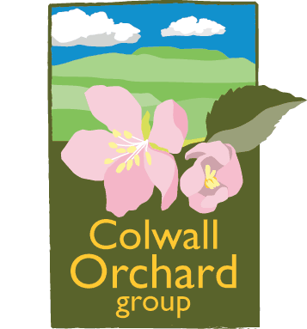
Fruit Tree Forms for Beginners

Introduction
The seemingly myriad choices of tree forms that fruit trees can be pruned into can be confusing in the extreme for the gardener who “just wants an apple tree”. However for successful fruit growing it is important to understand the characteristics and management requirements of each form and to be equally clear about where the tree is destined to be planted and what one expects from it in terms both of utility and beauty. You must also be under no illusions as to how much time that you are willing to invest in pruning! Only then can you choose your form. Having said all that what follows is a guide to the forms available to you (loosely from the smallest to the largest) and their advantages and disadvantages.
Minarette – a vertical, columnar-trained tree that bears fruit on short spurs up and down the length of a single, upright, un-branched stem. Particularly suitable for small gardens and for growing in tubs and pots. Requires annual summer pruning. Apples and pears can be spaced as close as 60cm and plums and cherries at 90cm.
Cordon – single stemmed trees which are usually grown as oblique cordons at an angle of 45°. Usually intended for growing against a low fence but can be grown supported by posts and wires. If planted close together (they can cope with being only 75cm apart) then many varieties can be grown in a small space. Need intensive annual summer pruning to maintain fruitfulness. The Double (‘U’) cordon is a variation on the single cordon with two, or even more, vertical arms and is suited to narrow areas of fence or wall.
Espalier – consists of a vertical stem with one or more tiers of horizontal branches at intervals of 40-45cm. The tree is trained in a flat plane and can be used to cover walls or fences. Suits apples and pears very well but not stone fruit. They need intensive annual summer pruning. Usually grown on permanent wires. Need significant amounts of space – 3.6m to 5m depending on rootstock.
Step Over – these are cordons bent at right angles and then trained horizontally in one direction. They can be single or double step overs, these latter being effectively single tier espaliers. They require permanent support on wires and need regular intensive summer pruning. Often planted at lawn edges and at the front of borders.
Fan – widely used for plums, gages, damsons, cherries, peaches, nectarines and apricots. The main stem is short and the ribs of the fan arise from two low-angled arms. Usually need permanent support on wires and need intensive summer pruning. Like espaliers they need significant amounts of space – 3.6m to 5m depending on rootstock.
Pyramid or Spindle Bush– similar to a bush but the main stem leader is maintained to give a conical shape. The tapering tree allows the lower branches to receive plenty of sun which results in better and more even ripening. Has the disadvantage that the formative pruning is intensive and needs to be precise to produce the correct form. Often requires festooning in the early years.
Bush – an open centred goblet shaped tree growing on a clear stem of 60-75 cm depending on rootstock and situation. Usually grown on dwarfing and semi-dwarfing rootstocks. Excellent for small gardens and allotments. Generally not suitable for lawns unless you are prepared to keep a weed free zone assiduously around the tree. Difficult to manage the grass if grown in lawns due to the short stem but easy to harvest the fruit.
Half Standard – similar to a bush but grown on a clear stem of around 1.4m. Grown on more vigorous rootstocks than bush trees. Only suitable for large gardens. Easy to mow underneath but extra height makes pruning and harvesting more difficult.
Standard – has an even taller clear trunk of 1.8m and can only be grown on the most vigorous rootstocks. Not suitable for gardens but is the common form in traditional, grazed orchards. Difficult to prune and harvest but needs only moderate pruning once formative pruning has finished.
Centre Leader – used mainly for traditional cider and perry trees on very vigorous rootstocks. Designed to be harvested either by gathering fallen fruit or by shaking the fruit down from the tree mechanically. Essentially a Christmas tree shape with an intact central leader and concentric whorls of branches ascending the stem. Needs only moderate pruning once formative pruning has finished.

Colwall Orchard Group/Tim Dixon
September 2013.

