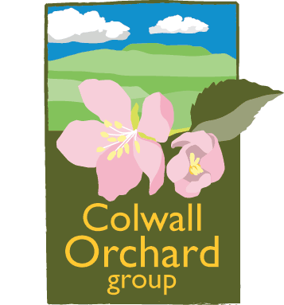Questions To Ask when Choosing Fruit Tree Varieties

- What kind of fruit tree am I looking for? (apples, pears, plums, medlars, cherries, etc?).

- How many of each type of fruit do I want to grow?

- What will I use the fruit for? (Cider, cooking, eating, leave for wildlife?).

- What do I want the fruit to taste like? (Sweet, aromatic, buttery, tart, etc?).

- When do I want the fruit to be available for harvesting?

- Do I want fruit ready for eating from the tree, or for putting into storage for later use?

- Are the types of fruit and the varieties I favour suitable for the climate where I live? Are the varieties resistant to diseases found in my area?

- Do I need late flowering varieties because late frosts are commonly found in the area where I live?

- Is there a suitable location in my orchard/garden for this tree? (Consider microclimate, soil, water, soil conditions sun/shade, etc).

10. What size and shape of tree at maturity do I require? (standard, half-standard, bush, cordon, espalier, fan?) Which rootstock will provide the right size?

11. Are the varieties that I’m choosing self-fertile, or do they need pollinating? If pollinators are required do I have a suitable mix of varieties to give the best chance of successful pollination?

Andy Ball, Colwall Orchard Group, 2020

Source: Based upon The Fruit Tree Handbook – Ben Pike.

