Safe Ways of Working: OPERATING THE STOVAX WOOD BURNING STOVE
Note: Do not use the Stovax if the extractor fan is in use

This stove can only be used for burning seasoned, untreated wood. Do not burn any damp wood, unseasoned word, tanalised or treated timber, such as old fence posts, tree stakes, pallets or construction timber. Do not use any other sort of solid fuel or liquid accelerants.

There are 3 air controls, from top to bottom (see diagram):
- The airwash control (above the window): supplies a downdraught to front of glass to keep glass clean
- The primary air control (below the window): provide a good flow of air when establishing the fire
- The secondary air control (at the base of the stove, under the ashlip): preheats air entering the stove to encourage combustion of unburned hydrocarbons, giving a cleaner burn.
All these controls become hot in use, so fire gloves should be used to adjust these controls.
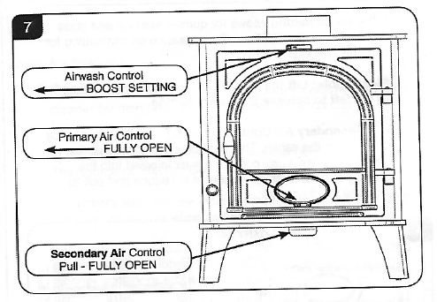
Lighting the fire
Set the airwash control to boost (lift lever slightly and slide fully to the left), and primary air control to fully open (slide lever fully to the left). Pull out the secondary air control to fully open.

Rake the ash to provide a bed of approx 2.5cm of ash. Lay a firelighter, tinder and kindling on the ash bed and light. Gradually build up the size of the material to allow the tinder to heat the stove and flue before attempting to add logs. Leave the door slightly open during this process to avoid condensation.

Do not load the fuel above the log guard or the secondary air inlets in the back wall of the stove.

Opening and closing the door
The door will become hot in use and must be opened using a fire glove and the tool provided. This slots over the handle and turns clockwise by 90º to open the door.

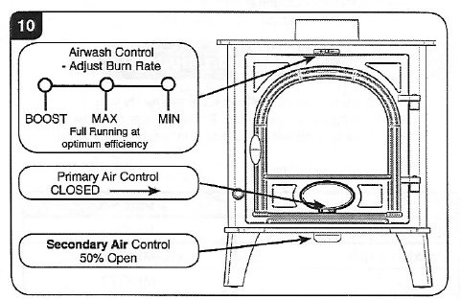
Managing the fire
Once the fire is established the stove should be run with the door shut, the primary air control closed and the secondary air control pushed in half way. The burn rate should be regulated with the airwash control. (more airwash burns fuel more quickly and increases the heat output)

Adjust the secondary air control so that flames are visible, but do not reach the glass.

Refuel little and often. Do not refuel if the firebox is full of flames. Close the door immediately after refuelling. If needed, increase the airwash briefly and/or provide a boost of primary air to get new logs burning, before returning to the previous settings.

Do not operate the stove with the primary air control open or the airwash on boost for long periods, as this could cause over-firing and damage the appliance

Always allow enough air to enter the firebox to maintain some flames.

Use of the woodburning stove must be supervised by adults at all times and this appliance should never be left unattended when lit.

Fire extinguishers are located in the following locations
- Inside the rear pedestrian entrance door to the Orchard Room
- Inside the main double entrance doors to the Apple Packing Shed
- Inside the small timber tool shed

Shutting down
The fire must be left in a safe condition before leaving the Orchard room. This can be achieved by reducing re-fuelling rates towards the end of your event, or by running the stove on a high setting until all the fuel has been used.

Do not shut down the air controls until all the fuel in the firebox has been burnt.

De-ashing
Ash should not be allowed to build up under the grate and should be removed regularly. Ash remains hot for a long time after the fire, so this should preferably be done the next day, once the stove is completely cold.

The door handle tool also operates as the handle for the ash riddle and as a handle for removing the ash pan. See diagrams.
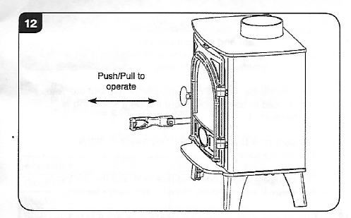
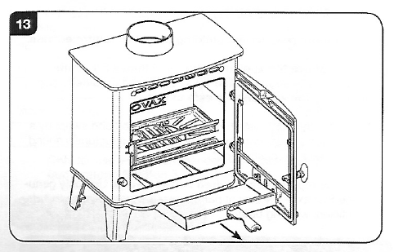
Take ash out through the fire exit and empty the ash pan onto one of the compost heaps.

General points
- Do not place any objects on or in contact with the stove
- Ensure that wood fuel is stored in the wood basket, and not left lying next to the stove
- When children or less mobile adults are present, use the fireguard to minimise the risk of contact with the hot surface in the event of trips or falls.

Warnings
If fumes are emitted, or the carbon monoxide alarm sounds:
- Open doors and windows to ventilate the room
- Leave the room
- Allow the fire to safely burn down
- Report the fault to a COG Trustee

If a chimney fire occurs:
- Close all the air controls
- Leave the room
- Call the fire brigade
- Report the fire to a COG Trustee

In case of emergency - calling emergency services
The Apple Packing Shed is on Old Church Road, Colwall at WR13 6HB. The grid reference is SO 747 426. If you do not have a mobile phone, or cannot get reception, the nearest public phone is c.60m away from the entrance to Colwall Village Garden, on Orlin Road (the entrance to Orlin Road is diagonally opposite our entrance track off Old Church Road).

