When Are My Apples Ready To Harvest?

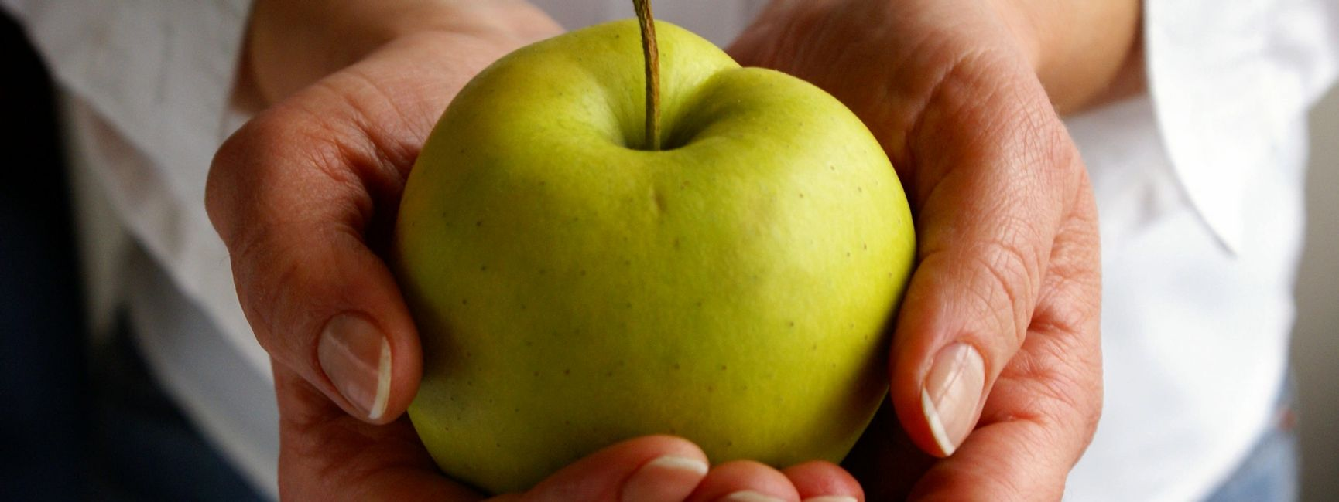

Working out when apples are ready for picking is a tricky decision for most of us. Commercial growers will use a variety of visual and physical indicators, their experience, and possibly even the use of science in the form of a Starch Iodine test to determine the state of maturity of their fruit and when to harvest it.

For those of us growing fruit on a less intensive scale there are a few rules and indicators that can give us a good idea when to pick fruit. A distinction also needs to be made between the right time to harvest fruit and the time to eat it - which can be quite different.

Detailed below are a few helpful tips and rules that may assist you with decision making before you start to take precious fruit from your favourite apple tree...

Know your apple variety - It's exceptionally helpful to know what you are growing. Perhaps the best introductory book on apple growing is 'The Apple Book' by Rosie Sanders. This beautifully illustrated book contains invaluable information on around 150 commonly found apple varieties and when they are ready to harvest, store and eat.

Use a general rule of thumb - Most apples varieties will need to be harvested sometime between early August and late October. If they are to be used for human consumption they should be gathered before the first winter frosts.

Let the tree guide you - When fruit is ripe it will fall from the tree.That's a common perception. Whilst that's sometimes true there are many exceptions to this including those varieties that resolutely continue to have apples hang on trees well after ripening; the 'June drop' when trees naturally shed excess fruit in early summer in order to give the remaining fruit the chance to mature; premature shedding due to environmental factors such as high winds or drought; shedding due to the presence of pests such as codling moth larvae which feed within the apples.

Palming - If you take a fruit gently in the palm of your hand and lift it slowly upwards with a slight twist it may snap readily where the stalk joins the branch. That's generally a good indicator that the fruit is ready to pick. If there's resistance and force is needed to detach the fruit then it's still not ready for harvesting.

Colour - Apples often take on a brighter external colour as they ripen. This will be especially true with exposure to the sun so apples should not all be picked at once from the same tree but instead picking should usually be undertaken over several weeks.

Pips - If you cut an apple open the pips are another good colour indicator of readiness and they will change from white to brown as the fruit ripens. If an apple is shaken and the pips rattle then the fruit is also likely to be ripe.

The time for picking can often be different from the time for storage or eating.When fruit is picked it is not killed but instead the cells are alive and will continue to develop dependent upon the air temperature surrounding the fruit. That leads us neatly onto different subjects of storage and when fruit is ready to be eaten at the 'peak of perfection'. Further guides to follow…

