Gospel & Sermon on Luke 12:13-21
“A Richer You: A Life Lesson from Jesus”

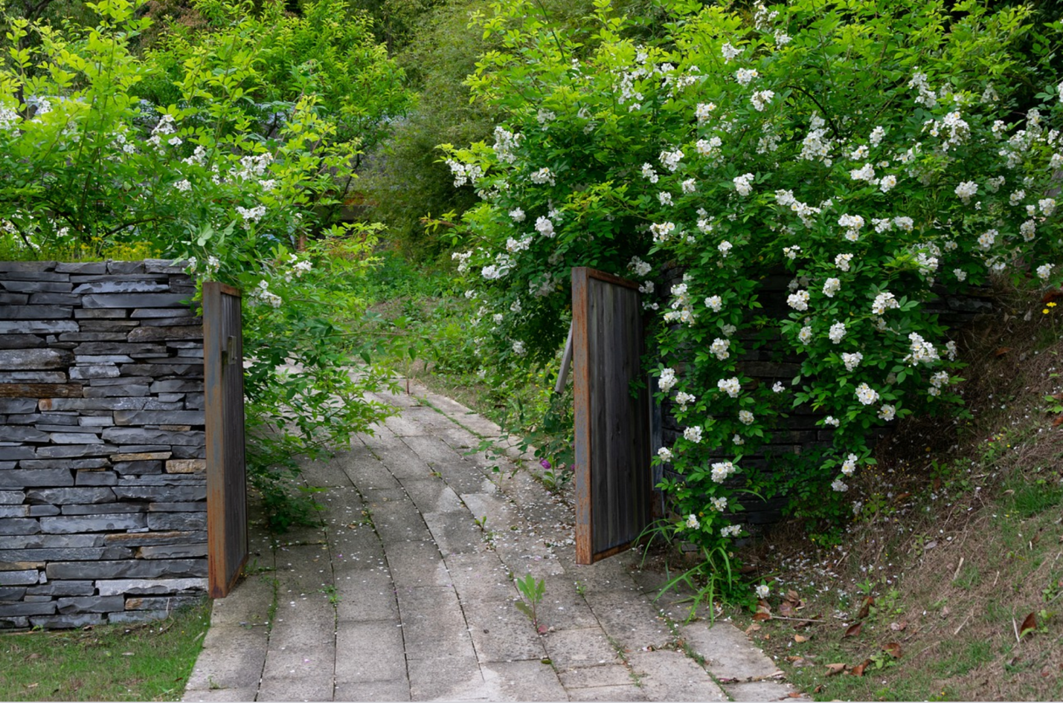
Jesus used parables to help us understand some of the gateways we’ll pass through in life, and to give us the wisdom to make choices for the greater good.

GOSPEL from Luke 12:13-21

Someone in the crowd said to [Jesus,] “Teacher, tell my brother to divide the family inheritance with me.” But he said to him, “Friend, who set me to be a judge or arbitrator over you?” And he said to them, “Take care! Be on your guard against all kinds of greed; for one’s life does not consist in the abundance of possessions.” Then he told them a parable: “The land of a rich man produced abundantly. And he thought to himself, ‘What should I do, for I have no place to store my crops?’ Then he said, ‘I will do this: I will pull down my barns and build larger ones, and there I will store all my grain and my goods. And I will say to my soul, Soul, you have ample goods laid up for many years; relax, eat, drink, be merry.’ But God said to him, ‘You fool! This very night your life is being demanded of you. And the things you have prepared, whose will they be?’ So it is with those who store up treasures for themselves but are not rich toward God.”

SERMON by Pastor Jaime Larson-McLoone

What a great problem to have: too big a harvest and nowhere to store it.

It seems that this farmer’s barns and bins are still full from the LAST harvest. And now he’s reaped another barn-burster! What to do?

This man seems to worry for a minute, but then he comes up with a plan: Here’s what I’ll do! I will tear down all my barns and build bigger ones!

He sounds pretty proud of himself, right?

But when you think about it, this is hardly a creative solution. It’s so obvious: More stuff, more storage. It’s still one of the primary ways we operate today. It’s why we have multi-level self-storage buildings. It’s why we have stores dedicated to selling containers.

But it doesn’t matter, at least not for the man in Jesus’ parable. He’s going to die this very night. And then what will become of his surplus? Whether his grain is sitting in a big, fancy, modern barn or piled next to an overflowing old one, this man has no control over what happens next. There will be no time to relax, eat, drink, and be merry.

Instead, his last night is spent in vain worry about how to secure all his stuff, followed by delusions about the control he has over the next few hours, let alone the next few years, or the next few decades.

What should I do, for I have no place to store my crops? I will do this: I will pull down my barns and build larger ones, and there I will store all my grain and my goods.

What a way to close out a life. Did it really have to end this way?

This man’s foolishness is so clear to us. Even if God didn’t say to him, “You fool!” Even if our Bible editors didn’t insert a title letting us know that this is the “Parable of the Rich Fool.” There still would be no question. This man is clueless.

But I wonder: Do we see our own foolishness so clearly?

Can we admit that we, too, forget that so little lies within our control? Can we admit that uppercase-G-God is not the only god we worship? Not the only God in whom - or in which - we trust?

In confirmation class last week, we talked about the Ten Commandments. We worked through them one by one, and we had a great conversation about how God’s commandments and Luther’s explanations help us live faithfully today.

Of course, we started with the First Commandment: You shall have no other gods. Luther explains it this way: We are to fear, love, and trust God above all things.

Yet it took us no time at all to come up with a list of other lower-case-g gods we are tempted to turn to first: money, fame, our own power or abilities.

I wonder if we might have sounded a little like the farmer with the bumper crop: my money, my fame, my power, my abilities, my possessions.

That farmer believed he could control his future, secure his future, through his abundance of grain. Where are we tempted to believe that we can control our future, secure our future, through our abundance of possessions, or by our own power?

Where are we tempted as individuals? Where are we tempted as a congregation? If we are honest, is there something we are hoarding? What gives us the illusion of control?

And what might happen if we let go?

The parable of the rich fool could have an alternate ending. Jesus tells us how: Stop storing up treasure for yourselves. Be rich toward God.

Jesus isn’t saying wealth is bad and rich people are evil. Jesus isn’t saying don’t save for the future. This isn’t a call to drain our retirement accounts. It’s not a call to sell all our property and give the proceeds to the food pantry.

It’s a call to community. A call to realize this life is about more than taking care of ourselves. To realize that a self-focused life is a small life. To realize that a generous life, shared with our neighbors, is where we enjoy the true richness that God intends.

What if the rich farmer had spent his last night on this earth together with his neighbors, celebrating not his abundance, but God’s abundance? Maybe they would have wondered together how the man might save a prudent amount of the harvest for the future and bless the community with a portion, too. In my imagination, neighbors brainstorm joyfully over food and wine. In my imagination, even if this is the farmer’s last night in this life, it is an evening together his friends and neighbors will never forget.

That’s one way I think the farmer’s story could end.

Our present and our future could be different as well. We don’t know when we will die. While we can take proactive and preventive measures, we can’t know when or whether sickness or injury or severe weather might dramatically alter our lives or our life together. So what should we do?

Jesus invites us to trust God with the future so much that we let go of our worries and live well in the present. Jesus invites us to hold our possessions more loosely. To express our richness toward God through generosity toward our neighbors.

And to rely on God to take care of the rest. Jesus promises, our God is worthy of our trust. Today’s gospel doesn’t include the words Jesus uses to reassure his disciples, but you might recognize them.

Do not worry about your life, what you will eat, or about your body, what you will wear. For life is more than food, and the body more than clothing. Consider the ravens: they neither sow nor reap, they have neither storehouse nor barn, and yet God feeds them. Of how much more value are you than the birds! And can any of you by worrying add a single hour to your span of life? If then you are not able to do so small a thing as that, why do you worry about the rest? Consider the lilies, how they grow: they neither toil nor spin; yet I tell you, even Solomon in all his glory was not clothed like one of these. But if God so clothes the grass of the field, which is alive today and tomorrow is thrown into the oven, how much more will he clothe you—you of little faith! And do not keep striving for what you are to eat and what you are to drink, and do not keep worrying. For it is the nations of the world that strive after all these things, and your Father knows that you need them. Instead, strive for his kingdom, and these things will be given to you as well.

Those promises are for us, too. In God, our eternal future is secure. This is true regardless of what we have now. It’s true regardless of what we lack, or what we think we lack. We can wait till death makes this clear. Or we can trust now and respond in generosity. We can be rich toward God in a way that allows us to fully enjoy life with our neighbors in the present.

©2022 Jaime Larson-McLoone
Presented 7/31/22 at Bethel Lutheran Church in Muskego, WI

