Pastor Jaime Larson-McLoone
“Investment Advice from Jesus”

Gospel of Luke 12:32-40
Do not be afraid, little flock, for it is your Father’s good pleasure to give you the kingdom. Sell your possessions, and give alms. Make purses for yourselves that do not wear out, an unfailing treasure in heaven, where no thief comes near, and no moth destroys. For where your treasure is, there your heart will be also. “Be dressed for action and have your lamps lit; be like those who are waiting for their master to return from the wedding banquet, so that they may open the door for him as soon as he comes and knocks. Blessed are those slaves whom the master finds alert when he comes; truly I tell you, he will fasten his belt and have them sit down to eat, and he will come and serve them. If he comes during the middle of the night, or near dawn, and finds them so, blessed are those slaves. “But know this: if the owner of the house had known at what hour the thief was coming, he would not have let his house be broken into. You also must be ready, for the Son of Man is coming at an unexpected hour.”

Who do you trust with your investments? In the Gospel this week, we receive a referral not to a banker or financial muse: we are told to place our trust in God. Read on for this uplifting message, because “...where your treasure is, there your heart will be also.” Luke 12:34
(Pastor Jaime begins Sermon)
“Jesus is watching you.” Those words were definitely a threat. I heard them back when I was working at Mount Carmel Lutheran Church in Milwaukee. One night a week, the Milwaukee Children’s Choir rehearsed in the Fellowship Hall there. And often parents and siblings would wait in the conference room or hallway.

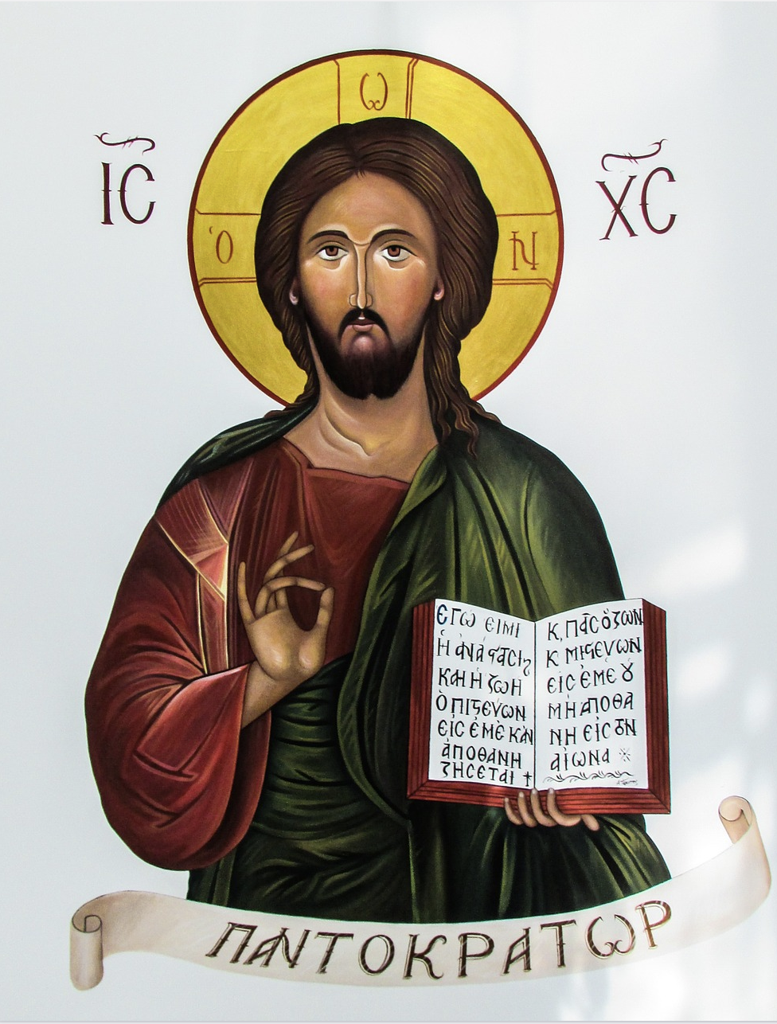
The hallway with the Jesus mural. Where a large image of Jesus looked down on whatever behavior, or misbehavior, was taking place in that hallway. There was also a candy dish nearby, and that had something to do with the alleged misbehavior on this particular rehearsal night.
“I said just one piece of candy. Did you take just one piece of candy? Jesus is watching you.”
My first thought was: There’s a kid who won’t want to come back here again. I can understand trying any angle to keep a child from overindulging in candy before dinnertime. But I also hoped that this child had learned something about Jesus that sounded more like love than a warning.
“Be ready.” That can sound like a warning sometimes, too. While it’s not biblically sound, there’s a popular line of teaching (and books and movies) cautioning that Jesus will return to snatch some of us away to heaven and leave others behind. So we better be ready! Lamps lit, clothes on, bags packed - in order to be carried away ... or not. Jesus has been watching you! That thought is pretty scary to me.
But in our gospel today, Jesus has just said, “Do not be afraid, little flock, for it is your Father’s good pleasure to give you the kingdom.” Do not be afraid. God is doing something that brings God delight. That doesn’t sound scary. If we are not supposed to be afraid - and we’re not - then what does it mean to be ready?
Jesus says it means keeping our lamps lit. Not just keeping the lights on. For most of us today, keeping the lights on takes very little effort. The flip of a switch. Or pressing a button on your smartphone. Or if you don’t have a smartphone, believe it or not, you can still get the clapper!
But in Jesus’ day, keeping the lamps lit required ongoing activity. Refilling the oil. Making sure that oil didn’t run out. Adjusting the wick.
This kind of being ready required diligence and action, not just sitting in the chair with the lights on, sins confessed and prayers prayed, waiting for Jesus to arrive. Our being ready calls for diligence and action as well.
Right before Jesus tells the disciples that God desires to give them the kingdom, he also says this: Strive for God’s kingdom. We heard those words last week. Jesus told his followers not to be caught up in striving for worldly things but to strive for God’s kingdom and trust God to provide whatever else they needed.
God delights in giving us the kingdom, but Jesus invites us to strive for that kingdom as well. How do we do that?
It starts with knowing what God’s kingdom is like. Knowing what Jesus has already told us in Luke’s gospel: That God’s kingdom means healing, freedom from oppression, release from debts, blessings for the poor, the hungry, and those who weep.
Striving for God’s kingdom is knowing what that kingdom is like, and putting our treasure there. It’s investing our money and our time and our relationships and our prayer in those places where people are being healed, freed, and blessed. It’s investing our resources in those places, even if our hearts aren’t quite there yet. It’s trusting that our hearts will follow our investments.
When we invest our whole selves in God’s kingdom, we will see glimpses of that kingdom coming among us. That’s what is worth striving for. That’s what helps us be ready for God’s kingdom to come in all its fullness.
When we invest our whole selves in God’s kingdom, we will realize: There’s no reason to be afraid. We are not keeping the lamps lit, dressed and ready in order to avoid a terrible surprise. Jesus tells the disciples to be ready for a delightful surprise. The master arrives and says to his household servants: Sit down, while I get dressed and ready to serve you. Get ready to eat.
This is a sign of the upside-down world that Mary sang about, glorifying God even before Jesus' birth: He has scattered the proud in the thoughts of their hearts. He has brought down the powerful from their thrones, and lifted up the lowly; he has filled the hungry with good things, and sent the rich away empty.
An upside-down world like one where the master serves the servants. Jesus tells us that in God’s kingdom, relationships aren’t based on hierarchy, class, power, wealth, and advantage. They are not commodities, useful only as long as they fulfill our needs. God’s kingdom is marked by relationships of mutual care. Relationships in which our Christ-like love for one another displaces any desire for power over one another.
This is the kingdom that has come near to us in Jesus.
If we are busy with the work of the world, we risk missing glimpses of God’s kingdom unfolding all around us. If our treasures and our hearts are invested in the hierarchical, consumer-driven, me-first or us-first ways of this world, we risk missing these glimpses of Jesus among us.
But when our treasures and hearts are in those places where God’s kingdom is taking root - we will be ready. When Jesus shows up in our day-to-day lives through the power of the Holy Spirit, we will be ready. And when God’s kingdom arrives in its fullness, and all creation is renewed, we will be ready. And it will be the delightful surprise that God intends.
Don’t get me wrong. It will be a terrible surprise for some: for those people and communities whose lives are centered on themselves, for those whose resources are devoted to self-preservation, for those who hoard earthly treasures. Their worlds will be upended when the temporary nature and limited value of these investments is revealed.
So Jesus invites us to take an inventory. Where have we invested our treasures? How are we using our money, our time, our energy? Jesus doesn’t relegate stewardship to just a couple Sundays in the fall. Jesus invites us to reinvest now. To store our treasures where God’s heart is. To delight in what happens to us and in us – to delight in what happens to our neighbors and in our communities – as our hearts follow those treasures. To take good pleasure in the signs of God’s kingdom springing up all around us.
There is no need to be afraid. It is God’s good pleasure to give us this kingdom.
Pastor Jaime Larson-McLoone

©2022 Jaime Larson-McLoone
Presented August 7, 2022 @ Bethel Lutheran Church, Muskego, WI

