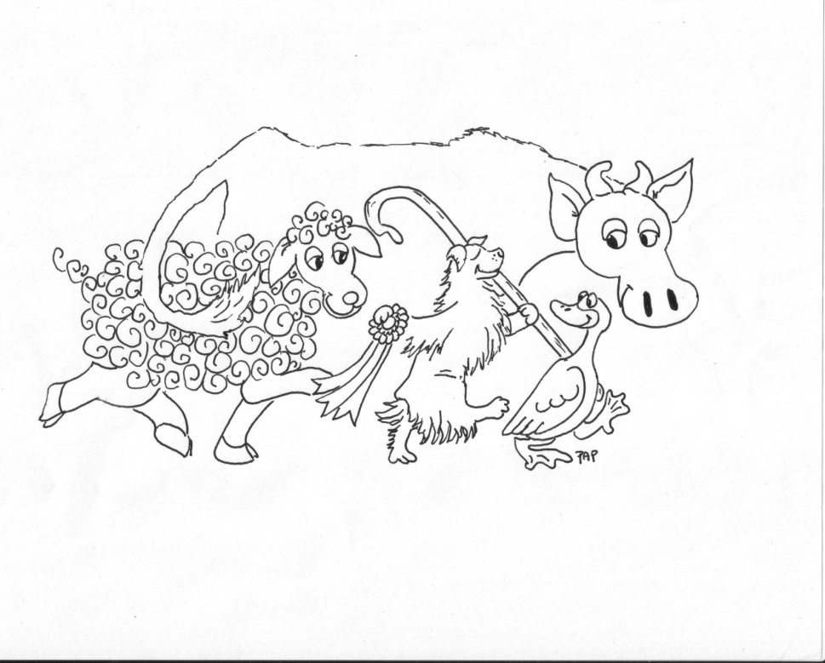

Greater Atlanta Australian Shepherd Club
Spring Fling
http://www.gaasc.org
March 20-22, 2026
6 ASCA Conformation Shows
Indoors
Held at the Augusta Kennel Club
3970 East White Oak Rd, Appling, GA 30802
Sanctioning pending

Conformation Secretary: Terry Dickey

Best in Show
Based on a compilation of wins across the weekend.

CONFORMATION WILL BE INDOORS
Crating indoors is available on a limited basis. No grooming inside. Please clean up all loose dog hair at your site every day. Consider bringing canopies/shade for you and your dogs if you set up outside.

Building opens at 3 p.m. on Friday and 7 a.m. Saturday and Sunday and closes one hour after the last show of the day.

Run order: Juniors, Non-regular, Altered and Intact.

Friday, March 20, 2026 Judge Entry times Judging
Conformation #1 Bruce Caldwell 3:00 – 5:00 PM 6:00 PM
(ASCA Provisional Judge)
Saturday, March 21, 2026
Conformation #2 John Schoeneman 7:00 – 8:00 AM. 9:00 AM (AKC Judge)
Conformation #3 Rick Gann 12:00 – 12:30 PM 1:00 PM (ASCA Senior Breeder Judge)
Conformation #4 Gail Karamalegos 12:00- 12:30 PM 30 minutes*
(ASCA Senior Breeder Judge)

Sunday, March 22, 2026
Conformation #5 Ally Bryant 7:00 – 8:00 AM 9:30 AM
(ASCA Breeder Judge)
Conformation #6 David Clayton 7:00 – 8 :00 AM 30 minutes*
(ASCA Senior Breeder Judge)
*Show will start 30 minutes after the end of the previous show/trial.

Classes |  |  | Pre-Entry Fee | Day-of-Show Entry
Non-Regular Conformation |  | 2-4; 4-6 Month, BOB puppy; Veteran 7-10; 10 and over, Best Veteran, Best Op Veteran, Stockdog. | $10.00 per show or $50 all six shows | $15.00  Per show
Intact & Altered Conformation |  | 6-9; 9-12; 12-15, 15-18, Novice, American Bred, Bred by Exhibitor, Open (divided by color).  All divided by sex. | $25.00 per show or $125 all six shows | $35.00  Per show
Junior Showmanship | 3-5 Pee Wee, 6-7 Sub-Novice, 8-12 Novice/ Open, 13-17 | $5.00 per show or $25 all six shows |  | $5.00  Per show
Pre-entries open postmarked February 1st, 2026.
Pre-entries for the discount close postmarked March 13th, 2026
Please use the Official ASCA Entry Forms found at www.ASCA.org (under Forms) and attached to this document. Entry forms can be filled in online (as “text entry”) at: https://www.asca.org/wp-content/uploads/2016/04/conentyform.pdf, then printed out, SIGNED, and mailed in.

There will be a $35.00 service charge for any returned checks. Refunds issued up to pre-entry deadline. No refunds after that date. Substitutions allowed with dogs that you own or co-own. Copies of registration papers do not need to be included with the entry.

Mail entries to: Terry Dickey, 130 Ben S. Dickey Road,
Waynesboro, Georgia, 30830.
Make checks payable to Greater Atlanta ASC.
Direct questions to Show Secretary Terry Dickey at terrydickey17@yahoo.com or text/call (706) 830-4590).
Show Committee: Susan Herdman, Wendy Eldredge, Renee Watson

Facility: Shows will be held indoors, on mats with ring gating. Crating indoors is available. No grooming inside. There is a large parking area. Dry camping is available onsite for $20/night. Please indicate on your entry how many nights you need. Please pick up after your dog in all areas. Dogs must be on leash. All children on site must be carefully supervised at all times, for their safety. There are no food vendors onsite, but there are several fast-food restaurants off I-20 exits 172 and 190 such as Wendy’s, McDonalds, Arby’s, Chick Fil-A, and others.

Conformation: Ribbons awarded for 1st through 4th place, with large rosettes for premium awards. Dog-related prizes for premium awards may also be available. If you are interested in sponsoring Class or Show, please contact the show secretary for more information.

NOTE: These events are being held on private property; you must obey all Augusta Kennel Club rules. The Augusta Kennel Club is not responsible for any damages, injuries, trauma, losses or etc. that may occur while you are on the property. No alcohol, drugs or firearms are allowed on this property.

Directions to Augusta Kennel Club, 3970 East White Oak Rd, Appling, GA 30802
- I-20 Exit 183 go south on 221 South
- Go about 1 mile to roundabout- turn right onto 223 West
- Go about 4 miles to building on the LEFT

Veterinarian Services:
Emergency Veterinarian Information:
- Blue Pearl Pet Hospital (706.733.7458); 410 Topgolf Way, Augusta GA 30909; Emergency hours: 7 a.m.- Midnight 24/7. Please call before arriving.
- St. Francis Animal Hospital ((706) 420-3614. 2647 Perimeter Parkway, Augusta GA 3099. Mon-Thurs 8 am – 8 pm.; Friday 8 am – 6 pm. Sat 10 am - 4 pm, closed Sunday.

Hotels - Double check pet policy before booking your rooms.
- Holiday Inn Express & Suites 3341 Log Deck Way, Grovetown GA 30813 (706) 303-1002; allows dogs
- Fairfield by Marriott Inn & Suites; 893 Husk Box Way, Grovetown GA 30813, (762) 377-8150. allows dogs
- Home2 Suites by Hilton 903 Husk Box Way, Grovetown GA 30813, (706) 261-9100. allows dogs
- Holiday Inn Express Griffith Hall 250 Chamberlain Ave, Fort Eisenhower GA (706) 790-; allows dogs
- Thomson Exit 172: more hotels

Please, no dog washing in the motels. Pick up after your dog on the motel grounds.
Any complaints made by the hotel could result in loss of future trial privileges.

General Information:
- All dogs' ages will be calculated March 20, 2026. All dogs six months of age or older must be ASCA registered.
- Greater Atlanta ASC, ASCA, and the Augusta Kennel Club will not be responsible for the loss or damage to any dog exhibited, or for the possessions of any exhibitor whether the result was by accident or any other cause. It is distinctly understood that every dog at this event is in the care and custody and control of his owner or handler during the entire time the dog is on the show premises.
- Any exhibitor whose dogs and/or children create unnecessary disturbances or repeatedly engage in unsafe or disruptive behavior may, at the discretion of the Show Committee, be asked to leave the show site. In such case, no refund of fees paid will be made. No entry will be refunded if the trial cannot open or be completed by reason of riot, civil disobedience, fire and act of God, public emergency, and act of a public enemy, COVID or any other cause beyond the control of the organizing committee.
- COVID Policies - Please check ASCA’s website at https://asca.org.
- This is an ASCA sanctioned event and will be governed by the rules of the Australian Shepherd Club of America. For a copy of these rules, contact: ASCA, 6091 E. State Route 21, Bryan, TX 77808, 979-778-1082. Show rules for conformation can be viewed online at http://www.asca.org/Forms+and+Rule+Books. Visit the asca.org website for more information on these events. Exhibitors, through submission of entry, acknowledge that they are knowledgeable of ASCA rules and Regulations, and agree to abide by all rules in effect at the time of this trial.
Any handler, owner, or spectator being abusive towards a dog or exhibiting poor sportsmanship will be asked to leave the show site for the duration of the show, and no refunds will be given.
- ASCA has the right to reprimand or suspend any person or persons from any or all privileges of ASCA for conduct prejudicial to the best interests of the Australian Shepherd, ASCA events or ASCA. Exhibitors are to maintain the highest level of sportsmanship and are to conduct themselves accordingly. Foul or abusive language, yelling at exhibitors or judges, disorderly conduct, and/or poor sportsmanship will not be allowed and shall be disciplined in accordance with Chapter 11 and the ASCA Dispute Rules and ASCA Discipline Guidelines.
No entry shall be accepted from a dog or handler disqualified from the ASCA Conformation program; a dog or handler disqualified from all ASCA programs; or a person not in good with ASCA.

