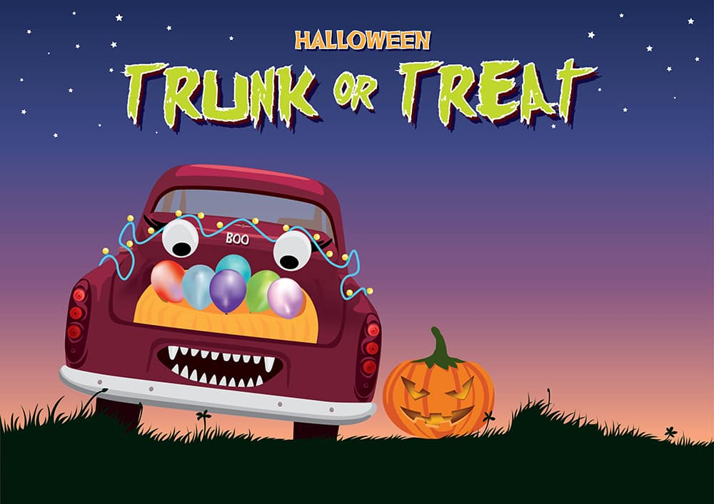

WHO wants to join this amazing event?

All cars are responsible for their own candy distribution.

ALL CANDY MUST BE SEALED. All cars must be registered by 10/27. Please make sure your cars are family friendly decorated.

|  |  |
| --- | --- |
| Name |  |
| Address |  |
| Phone # |  |
| Car Type |  |
| License Plate # |  |
| Email |  |

Please return to [foodtruckfridaypeople@gmail.com](mailto:foodtruckfridaypeople@gmail.com) by 10/27

Questions? Contact Joe Fradella

Brought to you by the Levittown Angels and Food Truck Friday People