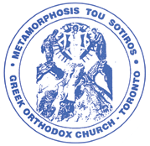

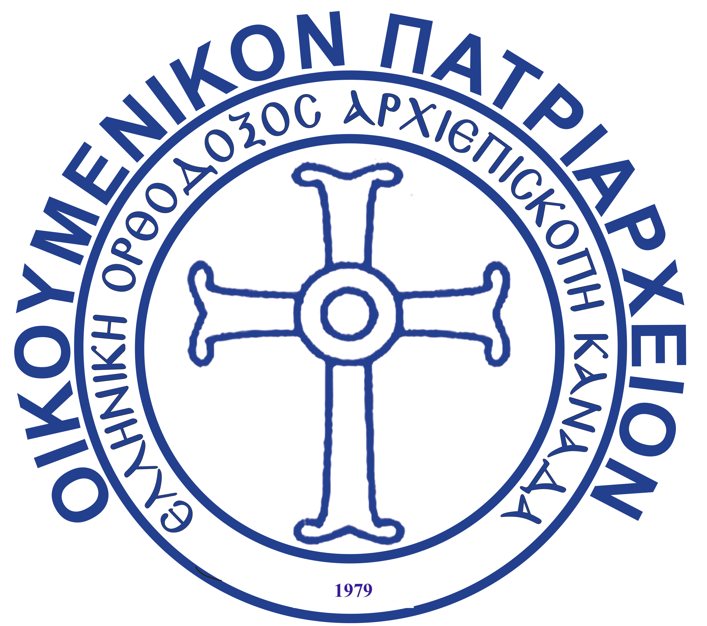GREEK ORTHODOX ARCHDIOCESES OF CANADA

ΕΛΛΗΝΙΚΗ ΟΡΘΟΔΟΞΟΣ ΑΡΧΙΕΠΙΣΚΟΠΗ ΚΑΝΑΔΑ **METAMORPHOSIS TOU SOTIROS**

**GREEK ORTHODOX CHURCH**

40 Donlands Avenue, Toronto, Ontario, M4J 3N6 Tel: (416) 465 2345, Fax: (416) 465 2684[*metamorphosisgoc@gmail.com*](mailto:metamorphosisgoc@gmail.com)

**Sacrament of Baptism**

Please provide the following:

* Baby’s birth certificate.
* The names of the parents (including maiden name of the mother), where they were born, date and place of marriage (if applicable) and their religion.
* A copy of the sponsors (Godparents) baptismal certificates and ecclesiastical marriage certificate if they are married. Please note that if the godparent is married it must have taken place in an Orthodox church. (Godperent(s) they themselves **must** be Baptized - Orthodox to take part in the sacrament)
* The fee for the baptism is $500 which may be paid in cash, cheque or via e-transfer to the church’s email address (metamorphosisgoc@gmail.com). This includes a membership for parents and godparents ($200 total). If you have paid for a membership this year $100 be will deducted from the total amount.
* Please note once date is booked we require a deposit fee of $150 and full payment week before Baptism.

*The names, mailing addresses, telephone numbers and email addresses of:*

* *The parents*
* *The godparent(s)*

Should you have any further questions, please let me know.

Thank you,

Kelly