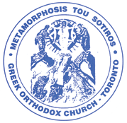

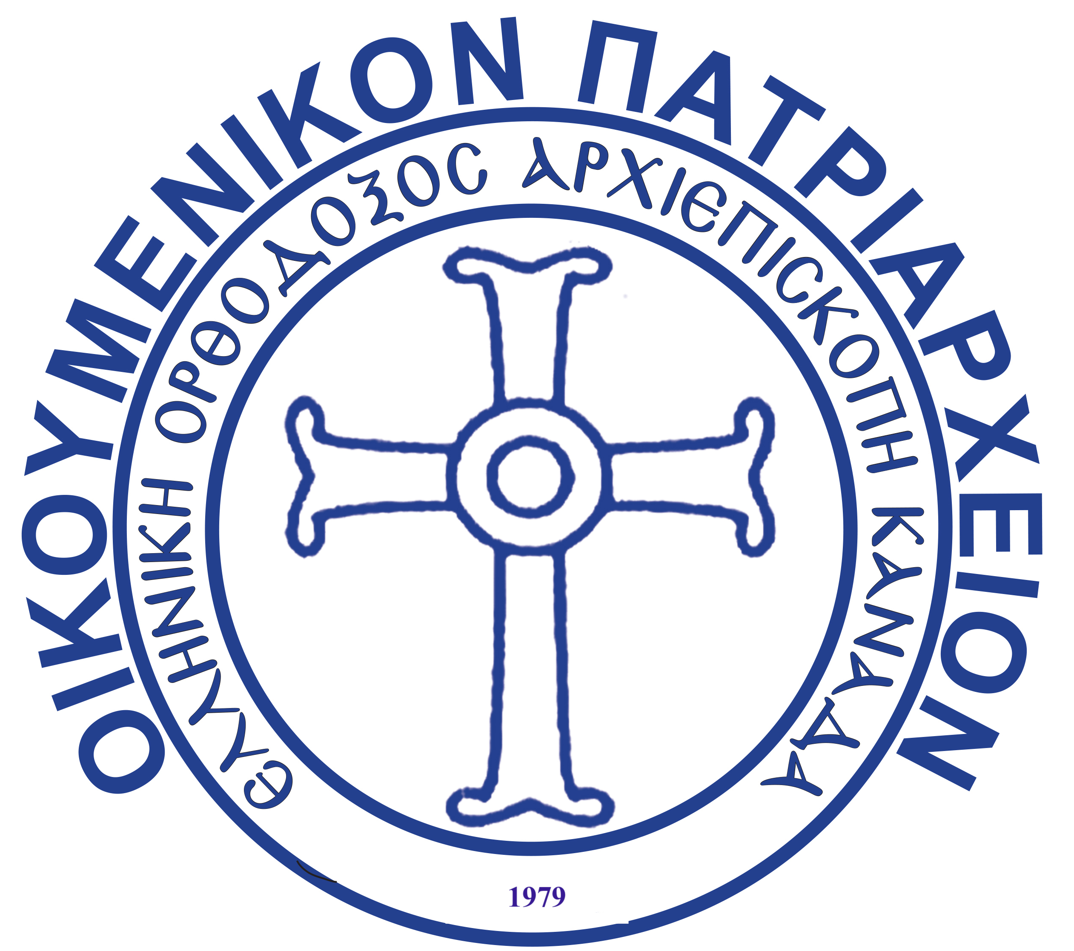
GREEK ORTHODOX ARCHDIOCESES OF CANADA

ΕΛΛΗΝΙΚΗ ΟΡΘΟΔΟΞΟΣ ΑΡΧΙΕΠΙΣΚΟΠΗ ΚΑΝΑΔΑ METAMORPHOSIS TOU SOTIROS
GREEK ORTHODOX CHURCH
40 Donlands Avenue, Toronto, Ontario, M4J 3N6 Tel: (416) 465 2345, Fax: (416) 465 2684 metamorphosisgoc@gmail.com

WEDDING REQUIREMENTS

- Bring in your Marriage License from the city (within 3 months of your wedding day)

- Copy of bride and grooms Baptismal Certificate and identification (ie. Drivers License)

- Copy of Sponsors (Koumbari’s) Baptismal Certificate. If they are married their Ecclesiastical Certificate will suffice.

- Fee for the wedding is $550 and can be paid by cash, cheque or e-transferred to metamorphosisgoc@gmail.com

- Please note once date is booked we require a deposit fee of $150.00 and full payment week before wedding

The names, mailing addresses, telephone numbers and email addresses of:

- Bride & Groom

- Koumbari

- Parents of the Bride

- Parents of the Groom

Please let me know if you have any further questions.

Many thanks,

Kelly

