**33 Resistance Band Exercises You Can Do Anywhere**

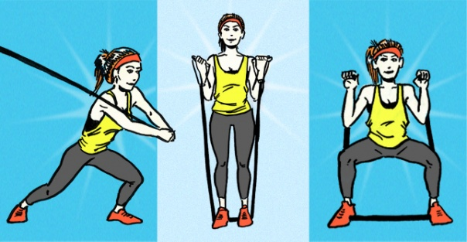

Illustrations by Shannon Orcutt

Rock out with the band! Resistance bands are a great addition to any strength training routine or rehabilitation program and come in a variety of sizes, lengths, and strengths [[1]](http://greatist.com/fitness/resistance-band-exercises#citation-1) [[2]](http://greatist.com/fitness/resistance-band-exercises#citation-2). This portable exercise equipment is also easily stored, making it perfect for home use, hotel workouts, or when you’re tight on space at the gym. Just like [free weights](http://greatist.com/fitness/30-dumbbell-exercises-missing-from-your-routine-041912/), exercise bands come in a range of resistance levels, from highly stretchable to heavy-duty strength. The most common [types of bands](http://youtu.be/twiD_61LGFA) include tube bands with handles, loop bands (aka giant rubber bands), and [therapy bands](http://www.thera-band.com/store/index.php?CategoryID=11). (When in doubt, a fitness professional can help determine which band is right for you, depending on your fitness level and specific workout plan). For most exercises, **try aiming for 8-25 reps for 2-3 sets per exercise. And don’t miss our sample workout suggested at the very end.** Ready, set, streeetch!

### Bend, (Don’t) Snap! — The Moves

##### Lower Body

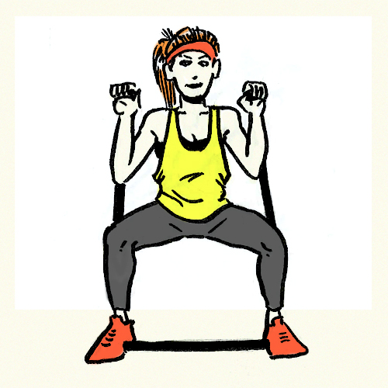

**1.** [**Front Squat**](http://www.bodybuilding.com/exercises/detail/view/name/squats-with-bands)**.** Squat like you mean it. Stand on a tube band with the feet slightly wider than your shoulders and center of the band between the feet. Holding a handle in each hand, bring the top of the band over each shoulder, securing the band in place by crossing your arms at your chest. [Sit straight down](http://greatist.com/fitness/perfect-squat/), chest up, abs firm, pressing your knees out over your toes. Rise back up to start position and repeat for 8-12 reps.

**2.** [**Leg Extension**](http://www.acefitness.org/exerciselibrary/133/standing-leg-extension)**.** Kick it up a notch with this quad-builder. Anchor the loop band in a low position on a support, looping the other end around your ankle with the band positioned behind you. Step away from the anchor to create tension on the band, and position feet hip-width apart. Shift your weight to the left foot, and lift the right leg from the floor. Extend the knee until it straightens out in front of you. Slowly return your leg to starting position and repeat for 8-12 reps before switching legs.

**3.** [**Prone (Lying) Leg Curl**](http://www.acefitness.org/exerciselibrary/131/prone-lying-hamstrings-curl)**.** Lie belly down and loop a band around your right ankle, anchoring the other end to a door or support. Scoot way from the anchor to create tension. Tighten your core and bend your leg at the knee, bringing your heel toward your glutes as far as you can comfortably go. Slowly return your leg to starting position and repeat for10-15 reps, then switch sides.

**4.** [**Standing Adductor**](http://www.sportsinjuryclinic.net/rehabilitation-exercises/resistance-band-exercises1/resistance-band-hip-adduction-exercise)**.** Anchor your loop band at ankle height to a support and stand with your left side facing the support, wrapping the free end around your right (outer) ankle. Stand perpendicular to the band and step away from the support to create some tension (the good kind, of course). From a wide stance, get into a quarter squat or an athletic stance, and then sweep your working ankle across your body past your standing leg, squeezing your thighs together. Slowly return to starting position and repeat for 12-15 reps before switching sides.

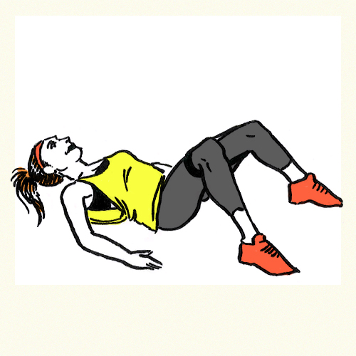

**5.** [**Supinated Clamshell**](http://www.tensegrityphysicaltherapy.com/supine_clamshell_miniband.html')**.**Feeling a bit clammy?Loop a band around your legs just above your knees. Lie on your back with hips and knees flexed to 90 degrees. Pull the knees apart while contracting your glutes for 2-3 seconds. Slowly return to starting position and repeat, aiming for 10-12 total reps.

**6.**[**Plantar Flexion (Ankle Flexion).**](http://www.acefitness.org/exerciselibrary/23/ankle-flexion)Take a load off for this one. Secure a loop or therapy band around an anchor (like the leg of a coffee table or chair), and sit with one leg straight out, wrapping the other end of the loop around the top of your foot. Lean back, supporting your weight on your hands, and flex your foot forward until you feel a good stretch in your shin. In a controlled movement, bring your toes back up, flexing them toward your knee as far as comfortable. Slowly return to starting position and go for 10-12 reps on each side.

**7.** [**Standing Abduction**](http://www.acefitness.org/exerciselibrary/103/standing-hip-abduction). This one’s a bit of a balancing act. Anchor your loop band at ankle height, and stand with your left side toward the anchor. Attach the free end to your outside ankle and step out to create tension on the band. Move your supporting leg back so your foot is elevated from the floor, lift your working leg up, slowly bringing your looped foot out to the side, contracting your outer glutes. If you feel wobbly, grab a support (like the wall or the back of a chair). Lower back down to starting position and repeat for 15-20 reps on each side.

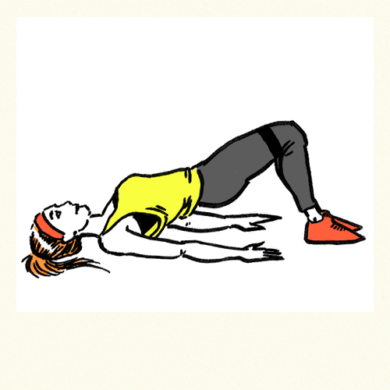

**8.** **[Glute Bridge](http://www.coreperformance.com/knowledge/movements/glute-bridge-with-mini-band.html" \t "_blank).**Salute those glutes!Tie a band around your legs right above your knees. Lie on your back with your feet on the floor, bending your knees to 90 degrees. Rise up with your hips until your shoulders, hips and knees align, contracting your glutes through the entire movement. Slowly lower down and bridge back up for 15-20 bridges.

**9.** [**Seated Abduction**](http://www.exercise.com/exercise/band-assisted-seated-hip-abduction)**.** Move over, [Susan Summers](http://www.suzannesomers.com/Suzanne-Somers-ThighMaster-Gold-P7.aspx)! To really show those thighs who’s boss, sit at the edge of a chair or bench and tie a loop band around both legs, just above the knees. Place your feet slightly wider than your shoulders. Slowly press your knees out, turning your feet in as your legs move apart. Hold for two seconds, and then bring your knees back together. Aim for 15-20 reps. 

**10.** [**Lateral Band Walk**](http://sportsmedicine.about.com/od/injuryprevention/qt/Lateral-Band-Walking-Exercise.htm)**.** Don’t sidestep these side steps! Step into a loop band or tie a therapy band around the lower legs, just above both ankles. Place your feet shoulder-width apart to create tension on the band. From a half-squat position, shift your weight to the left side, stepping sideways with the right leg. Move the standing leg slightly in, but keep the band taught. Continue in this walking fashion, repeating for 8-10 steps before heading back the other way.

##### Back

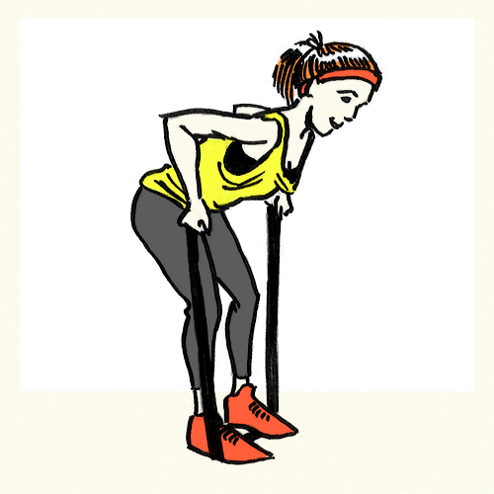

**11.** [**Bent Over Row**](http://www.exercise.com/exercise/row-with-resistance-band)**.** You can do it, put your back into it. Stand over the center of the band with feet shoulder-width apart. Bend slightly at the knees and hinge at the waist, keeping your hips back. Grasp each handle with hands facing the outside of your knees. With elbows bent, pull the band up toward your hips, squeezing your shoulder blades together until your elbows form a 90-degree angle. Lower and row for 10-12 reps.

**12.** [**Seated Row**](http://health.howstuffworks.com/wellness/diet-fitness/exercise/back-strengthening-exercises4.htm)**.** Take a seat, but don’t get too cozy. With legs extended, place the center of the band behind the soles of your feet. Grab the band with both hands, arms extended and palms facing each other. Sitting nice and tall, bend at the elbow and pull the band toward your core, squeezing your shoulder blades together. Slowly return to starting position and repeat for 10-12 reps.

**13.** [**Lying Pullover**](http://www.sportsinjuryclinic.net/rehabilitation-exercises/shoulder-exercises/resistance-band-pullover)**.** No, this doesn’t involve pulling the covers over your head. For this effective pec and lat exercise, anchor the tube band in a low position. Next, lie on your back, grabbing the free end of the band with both hands, stretching arms straight out overhead. With elbows slightly bent, pull the band overhead, crossing your torso until the handle reaches your knees. Slowly return to starting position and keep it up for 8-10 reps.

**14.** [**Pull Apart**](http://www.exercise.com/exercise/back-squeezes-with-resistance-band)**.** Stand with knees slightly bent, feet shoulder-width apart. Grip the middle section of the band with both hands at shoulder level with palms facing down. Keeping your arms straight, pull the band out and back until your shoulder blades contract. Slowly return to starting position and stretch, squeeze, and release for 8-10 reps.

**15.** [**Lat Pulldown**](http://fitbie.msn.com/exercise/resistance-band-lat-pulldown-women)**.** Ready to work the upper back? Anchor the band overhead to a horizontal bar (or even a sturdy tree limb), pulling the free ends down at your sides. Kneel facing the anchor so the bands are positioned in front of you, gripping each end with arms extended overhead and hands slightly wider than shoulder-width. Bending the elbows, pull the band down toward the floor while contracting your back muscles. Once the hands reach your shoulders, slowly raise them back to the starting position and rock out 10-12 reps.

##### Chest

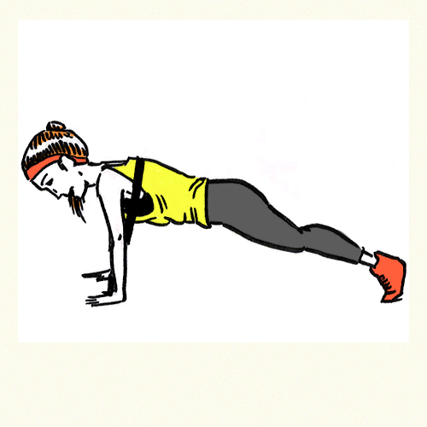

**16.** [**Push-Up**.](http://resistancebandtraining.com/2010/09/resistance-band-workout-push-ups/) Level up those push-ups with bands. Get in plank position, draping the resistance band across your low back. Loop the ends of the band through each thumb, and place your hands on the ground in starting position — body facedown on the ground. Contract your glutes and abs, and push straight up until your arms fully extend. Lower back down, chest to the floor, and see what you’ve got for 5-20 reps (depending on your strength).

**17.** [**Standing Chest Press**](http://www.womenshealthmag.com/fitness/chest-press-with-resistance-band). Anchor the tube band on a cable column or sturdy support at chest height. Grab each handle with your back to the band. Step forward to reduce slack, positioning your hands at chest height. With elbows up and palms facing down, press the band straight out in front of you until your arms reach full extension, and squeeze those chest muscles. Return to starting position and press on for 12-15 reps.

**18.** [**Incline Chest Press**](http://resistancebandtraining.com/2010/09/incline-chest-press-with-resistance-bands/)**.** Next up: The upper chest muscles! In a right forward lunge position, place the middle of your band beneath your back foot. Grabbing a handle in each hand, bring the band to shoulder level. Press the bands upward straight over your chest like a rainbow until the arms fully extend. Lower back down and repeat for 10-12 reps.

**19.** [**Bench Press**](http://fitbie.msn.com/exercise/resistance-band-bench-press-women). No barbell? No problem! Anchor a tube band on the bench legs, and lie on the bench, face up. Grabbing a handle in each hand. position them at shoulder height (so your thumbs touch the front of your shoulders). Extend the arms straight up overhead to full extension, moving your hands toward each other at the top. Lower back down and repeat for 10-12 reps.

##### Shoulders

**20.** [**Overhead Press**](http://www.exercise.com/exercise/overhead-press-with-resistance-band)**.** Stand over the center of a tube band with feet shoulder-width apart. Grip each handle, positioning your hands at shoulder level with palms facing each other so your thumbs touch your shoulders. Press straight up, rotating your palms forward as you fully extend your arms. Lower back down slowly and repeat for 8-10 reps

**21.** [**Lateral Raise**](http://www.exercise.com/exercise/side-laterals-with-resistance-band)**.** Build bolder shoulders with this isolation move. Stand with feet positioned over the center of a tube band, shoulder-width apart. Grip each handle with arms down at your side and palms facing in. Bending your elbows ever so slightly, raise your arms straight out to the side to shoulder-level. Slowly lower back down and go for a total of 8-10 reps.

**22.** [**Forward Raise**](http://www.exercise.com/exercise/forward-raise-with-resistance-band)**.** To hit the front of the shoulders, stand on the middle of the band with feet shoulder-width apart and grip each handle at your sides with palms facing in. Next, without locking your elbows, bring your right arm straight out in front of you to shoulder height. Slowly lower back down and raise the roof for 8-12 reps before switching arms.

**23.** [**Upright Row**](http://www.exercise.com/exercise/upright-rows-with-resistance-band). Stand proud as you target your traps. With feet positioned over the center of the band, shoulder-width apart, grip each handle and position them with palms facing each other just in front of your thighs. Pull the band straight up the front of your body to shoulder-level, keeping your elbows bent and positioned in a high “V.” Slowly lower back down to starting position and keep rowing for 10-12 reps.

**24.** [**Bent Over Rear Delt Fly**](http://www.exercise.com/exercise/bent-over-lateral-raise-on-chair)**.** Target the whole shoulder with this fierce move. Sit at the edge of a chair or bench, positioning your feet over the middle of the band. Cross the band at your knees, grabbing each handle with palms facing each other. Bend forward at the waist, back straight, and raise your arms straight out to your sides until the band reaches shoulder level. Lower back to starting position and fly away with 10-12 reps.

##### Arms

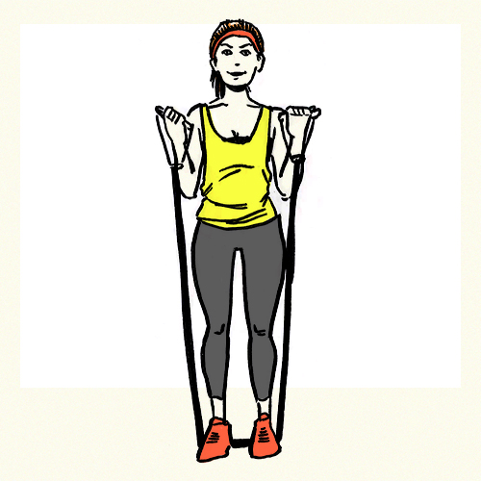

**25.** [**Standing Double Bicep Curl**](http://www.fitstudio.com/exercises/resistance-band-biceps-curl/print). Stand with feet shoulder-width apart with your feet placed over the middle of the band. Grab a handle in each hand, starting with your arms down at your sides. With palms facing in front of you, pull your arms toward your shoulders by bending at the elbow until you get a good bicep contraction. Slowly lower back down and go for a total of 12-15 curls.

**26.** [**Concentration Curl**](http://www.exercise.com/exercise/concentration-curls-with-band). Want to really get ready for the gun show? Start in a forward lunge position, right leg in front, and place the middle of the band under the right foot. Grasp one end of the loop band with your right band, resting your elbow on the inside of your knee (to target those biceps a little deeper). With palm facing away from your knee, curl the band up toward your shoulder, squeezing your biceps at the top. Slowly lower back down and repeat for 8-10 reps before switching sides.

**27.** **[Tricep Kickback](http://www.exercise.com/exercise/kickbacks-with-resistance-band" \t "_blank)**. Kick back and relax. Just kidding! Stand in a forward lunge position with your right foot in front, positioned over the center of the band. Holding each end of the band, position your arms at your sides with palms facing behind you. Bend at the elbows (keeping them tucked by your sides) until your forearms are parallel to the floor. Next, press down the arms, pushing the band behind your body until the arms fully extend. Lower back down and repeat for 8-10 reps.

**28.** [**Overhead Triceps Extension**](http://www.exercise.com/exercise/triceps-extensions-using-bands). Sit on a chair or bench, placing the center of a tube band beneath your glutes. Grab a handle in each hand, and stretch your arms up, bending your elbows so that your hands are positioned behind your neck. With palms toward the ceiling, press your arms straight up until they fully extend. Lower back down and repeat for 10-12 reps before switching sides.

Core

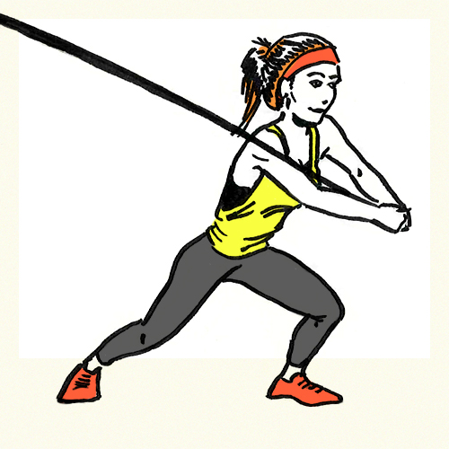

**29.**[**Woodchoppers**](http://www.sportsinjuryclinic.net/rehabilitation-exercises/resistance-band-exercises1/resistance-band-wood-chop-exercise)**.**Be an ax man (or woman) in training with this great core move. Anchor the loop or tube band toward the top of a cable column or support. With your right side to the support, grab the free end of the band with your arms stretched out overhead. In one smooth motion, pull the band down and across your body to the front of your knees while rotating your right hip and pivoting your back foot. Slowly return to starting position and repeat for 8-10 reps on each side.

**30.** [**Anti-Rotation Band Walkouts**](http://www.beyondstrengthperformance.com/core-exercises)**.** Know when to walk away. Anchor a loop or tube band on a cable column or support positioned slightly below your chest. Grasping the free end, create tension on the band and squat to an athletic stance. Holding the band with both hands straight out in front of your chest, keeping your core tight, step laterally until the band is too tense to go any further. Slow and controlled, move back toward the column to starting position. Repeat for 6-8 reps on each side.

**31.** [**Russian Twist**](http://www.fitnessmagazine.com/workout/abs/express/fast-belly-blaster/). Not your vodka with a twist. Sit on the floor with legs extended, wrapping the center of the band around the bottom of your feet. Hold the free ends in each hand. Slightly bend your knees, keeping your feet on the floor, and lean back at a 45-degree angle. Rotate the band right by bringing your left hand across your body and your right hand down by your right hip. Contracting your oblique muscles, bring the band toward your right hip while keeping your middle and low back neutral. Return to starting position and rotate left then right for a total of 10-12 reps on each side.

**32.** [**Kneeling Crunch**](http://www.fitstudio.com/exercises/resistance-band-kneeling-crunch/print). Attach the band to a high anchor (such as the top of a door or cable column) and kneel down, grabbing each side of the band. Extend the elbows out at shoulder-level, engage your abdominals, and crunch down toward your hips while contracting your abs. Slowly return to starting position and repeat for 10-12 reps.

**33.** [**Reverse Crunch**](http://www.sparkpeople.com/resource/exercises.asp?exercise=166)**.** Ready to put it in reverse? Anchor the band in a low mount position. Lie on your back, bending your knees to form a 90-degree angle. Wrap the band around the tops of both feet and scoot back enough to create tension the band. Abs tight and back flat, pull your knees toward your shoulders, contracting your abdominal muscles. Slowly return to starting position and repeat for 12-15 reps.

**The Workout**

Ready to put it all together? Check out this sample workout that'll work the whole body in 30 minutes or less!

