Scoliosis and Early Detection
Many schools perform routine spinal screenings to detect scoliosis, also known as “curvature of the spine.” But did you know that chiropractors are uniquely qualified to perform these spinal screenings because of their extensive education and training?
Early detection is critical in terms of treating scoliosis to obtain the best possible outcome. Scoliosis occurs 8 – 10 times more frequently in girls than in boys. There are several tests that you can conduct at home to determine whether your child should be checked. You can measure your daughter’s hem length, from the bottom of the hem to the floor, to determine whether it is of equal length all the way around. You can also take a look at the bottom of your child’s shoes to check for signs of uneven wear.


Kids have enough to worry about without adding scoliosis braces or surgery to the mix
When we screen a child for scoliosis, these are the symptoms we look for:
• Your child’s head is not centered over his/her body
• One shoulder is higher than the other; one shoulder blade is higher or stands out more than the other
• Hips are uneven or one is more prominent than the other
• Spine is obviously curved when viewed from both a standing straight and bending over position
Left undetected, scoliosis tends to get worse over time, often requiring braces, or even surgery, depending on the severity of the curve and the presence of new symptoms, such as difficulty breathing or back pain.
Chiropractors use specific adjustments and exercises to help reduce the degree of curvature in your child’s spine. They can achieve significant success in many children when their scoliosis is discovered in its early stages, keeping in mind that bones continue to grow – often into the early 20’s.
If you or someone you know would like to have a child checked for early scoliosis detection, please give our office a call, or have them give us a call, so we can set up a screening.

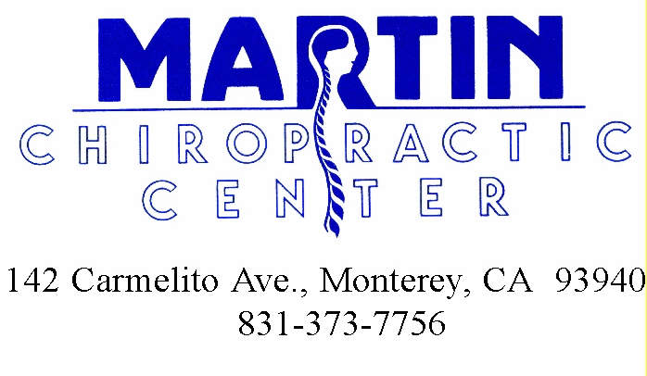
This is the most current information on this topic. Please make good use of it in your health development. Pass on the information to those you care about so they can benefit too! Stay focused on learning new Healthy Life Habits

