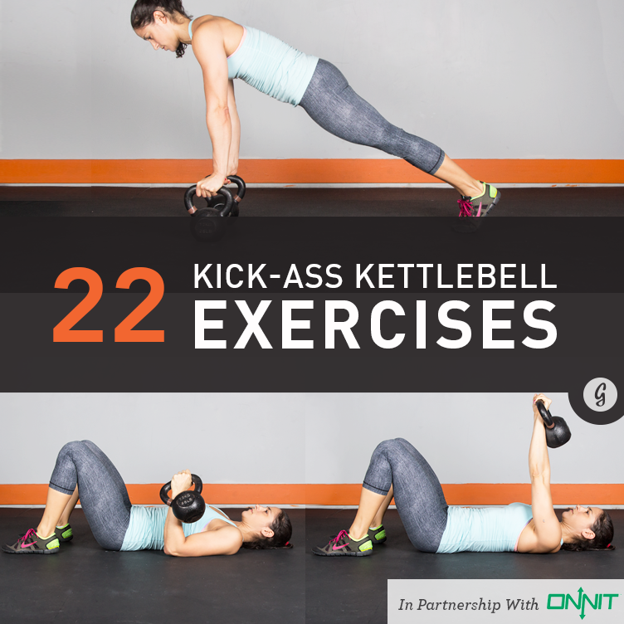
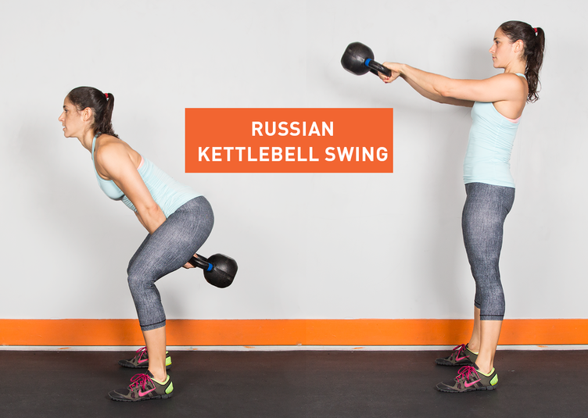
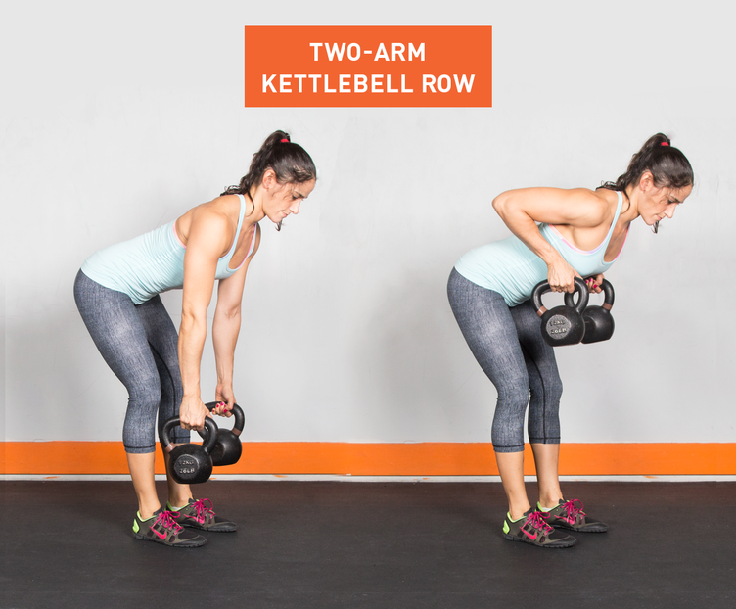
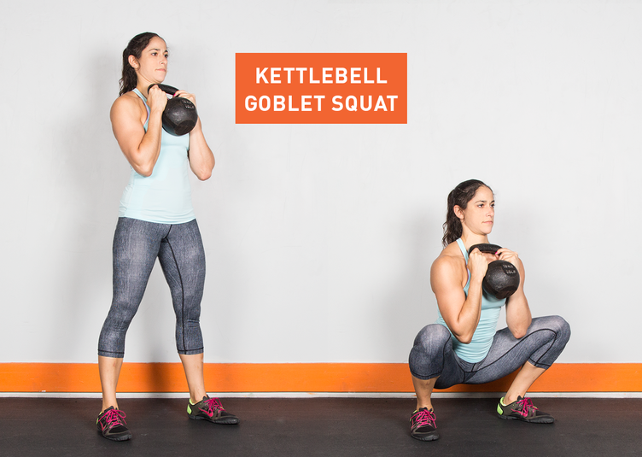
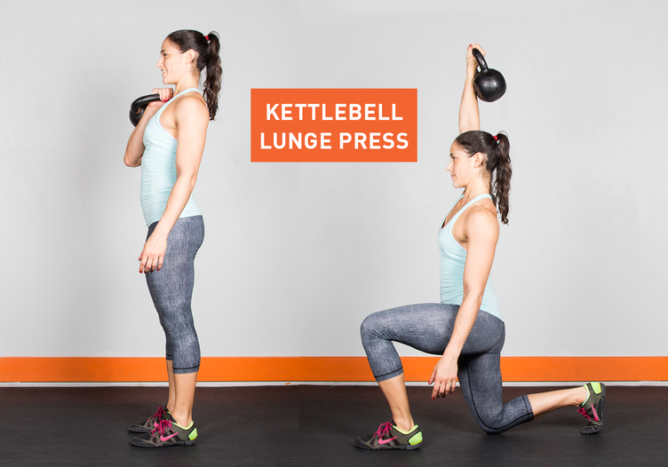
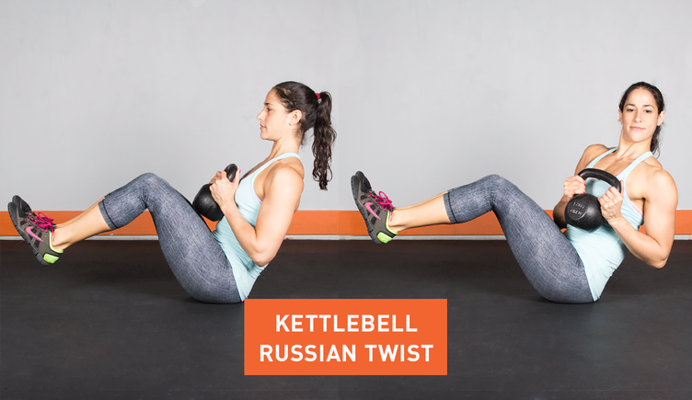
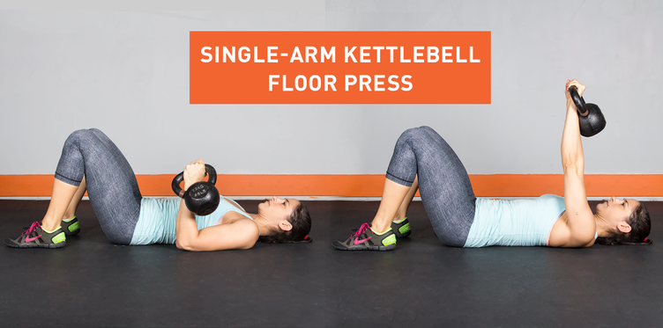
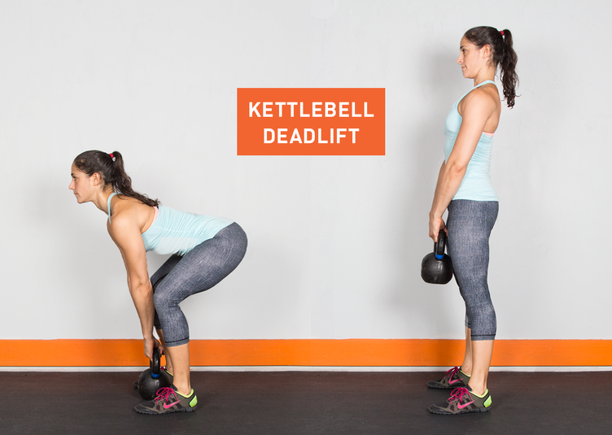
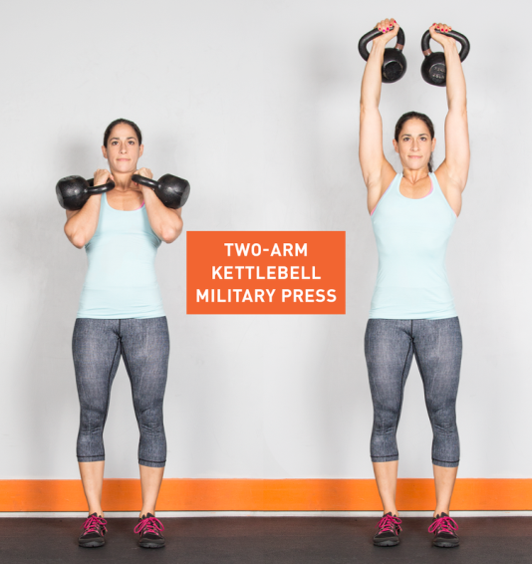
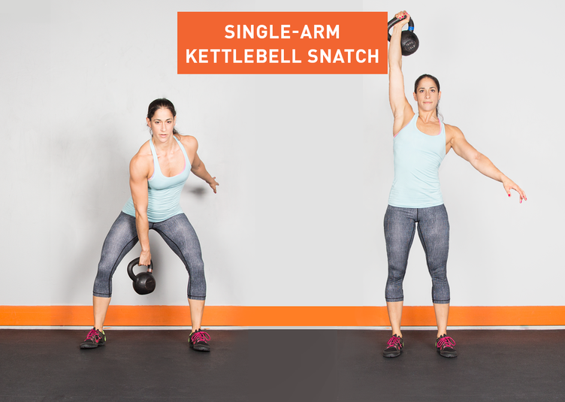
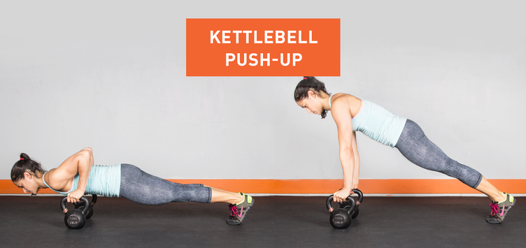
Kettlebells are all bells, no whistles. Resembling a mini bowling ball with a handle, kettlebells are great for cardio, strength, and flexibility training [1] [2] [3]. Start by picking up the weight of your choice—women usually grab between eight and 16 kg weights, while men go for 16 to 32 kg, though these weights vary depending on the exercises of choice. (No harm in starting low and working your way up!) Reps and sets will depend on intensity and fitness levels, for most of these moves, we recommend aiming for 3-5 sets of 10-30 reps with good form. (We suggest starting with a trainer or kettlebell aficionado to make sure everything’s kosher). Ready to rock? Let’s give these kettlebells a swing, snatch, or clean!
1. Russian Kettlebell Swing
Targets: Shoulders, back, hips, glutes, legs
Level: Beginner
How to: To do the perfect kettlebell swing, stand up straight, with feet a bit wider than hip-distance apart. Grab the handle with both hands, keeping the palms face down and arms in front of the body. Maintain a slight bend to the knee and drive the hips back, lowering the body—but not too low (this isn't a squat!). Then, in a fluid motion, explosively drive the hips forward while swinging the kettlebell, keeping the glutes and core engaged. Remember: The motion should come from the hips, not the arms, as the body returns to standing. Lower the weight back down between the legs and keep this swinging motion going for 12 to 15 reps.

2. Single-Arm Kettlebell Swing
Targets: Shoulders, back, hips, glutes, legs
Level: Beginner-Intermediate
How to: This movement is just like the two-handed swing, but uses one hand at a time. Swing the kettlebell up with one arm, but still swing the other arm to help drive momentum. Alternate hands when the kettlebell is behind the legs; aim for 10 to 12 reps with each arm.
3. Two-Arm Kettlebell Row
Targets: Back, arms, shoulders
Level: Beginner-Intermediate
How to: Grab two kettlebells for this one. (Double the pleasure, double the fun, right?) Place them in front of the feet and bend the knees slightly. Next, bend over to grab both kettlebells and pull them towards the stomach, keeping the elbows close to the body and the back straight. Lower the weights, repeat for 12 to 15 reps max, feel like a champ.

4. Kettlebell Figure-8
Targets: Arms, back, abs
Level: Intermediate
How to: Looking to impress a certain someone at the gym? Then try this: Start with legs a bit wider than hip-width distance apart, and lower yourself into a quarter-squat position. (Keep that back straight and chest up!) Grab the kettlebell with the left hand and swing it aroundthe outside of the left leg and then back between the legs. Next, pass the kettlebell to the right hand and swing it around the outside of the right leg. Keep this motion going, similar to the classic basketball drill! Can you do a minute straight? (Be sure to switch directions half-way through!)
5. Kettlebell Goblet Squat
Targets: Legs, glutes, back
Level: Intermediate
How to: What’s a squat without a kettlebell in hand? Stand up straight, holding the kettlebell in front of the chest with both hands, keeping the elbows close to the body. Start squattingby driving the heels into the ground and pushing the hips back until the thighs are parallel to the ground or just below. Return to standing, and repeat for 15-20 reps (or more!) Just remember: quality over quantity!

6. Kettlebell High Pull
Targets: Shoulders, arms, glutes, legs
Level: Intermediate
How to: Turn those toes out 45 degrees with feet a bit wider than shoulder-width apart. Place the kettlebell on the ground between both legs and begin to squat while keeping the core engaged, and grip the kettlebell handle with one hand. Then, using force from the hips, push through the heels to rise to standing, pulling the kettlebell upwards while the elbow drives up. Lower back down and switch arms. Shoot for 10 to 12 for each arm.
7. Kettlebell Lunge Press
Targets: Shoulders, back, arms, abs, glutes, legs
Level: Intermediate
How to: Here’s a new way to spice up those lunges. Stand up straight while holding the kettlebell in front of the chest with two hands, arms bent and palms facing each other. Lunge forward with one leg while raising the kettlebell overhead (raise the roof!). Return to standing while returning the kettlebell to the chest. Try for 10-15 reps on each leg.

8. Kettlebell Sumo High-Pull
Targets: Back, legs, shoulders, arms
Level: Intermediate
How to: We promise no wrestling is involved. Start with the kettlebell between the feet, set a bit wider than hip-distance apart. Grab onto the handle with both hands with the knees bent and hips back. Then, pull the kettlebell to the shoulders while the knees straighten and elbows rise. Remember: The force is coming mostly from the hips, the arms pulling at the very end. Keeping the core engaged the whole time, move the weight back down by the ground and repeat for 12-15 reps.
9. Kettlebell Russian Twist
Targets: Abs, obliques
Level: Intermediate
How to: Forget crunches. Sit with the legs bent and feet flat on the floor, about hip-distance apart. Hold the kettlebell with both hands at the chest, and then lean back to a 45 degree angle. Here’s the fun part: Rotate the torso from left to right by twisting at the waist and swinging the kettlebell across the body. See how many you can do, with perfect form of course!

10. Kettlebell Windmill
Targets: Shoulders, back, abs, obliques, hips
Level: Advanced
How to: Hold the kettlebell in the right hand and angle the feet 45 degrees away from the right arm. Raise the kettlebell overhead, lock the arm, and keep your eyes on the weight (which will help keep the shoulders aligned!). Shift your weight onto the right leg and begin bending forward at the waist. Keep the right arm extended overhead as the body bends forward and the left arm is pointed toward the ground. (For all you yogis out there, this should feel similar to triangle pose.) Lift back up slowly, staying in control. Repeat for 6 to 8 reps on each side.
11. Single-Arm Kettlebell Floor Press
Targets: Chest, arms, core
Level: Intermediate
How to: Lie on the ground with your legs straight. (Nope, it’s not time for savasana!) Grab a kettlebell by your side and, with the palm facing in, press the weight straight up while rotating the wrist (so the palms face the feet). Bring the kettlebell back down to the starting position, and repeat for 6 to 8 reps.

12. Kettlebell Slingshot
Targets: Back, arms, abs, obliques
Level: Intermediate
How to: No rocks or rubber bands required for this move. Keep feet shoulder-width apart, and hold the kettlebell in front of the body, arms extended at chest level. Swing the kettlebell behind the back with one hand, then reach back with the opposite hand to grab it, swinging the kettlebell to the front of the body. Continue round 'n round for 8-12 reps, then switch directions!
13. Side Step Kettlebell Swing
Targets: Legs, glutes, back
Level: Intermediate-Advanced
How to: This move is like a traveling kettlebell swing—now we’re going places! Grab a kettlebell and start with the basic two-handed swing (see move No. 1). When the bell is down between the feet, step the right foot out to the right; then, when the bell is up, bring the left foot to meet the right (so the legs come together). Keep side-steppin' your way to the right (10 to 15 steps), then head on back the other way, leading with the left foot.
14. Kettlebell Deadlift
Targets: Legs, glutes, arms, back, abs
Level: Intermediate-Advanced
How to: Who says you need a barbell to deadlift? Stand with the kettlebell between the feet on the floor. Squat down and grab a hold of the handle with both hands while the back remains flat. Engage the core, tighten those glutes, and keep the arms extended as the body rises on up, kettlebell and all! Aim for 12 to 15 reps, maintaining proper form throughout.

15. Kettlebell Clean
Targets: Legs, butt, back
Level: Advanced
How to: Start with the kettlebell between the feet. Begin to swing upwards: Shrug the shoulders, pulling the body and 'bell up to the shoulder. The 'bell should end in the “rack” position: resting on the forearm, which is tucked close to the body, the fist at your chest. Bring the weight back down to the floor and repeat for 10 to 15 reps.
16. Two-Arm Kettlebell Military Press
Targets: Shoulders, arms, back
Level: Advanced
How to: Made it through move the kettlebell clean without breaking a sweat? Grab twokettlebells and clean them to the “rack” position. Then, press the kettlebells up while leaning forward at the waist so the weights are positioned behind the head. Bring them back down to the shoulders and continue pressing for 10 to 20 reps, depending on the weight you’re pushin’.

17. Single-Arm Kettlebell Split Jerk
Targets: Shoulders, chest, back, legs
Level: Advanced
How to: Start by cleaning the kettlebell to the shoulder, finishing with the palm facing front. Next, bend the knees and press the kettlebell overhead while jumping into a split jerkposition. (Stay steady!) Return to standing while the kettlebell remains overhead, and then lower the weight. Aaand repeat! Shoot for 4 to 6 on each side for starters.
18. Single-Arm Kettlebell Snatch
Targets: Shoulders, chest, back
Level: Advanced
How to: Start with a kettlebell between the feet with the knees bent. Then, explode up onto your toes, pulling the kettlebell until it reaches the chest with the elbow tucked in. From there, bring the weight overhead (hold on tight!). Then bring it back down close to the ground—that’s one rep; try for 6 to 8!

19. Kettlebell Power Plank With Row
Targets: Abs, arms, back
Level: Intermediate/advanced
How to: Think of this move as the fancy plank. Start in a plank position, but with hands grasping two kettlebell handles. Then, lift one kettlebell up so it reaches the hip— remember to keep the elbow in! Lower back down and repeat with the opposite arm. Do 6 to 8 on each side, or until you feel the burn!
20. Kettlebell Half Get-Up
Targets: Abs, arms, back
Level: Intermediate-Advanced
How to: It’s time to get low. Lie down on your back with legs straight out. Extend the right arm straight up, kettlebell in hand. Next, bend the left knee and begin to rise, with the left arm keeping the body propped up. Feel the abs burn? You’re doing things right! Sit all the way up, then carefully return to starting position. Knock out 8 to 10 reps per side if you’re upfor the challenge.
21. Kettlebell Push-Up
Targets: Chest, arms, back
Level: Intermediate/advanced
How to: This move is simply a push-up, but with kettlebells included! Grab hold of each handle in the usual start position, then lower the body before pushing back up. It’ll definitelyfeel challenging with those hands on handles rather than on the floor! Shoot for 10-15 reps.

22. Kettlebell Push-Up With Row
Targets: Chest, arms, back
Level: Advanced
How to: Let’s take this push-up up a notch! Begin in a push-up position with the right arm holding the kettlebell. Perform a push-up and, at the top, lift the right elbow by squeezing the shoulder blades together with the weight about six inches behind the body. Then return back to the starting push-up position, pushin’ for 5 to 8 reps with each arm. Kettlebells are a great way to spice up the usual lifting routine. As with traditional strength training, two days a week is a great place to start—but don’t hesitate to weave those kettlebells into the standard weightlifting routine (dumbbells, bodyweight exercises, and cardio included!). Just remember to give each muscle group a break (48 hours should usually do it), and don’t forget to try these out with a trainer before swingin’ solo. Using proper form is key for a workout that’s safe, effective, and fun!
The Products
Ready and rarin' to give kettlebells a try?
- Start with beginner-friendly colors (and an instructional DVD to boot!) thanks to GoFit's Contoured Single Vinyl Coated Kettlebells.
- Buy single kettlebells or packages for beginners and advanced 'bell swingers from Onnit's selection of chip-resistant kettlebells.
- Want an adjustable kettlebell for any and every situation? We recommend the Power Block Kettle Block, which lets you go from 5 to 20 pounds in a snap.

