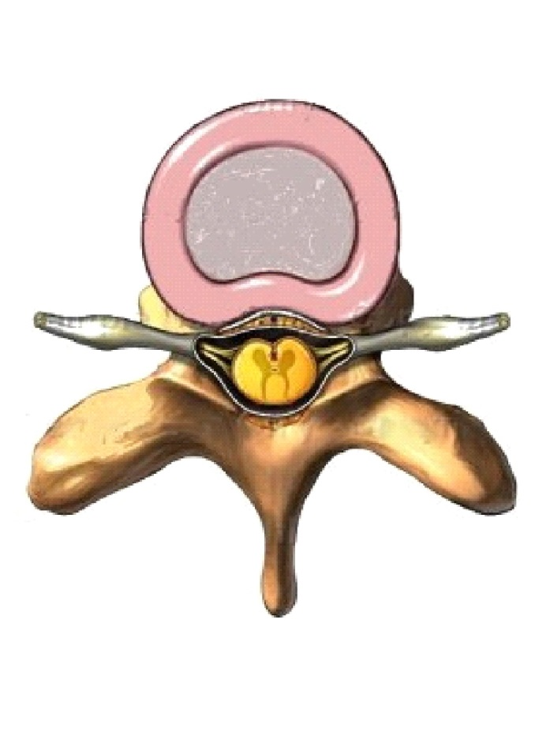
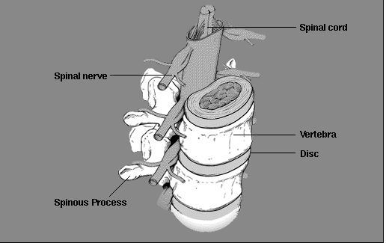
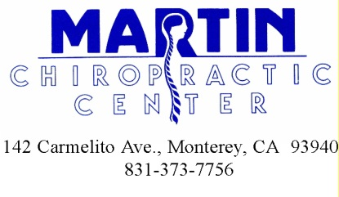

The Spinal Column and One Vertebrae

This is the most current information on this topic. Please
make good use of it in your health development. Pass on the information to those you care about so they can benefit too!
Stay focused on learning new Healthy Life Habits

