Think about Standing Up Straight.



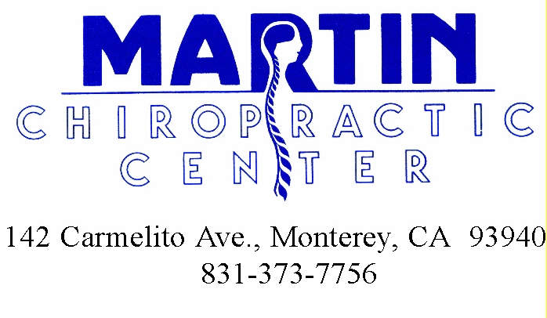
This is the most current information we have on this topic. Please make good use of it in your health development. Pass the information on to those you care about so they can benefit and be healthy too!
Use health promoting methods. Keep focused on Healthy Life Habits.

