Mental
Continuing education
Important books
Mentors
Hobbies
Music
Significant ideas
Love
Emotions
Tapes to listen to
People to learn from
Relaxation
Flowers smelled
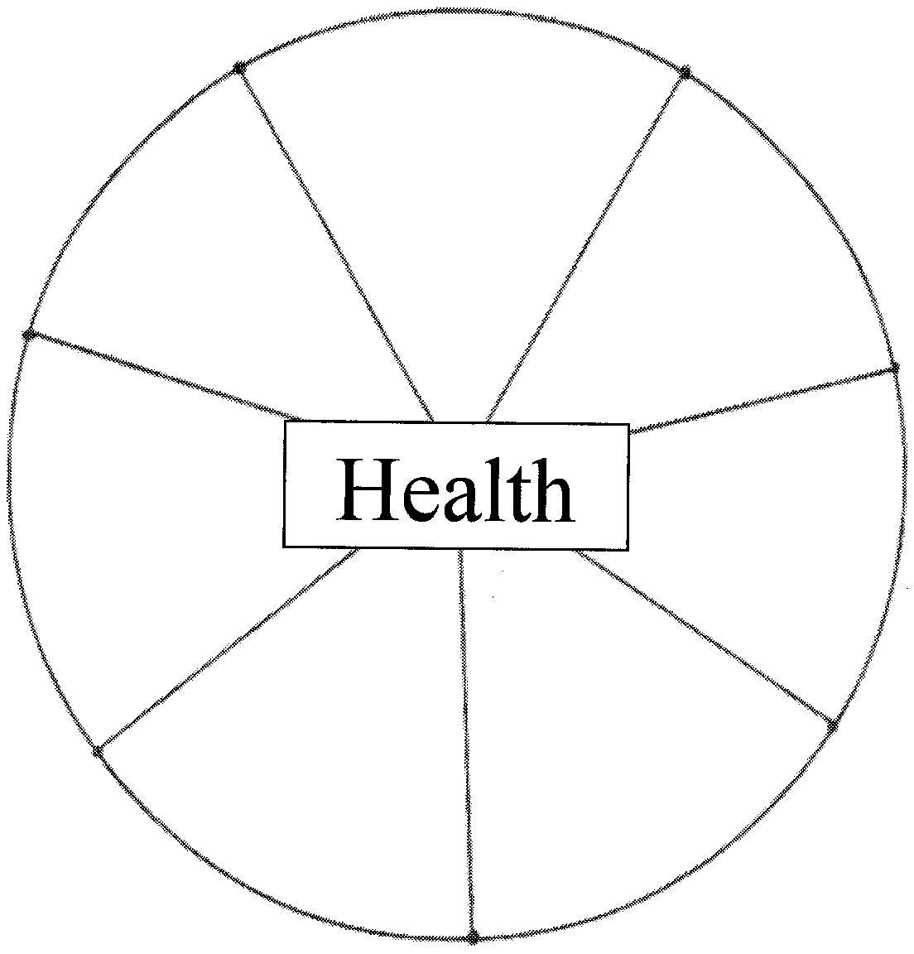 Sunsets watched
Attitudes
Formal education
Growth experiences
Creative activities
Cultural growth

Physical
Chiropractic Checkups
Posture
Health
Physical Condition
Holistic health care
Recreation
Weight
Sports
Energy level
Age – ten years, twenty, forty, etc..
Personal hygiene
Sleep and rest Patterns
Diet and nutrition
Preventive Maintenance
Overall appearance
Self image
Exercise/activities

Spiritual
Personal philosophy
Commitment
Tradition
Church affiliation
Participation level
Knowledge of faith
Financial contributions
Teaching
Sharing your faith
Family’s faith
Prayer life
Regular attendance
Reading/study
Spiritual fulfillment
Feeling of tapping into
a greater power
Meaning of life

Career
Current situation
Vacations
Educational opportunities
Retirement plan
Insurances
Benefits
Sense of fulfillment
Potential growth
20 Years from now
Lifestyle provided
Challenge offered
Camaraderie
Time commitments
Satisfaction
Self-improvement
Business skills
Helping others
Developing staff

Social
Clubs and
Organizations
Relationships
Public speaking
Mastermind groups
Social skills
Community
involvement
Political
involvement
Service to
country
Charitable efforts
Friendships
Entertaining
others
Reputation

Family
Marriage status:
Love relationship
Mutually set goals
Parenting skills
Number of people in family
Family activities
Vacations
Family environment:
My parents
My Children
Other relatives
Self-esteem taught
Love instilled
Children’s education
Values/morals shared
Reunions

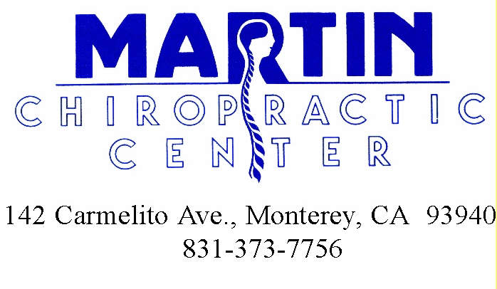

This is the most current information on this topic. Please make good use of it in your health development. Pass it on to those you care about so they can benefit too!

