WORKPLACE CAMPAIGN EMAILS

Email 1a: Campaign Welcome and Kick-Off
Audience: All company employees
Image:
Use below or your own images.
Subject line Together, we are United in Purpose
Preheader text When we are United, we can do more for White County

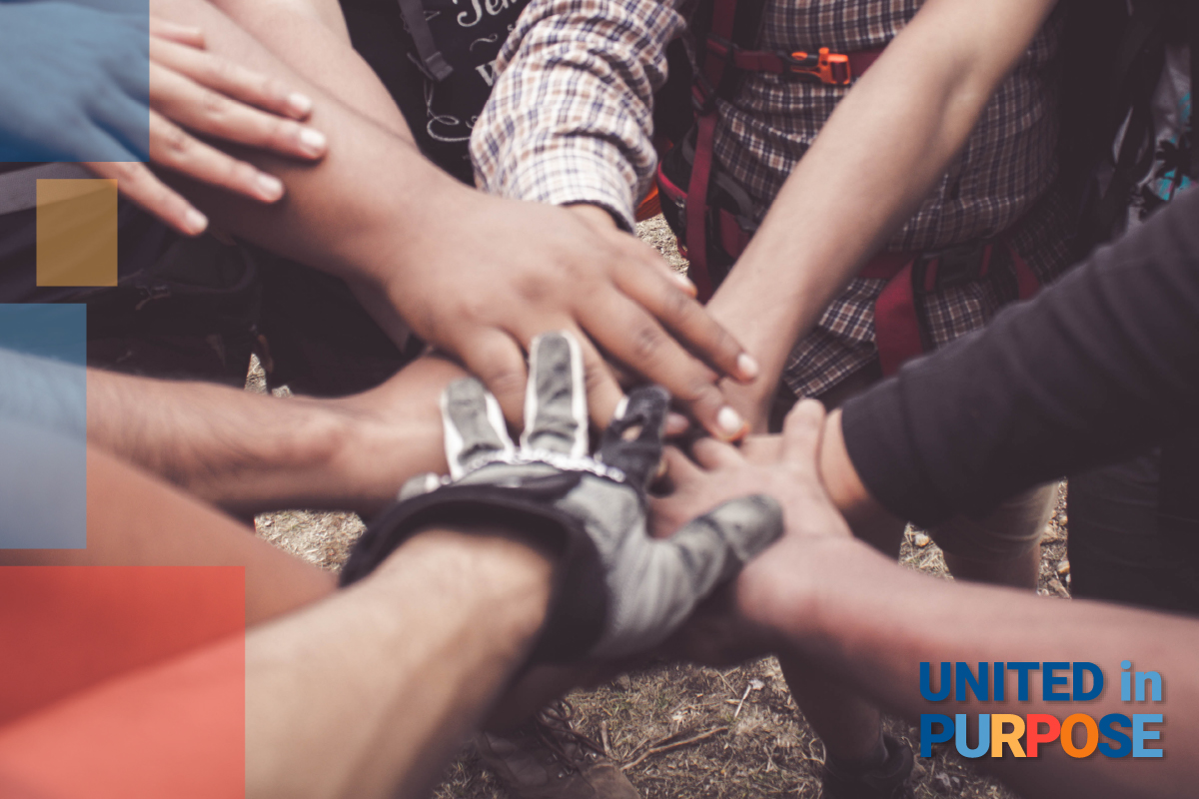

Body Dear [First name],

Every day, United Way of White County brings people together to support communities where everyone can access a quality education, build economic mobility, and live a healthy life. Our work is powered by people, and local businesses like [company name] that are committed to supporting the strength, vitality, and resilience of our community. This is not a regular campaign request. Joining United Way to be United in Purpose is a call to purposeful action.

To be United in Purpose is to recognize and amplify our power to make a meaningful difference in the community where we work and live. It’s not just a one-time gift to a single issue that will resolve quickly, but a call to collaborate on the complex issues White County faces. Here in [Anytown], we’re making a difference in thousands of people's lives every year.

By coming together to be United in Purpose, we can do so much more to accomplish goals that can change lives, like

• Programming that helps hardworking families living paycheck to paycheck make ends meet and gain financial independence.
• Community Investments for non-profit organizations in White County that collectively make a major impact annually.

We only succeed when we collaborate and become United in Purpose with people like you who care about our community, and collaborate with others to advance programs that meet urgent needs today while building strength for tomorrow. Join us today.

Closing,

Signature

Email 1b. Campaign Kickoff and Welcome

Subject line Together, we are United in Purpose
Preheader text When we are United, we can do more for White County!
Image: 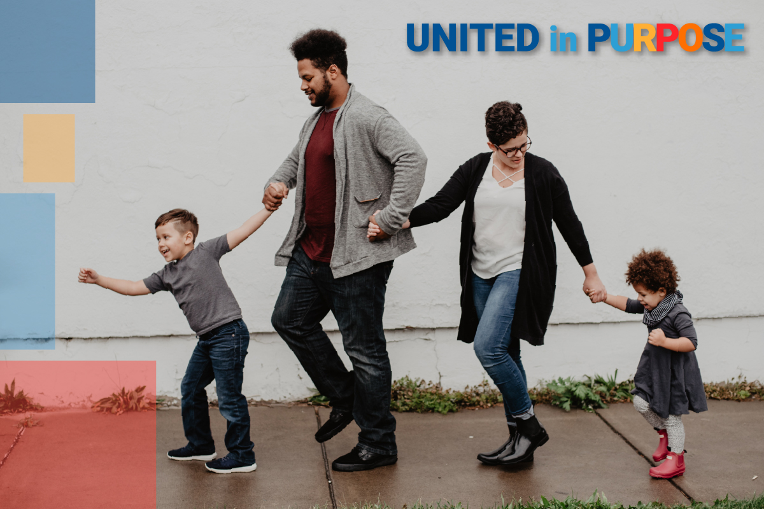
Body

Dear [Employee name], Our community is facing a number of challenges. Many hardworking families are living paycheck to paycheck and struggling with the cost of living. We are facing an affordable housing crises. People are reaching out to foodbanks and utility assistance organizations now more than ever. And, our children are suffering the consequences.

Tough times call for strong action and for us to dig deep and show up ready to join others in a spirit of collaboration. I’m excited to invite you to help improve the health, education, and economic mobility of every person in our community by becoming United in Purpose. This is more than a campaign – it is a call to action for us at [company name] to come together with thoughtful intention to support local solutions in the communities where we live and work. We have set an ambitious goal of raising [monetary goal/description] to help our neighbors thrive and strengthen our community. We’re counting on generous people like you and your teammates to help improve the lives of people in our community.

United Way of White County helps a variety of people in the community, such as grocery store stockers, caregivers, and hardworking teachers. They also help families who are struggling to choose between food or rent, neighbors at risk of losing their homes, and those facing difficult situations such as disabilities or abuse. The people helped by United Way are members of the community and often our neighbors.

Thank you in advance for your valuable support and demonstrating what it means to be United in Purpose at [company name].

Closing, Signature

Email 1c. Why Give to United Way

Subject line What makes United Way of White County so special?
Preheader text United Way is LOCAL, all over the world.
Body

Dear [First name], If you’re deciding whether or not to be United in Purpose [link to your campaign page/donation mechanism], you might be thinking, “Why United Way?” Allow us to introduce ourselves. United Way brings people together to build strong communities where everyone can get a quality education, a good job, and live a healthy life. But we don’t do it alone: United Way unites people, organizations, and communities in purpose. Together, we mobilize resources swiftly and purposefully to address needs and make life better for every person in every community. United Way helps our community be United in Purpose. Through United Way, your neighbors are making meaningful change, whether by charitable giving, volunteering, or speaking out for policies that improve our community. Funds raised by United Way of White County stay in White County.Together, we can make a difference and make life better for those who need help the most right now. Join us today.
[Attach Pledge Form}

Closing, Signature

Image:

Reminder Email

Subject: Time is Running Out
From: Board or Campaign Chair, or Company Contact
Audience: Company employees who have not made a campaign gift
C2A: Make your gift today

Image:

Subject line Time is running out to become United in Purpose!
Preheader text [Customize this for the countdown you want to maintain, I.e., one week, few days, today’s the last day!]
Body

Dear [First name], Whether you are interested in helping children or helping the homeless,
United Way of White County gives you an opportunity to make a direct impact on the issues you care about. Through United Way of White County, you can help advance effective solutions to community challenges making life better for every person.

With United Way of White County, we can build on [company’s] legacy of service to become United in Purpose. Join us today. [Attach Pledge Form].

Closing, Signature

General: Thank you Email
From: Your CEO/CPO, Campaign Chair or Company Contact
Audience: ALL company employees
Image:
Subject line Thank you! You’ve changed lives in White County
Body

Dear [First name], Join me in celebrating the incredibly successful [workplace giving campaign name] community-building effort! It takes an entire community to change lives. I could not be more appreciative that I work in this one.

I’m thrilled to report: [Company name] employees
- gave $ [dollars pledged] to United Way of White County
- [participation rate%] of [Company name] Employees gave to United Way of White County [number of donors] of [Company name] employees gave to United Way of White County

I thank you on behalf of the families, children, neighbors, and friends who will benefit from your generosity.

Closing, Signature

