**Special Unit Types and Formations**

Each of the national armies fighting in this campaign has a unique quality and tactical doctrine which is revealed in the rules and will necessarily change the perspective and play of the contestants.

***Elite* Infantry Troops (Grenadier Units)**

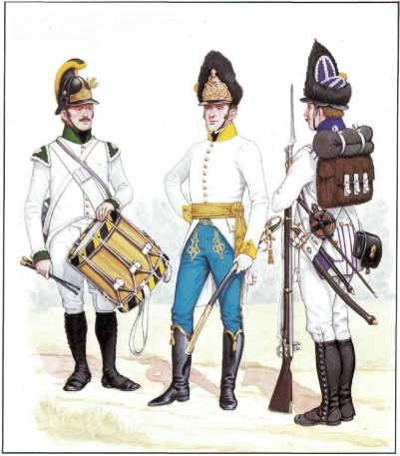A well trained and experienced infantry formation was able to refrain from firing until the command was given at close range. The discipline of *elite* troops and their ability to hold fire to the critical moment of an assault, despite loses, made them the ultimate reserve.

*Elite* infantry troops are defined as those with a printed morale, without modification, of **11 through 16**. When an *elite* unit fires defensively against any attacking hex and the attacker suffers a loss, the pre-melee morale check of all units participating in that attack, are impacted.

The effect is that all the attacking units in this case suffer a negative adjustment to the pre-melee morale check. The exact adjustment depends based on the morale of the defending unit with the lower the defender’s morale number, the higher the negative adjustment. A 15 or 16 morale is minus 6; a 13 or 14 minus 9: an 11 or 12 is a minus 12. These minus values are applied as modifiers to the attacker’s morale for each increment the attacker lost due to the Defensive Fire Attack.

When an *elite* unit attacks, the opposite is true. If the attacker inflicts a loss the pre-melee morale check of the defender all the defending units are impacted utilizing the relationship identified above. The attacking units must however have stacking points in a relationship of at least 1 to 1 of the defender.

If an *elite* unit is the attacker against an *elite* unit, this rule does not apply. In the event of an *elite* vs. an *elite*, the attacker has the standard modifier of minus 3 for each fire increment loss.

**Cavalry Recovery of Readiness**

Cavalry may not recover a level of readiness if it is in an enemy zone of influence or is under fire as a target of an offensive or defensive attack (feu).

**Karl’s Legion Troops**

Due to the soldier’s late mobilization and limited training, these Austrian troops are restricted to specific formations which they may adopt.

**Karl’s Legion** may only be in **Column**; **General Order; Skirmish; Carre; Masse** or **Marche Order**. These troops do not have the option of forming into line.

Karl’s Legion battalions that have a *range factor* of two, on the specific side of their counters, may enter *Skirmish formation*.

**Austrian Tactical Formations**

It is very important for the Austrian player to understand the use of these formations.

In accordance with the Instructionspunkte für die kk Armee zur Campagne des Jahres 1794, the doctrine is for Austrian and Hungarian Infantrie to attack and defend while in *line* formation. Many reforms were implemented but their use was sporadic. Some infantry had only received the most elemental training. Grenadiers were well trained troops.

All infantry battalions of the same regiment must be in the same formation at the same time, if possible. This requirement does not apply to Jaegers, Grenz or Karl’s Legion, nor does it apply if one of the units is currently in terrain which requires it to be in General Order or other types of morale conditions or in response to a cavalry charge.

The basic *line* formation regulations apply to all Austrian Infantrie and Grenadiers at the battle. These include fire defense, movement and fire multiplier.

* When charged by enemy cavalry, Austrian and Grenadiers Infantrie may not attempt to form *Carre* from either *column* or *battalion masse* or *divisional masse*. They may freely form *Carre* during their own movement phase, by paying for the formation change.
* In compliance with the standard Premier ME rules, all Austrian Infantrie in Line formation are **minus two** from their printed movement value.
* Austrian 0r Hungarian Linie Infantrie, in lines **subtract three** from the printed (column) morale values

**Austrian or Hungarian (Linie or Grenadier) *Battalion Masse***

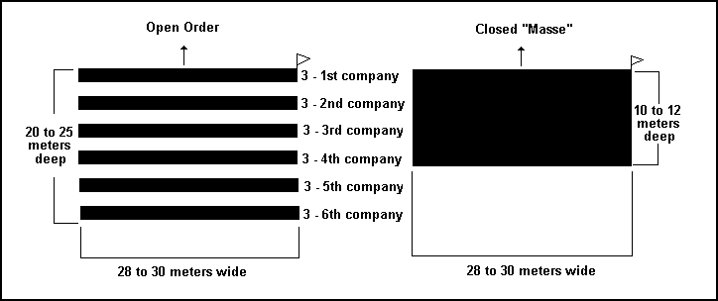Based on the Tactical Reforms of Archduke Charles,

as detailed in the *1807 Exercier-Reglement,* the *Battalion Masse* has the following characteristics;

* Only battalions may use this formation, and only in clear terrain. One battalion in a hex.
* The *Battalion Masse* faces a hexside. Use an informational counter to designate, when the battalion is in *Masse.*
* A *Battalion Masse* has 3 front and 2 flank and 1 rear hex sides.
* The *Battalion Masse* will exert a zone of influence into hexes adjacent to their front.
* *Battalion Masse* moves at minus two from the printed value; fires as a column; and has a fire defense of 5 from all orientations.
* 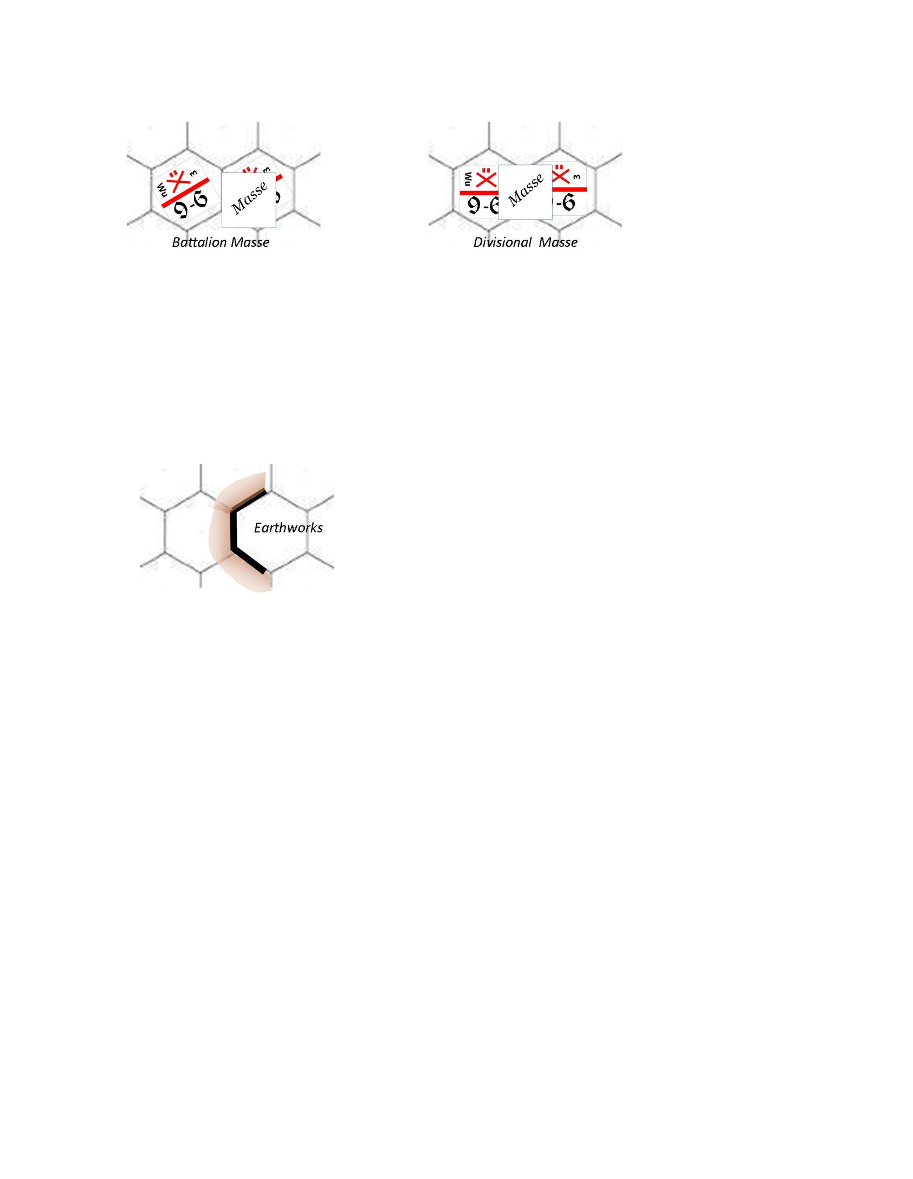*Battalion Masse* may only form *carre*, during the friendly movement phase.
* When an enemy cavalry combat formation charges a *Battalion Masse*, the infantry must check morale in an attempt to stand in its current formation, and when doing so adds 3 to the die roll. All other charge modifiers apply.
* Cavalry does not receive the doubling bonus for having charged in a straight line for the last three hexes, when attacking an Austrian *Battalion Masse* formation.
* Cavalry which melees an Austrian *Battalion Masse* has the cavalry melee value **X.5** after adjustment for losses. Lancer rules effect a *Battalion Masse*
* Artillery may not stack with units in *Battalion Masse*
* *Jägers* and *Grenz* infantry Types may not adapt Battalion Masse.

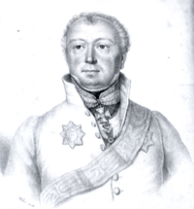

**Freiherr von Wimpffen**

Maximillian Freiherr von Wimpffen was born in Westphalia and was initially an officer of Infantrie Regiment 9. Clerfayt and Grenadier Battalion Morzin. Eventually he became a member of the General Staff of the Imperial and Royal Army, General-Adjutant and Chief of Staff to Karl. Von Wimpffen was awarded the Commander Cross of the Order of Maria Theresa at the conclusion of this campaign. He was responsible for the planning of Aspern-Essling, one of Napoleon’s few defeats. Aspern-Essling occurred approximately one month after Eggmuhl.

*Masse* formations, as described below; are only available to the Austrian Army. These specialty formations resulted from Austria’s experiences with the French cavalry during the battles of the Third Coalition. Von Wimpffen helped develop and train troops in their use.

**Austrian or Hungarian (Linie or Grenadier) *Divisional Masse***

* Only battalions of a regiment may use this formation and only in clear terrain. One battalion to a hex.



* The *Divisional Masse* faces a hex vertex. Use an informational counter to designate, when the battalion is in *Masse .*
* A *Divisional Masse* has 4 front and 2 rear hex sides.
* The Divisional *Masse* will exert a zone of influence into hexes adjacent to their front.
* *Divisional Masse* moves at plus one to the printed value; fires as a column; and has a fire defense of 6 from all orientations.
* *Divisional Masse* may only form *carre* during the friendly movement phase.
* When an enemy cavalry combat formation charges a *Divisional Masse*, the infantry must check morale in an attempt to stand in its current formation, and when doing so adds two to the die roll. All other charge modifiers apply.
* Like with a *Carre*, charging or moving cavalry may move adjacent, then on top of, and then adjacent to the *Divisional Masse* depending on movement points. The *Divisional Masse* fires defensively at each forward location or when cavalry is in the same hex. See Rule 15 Carre.
* The *Divisional Masse* fires x 1.5 value on the increments in the hex when cavalry is in the same hex. Cavalry treats the Divisional Masse Formation as an enemy *Carre* for all purposes except as outlined herein. In real terms the cavalry rides through the formation the same as a *Carre*.
* Cavalry does not receive the doubling bonus for having charged in a straight line for the last three hexes when attacking an Austrian *Divisional Masse* formation.
* Cavalry which melees a *Divisional Masse* has the cavalry melee value X.75 after adjustment for losses, whether adjacent or in the same hex. Lancer rules effect a *Division Masse*
* The *Divisional Masse* cannot voluntarily enter a zone of influence.
* Artillery may not stack with units in *Divisional Masse*

**Austrian Artillery Organization**

Austrian Artillery is not centralized as with other armies of the day.

Austrian brigade may only stack with infantry or other brigade batteries of the same korps.

Kavallerie Batteries may only stack with other Kavallerie batteries.

Batteries of position may only stack with infantry or batteries of position from the same korps.

**Artillerie Leaders of Special Ability**

Artillerie leaders of special ability may combine artillerie fire from three hexes, on a single target. For this battle that includes Napoleon only.

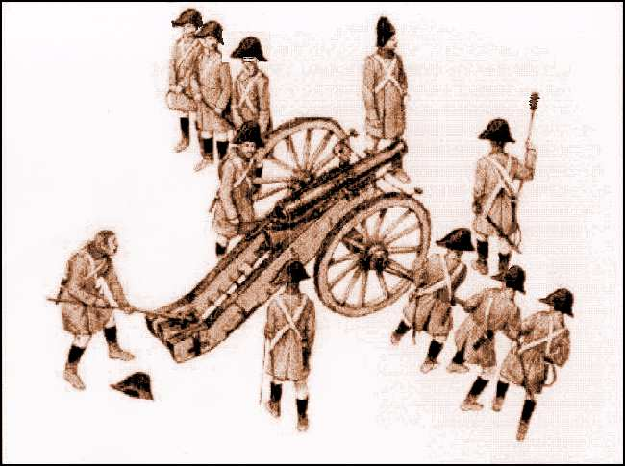

Karl, von Wimpffen and other Austrian Korps and French Corps commanders may combine two adjacent stacks of artillery, on one target hex.

Von Wimpffen, Grunne and Major Perl may combine any type of artillery, of the same Korps, in the hex he is in. He must remain in the hex for the combination to continue. If he leaves, limber and reorder as required. He directs fire at a single target.

**Austrians in Towns and Villages**

The Austrian Army was effective at digging into and fortifying strong points

* Austrian or Hungarian Linie Infantrie (not *Grenz* or *Jägers*) **subtract two** from their printed morale value when in a town or village hex.
* Austrian or Hungarian grenadier and linie printed fire values are multiplied by 1.5 during defensive fire when in towns and villages.
* Karl’s Legion **add two** to their printed morale value when in a town. They are much easier to control in the open rather than dispersed in a town. No change for village or hamlet.

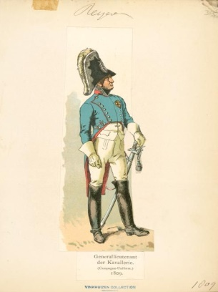**Rheinbund Infantry**

The Bavarian and Württemberg Infantry have the same tactical flexibility as the French.

**Morale Levels**

Consult the *Morale Levels Summary*. The chart sets a threshold, at the hour, to check the condition of the organization based on the number of battalions PGD or eliminated. Cavalry and Artillery don’t count against this total and are not affected.

The French Army is by Corps. The French VII Corps is a mix of French and Bavarian Units. The VIII is really a large Württemberg Division. The Austrian Army is by Korps

The Austrian Army had only recently developed a corps (korps) system of organization. They had made progress but lacked the experienced staff officers of the French. Karl was committed to using the Korps structure.

For the elite troops like the Grenadiers, being on level one does not really present a problem. They are designed for shock combat, as a reserve and not to man a line. The line regiments have large battalions and are oriented for sustained combat. However their organization is somewhat brittle.

Therefore, the Austrian player must be careful to watch the morale levels of each division. When one reaches level one it is best to pull it from the line, if possible and rotate with a fresh division. That also means not using all the divisions at once allowing for fresh reserves and frequent rotation when the fates go against battalions of a division.

If an Austrian Korps gets to level two, it is in danger of rapidly reaching level three. This is because the morale modifiers are cumulative. A 32 morale may become a 42 as a base at morale level two. If this battalion is routed, the morale becomes 52. If a Korps gets to level three, it rarely returns to level one. In essence it is finished for the rest of the day.

Morale management is a key consideration for the vast Austrian Army.

**Defining the Austrian Army – Informational Note**

The Austrian Army basically has two components, Royal and Imperial.

The Royal Army includes all of the regiments and batteries of Austria proper. Areas like Upper and Lower Austria; Steiermark; Burgenland; Salzburg; Tyrol and Carinthia for example.

The Imperial Army includes all of those regiments and batteries of the other areas controlled by Austria. This includes locations in Italy; Hungary; the Balkans; Poland; Germany; Bohemia; for example. Note: at this time Prussia is not Germany.

Therefore the Austrian Army operates with several languages and cultures.

**Scenario Information**

Scenario One is an equal contest between two corps per side and represents the first day of the battle, April 21, 1809

In Scenario Two the French are reinforced and the Austrians execute a slow withdrawal to the North and back to Austrian

Scenario Three combines the reinforcement of the French with Napoleon and Karl’s concept of the offensive he had planned to crush Davout.

**Timed Moves**

French 10 minutes and Austrian 8 minutes