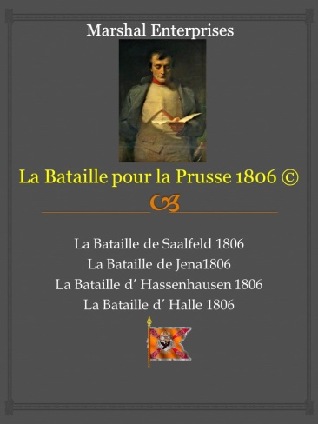
Instructions for counter sets for La Bataille pour la Prusse 1806

Each seven sheet set is $70.00, which includes postage. These are unused, original counter sheets left over from the printing.
- Coalition A,B
- French A,B,C,
Available only to domestic (USA) customers; given the postal expense for overseas.
Only one set per customer.
ME is only accepting checks or money orders as payment.

Please send you order with a complete address and payment to :
Marshal Enterprises
3031 Iroquois St.
Detroit, MI 48214

If you have any questions please email me at vonspor@labataille.me

