Organizational Charts and Counter Clarifications for the Austrian Army

1. In the III Korps there are two counters for the 21 Hussars. Use either one.
2. 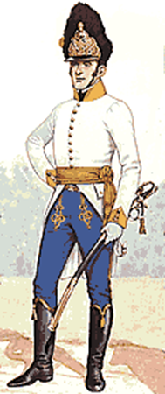In the III Korps Advanced Guard, the Karl’s Legion regimental counter is denoted as an “H” on the counter and an “L” Organizational Chart. They are the same Regiment. (black and blue)
3. In the IV Korps, the Artillery should be as follows:

AG -Kavallrie batterien (1,2)

Somarriva – Bridgade Batterie (3) black

Bartenstein – Schwer Position (1), Position Batterie (1) red and Brigade Batterie (2) black

There is not a spot for Brigade Batterie (3) on the Org,Chart but the batterie should be used.

1. In the Reserve Cavalry Korps – Segenthal is included as the commander. It was decided not to include a counter for all the brigade commanders, as is typical. They are denoted in the scenario for identification only.
2. In the VII Korps there are two spaces on the Organizational Chart for Sharouth. One with the leaders and one with the cavalry. Use either space.

Please forward any questions you may have to vonspor@labataille.me