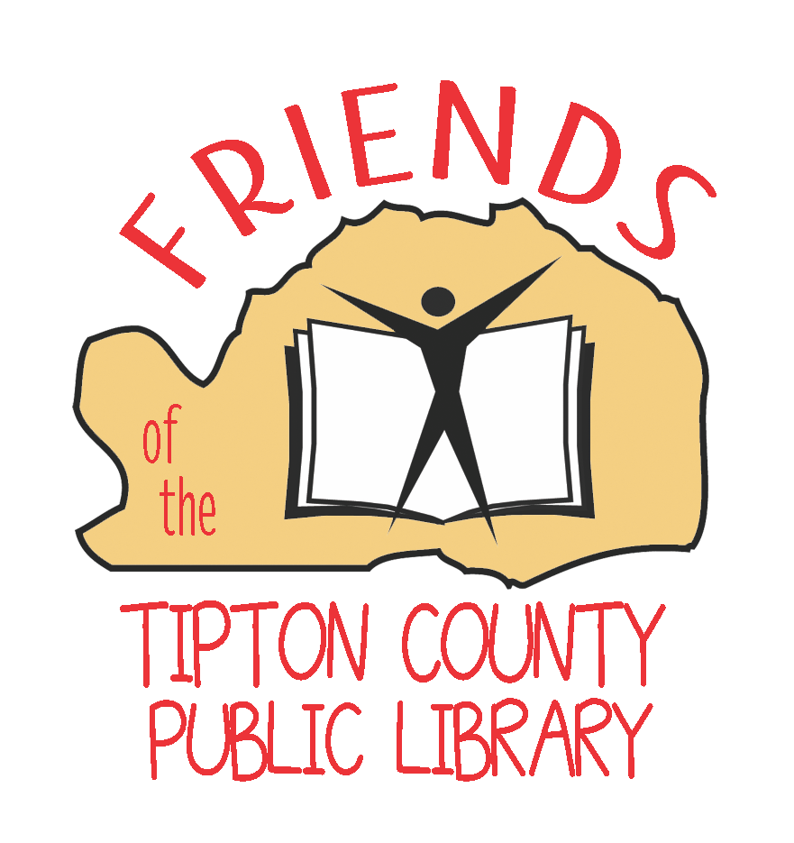
Friends of the Tipton County Library
Membership Application
The Friends of The Tipton County Public Library is a 501c3 non-profit, your membership and donations are tax-deductible.
Name: _______________________________________________________________________________________________________________
Mailing Address: ___________________________________________________________________________________________________
City/State: __________________________________________________________________________________________________________
Zip Code: ________________________ Phone: __________________________________________________________________________
Email: _______________________________________________________________________________________________________________
How would you like to receive the newsletter? (Please check one): □ E-mail □ Regular Mail
Please choose your membership category: □ New Member □ Renewal
□ Senior (55+) or Student (4-17) $10.00

- Friends Newsletter
- Buy 4 get 1 Free book sale
- Advanced notice of books sales and events

□ Individual Membership $15.00

- Same benefits as above

□ Family Membership $30.00

- Same benefits as above plus
- 10% discount on Friends merchandise

□ Patron Membership $50.00

- Same benefits as above plus
- 25% discount on Friends merchandise

□ Super Friend $100.00

- Same benefits as above plus
- 25% discount on Friends merchandise
- Free Friends of the Library book bag

□ Lifetime Membership…………………………………………………………………………………………………...$500.00

- Same benefits as above plus
- 25% discount on Friends merchandise
- Free Friends of the Library book bag

□ Organization Membership $200.00
- Logo on newsletter, website, and book bags

□ Check here if you would like information about serving on the Friends Board, assisting with a committee, or volunteering with the Friends.

Please print this form and make checks payable to the Friends of the Tipton County Public Library.

Completed forms and checks should be mailed to
Friends of the Tipton County Public Library, 3149 Hwy 51 S Bldg. C, Covington, TN 38019.

Your membership card will be mailed to you. Thank you for your membership.

