**Your Child by 2 Years of Age**

How your child plays, learns, speaks and acts offers important information about your child’s development. Developmental milestones are things most children are capable of doing by a certain age. These are some of the developmental milestones for a 2 year old.

Fine Motor/Self-Help/Play skills

* Draws vertical and horizontal lines
* Builds simple block designs
* Holds crayon with thumb and fingers
* Uses a pincer grasp to pick up small objects (see picture)

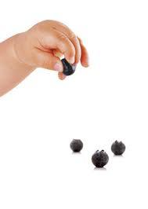

* Holds spoon in fingers- palm up
* Turns pages in a cardboard book, 1 at a time
* Places 3 shapes in a shape sorter or puzzle
* Independently removes socks and shoes and pulls pants down with assistance
* Displays shyness in unfamiliar situations
* Engages in imaginary play

Gross Motor Skills

* Runs without falling
* Walks up steps with or without handrail (may place 1 or 2 feet on each step)
* Jumps up with or without hands held
* Throws small ball overhand
* Kicks a ball

Language/Communication

* Follows simple, two step, directions (go to the car, get your jacket)
* Uses two word phrases (“mommy go”, “my ball” etc)
* Can say 50-100 words, parents/others understand speech greater than 50% of time
* Repeats words overheard in conversation
* Says names of familiar people , pictures and objects