Your Child by 4 Years of Age
How your child plays, learns, speaks and acts offers important information about your child’s development. Developmental milestones are things most children are capable of doing by a certain age. These are some of the developmental milestones for a 4 year old.
Fine Motor/Self-Help/Play Skills
- Holds marker/crayon with thumb, index and middle finger (see picture)
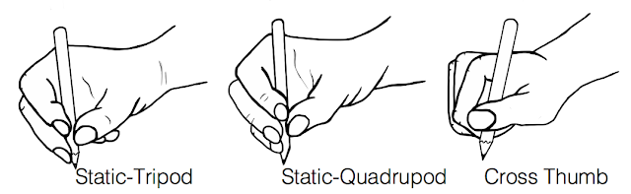
- Can draw a cross
- Draws a person with 2-4 body parts
- Uses scissors to cut on line
- Unbuttons/buttons large buttons
- Identifies 6 colors
- Uses utensils to eat
- Engages in turn-taking play
Gross Motor Skills
- Walks up and down stairs (alternating steps)
- Stands on tiptoes
- Runs and stops without falling
- Hops forward on both feet
- Walks on a balance beam without stepping off
- Throws tennis ball overhand and underhand
Language/Communication
- Follows 4-part directions
- Uses 4-5 word sentences
- Tells a story
- Counts four objects; rote counts 1 to 10
- Says first and last name
- Knows size and color adjectives
- Sings a song or recites a poem from memory
- Speech is more fluent; less repetition of words/sounds

