**Your Child by 5 Years of Age**

How your child plays, learns, speaks and acts offers important information about your child’s development. Developmental milestones are things most children are capable of doing by a certain age. These are some of the developmental milestones for a 5 year old.

Fine Motor/Self-Help/Play Skills

* Uses a mature pencil grasp (see picture)

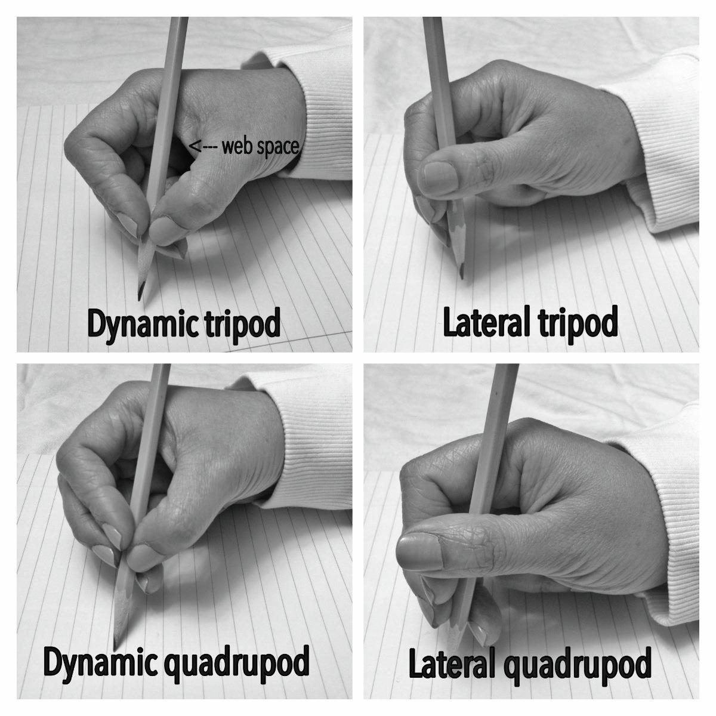

* Colors within the lines
* Draws a square and triangle
* Draws a person with at least 6 body parts
* Cuts out a circle and a square
* Touches with finger to thumb
* Can write some letters and numbers

Gross Motor Skills

* Jumps over 10 inches high off the ground
* Skips 8 steps
* Stands on 1 foot for 10 seconds on each leg
* Hits target with small ball 12 ft. away
* Catches a ball from 5 ft. away
* Completes 3 sit ups
* Hops on each leg

Language/Communication

* Uses 5-7 word sentences
* Tells simple stories clearly, using full sentences
* Uses future tense for example, “Grandpa will be there to see me.”
* Counts 10 objects
* Repeats days of the week in sequence, Says full name and addres