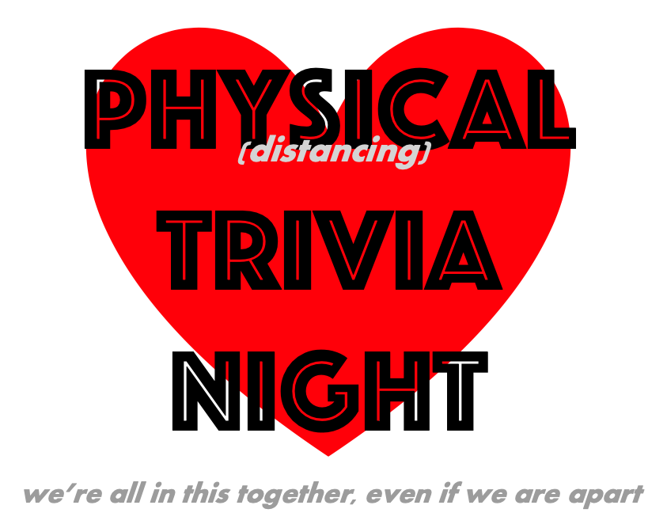

Team Name:

TOTAL SCORE: | / 75

RULES OF THE GAME
- Quizmaster is always right
- Please don't yell out the answers (or type them in the chat window). And don't sing along into the title of the song.
- No cheating. No Shazam. No Google. No Wikipedia. No phone-a-friend. Cheaters are jerks.
- When in doubt, see rule #1.

Part 1. Picture Round
1 | 6
2 | 7
3 | 8
4 | 9
5 | 10
PART 1 SCORE: / 10
Part 2. Short Answer
1 | 4
2 | 5
3 | PART 2 SCORE: /5
Part 3. Multiple Choice
1 | 4
2 | 5
3 | PART 3 SCORE: /5

Part 4. Music: Identify the title & artist for 1 point each
1 | Title:
 | Artist:
2 | Title:
 | Artist:
3 | Title:
 | Artist:
4 | Title:
 | Artist:
5 | Title:
 | Artist:
PART 4 SCORE: / 10
Part 5. Short Answer
1 |  | 4
2 |  | 5
3 |  | PART 5 SCORE: /10

Part 6. Music: Identify the title & artist for 1 point each
1 | Title:
 | Artist:
2 | Title:
 | Artist:
3 | Title:
 | Artist:
4 | Title:
 | Artist:
5 | Title:
 | Artist:
PART 6 SCORE: / 10
Part 7. Short Answer
1 |  | 4
2 |  | 5
3 |  | PART 7 SCORE: /5

Part 8. Music: Identify the title & artist for 1 point each
1 | Title:
 | Artist:
2 | Title:
 | Artist:
3 | Title:
 | Artist:
4 | Title:
 | Artist:
5 | Title:
 | Artist:
PART 8 SCORE: / 10
Part 9. Short Answer
1 |  | 4
2 |  | 5
3 |  | PART 9 SCORE: /5

Part 10. Short Answer
1 | 4
2 | 5
3 | PART 10 SCORE: /5
Part 11. BONUS
1 | 4
2 | 5
3 | PART 11 SCORE: /5
Tiebreaker
In case of a tie, you will be asked to print your team’s answer clearly in the space below. Winner is the team closest to the correct answer.

brought to you by the good people at:

Follow us: facebook.com/customtrivia
Message us: mike@customtrivia.com

