Acceptance and Commitment Therapy (ACT)

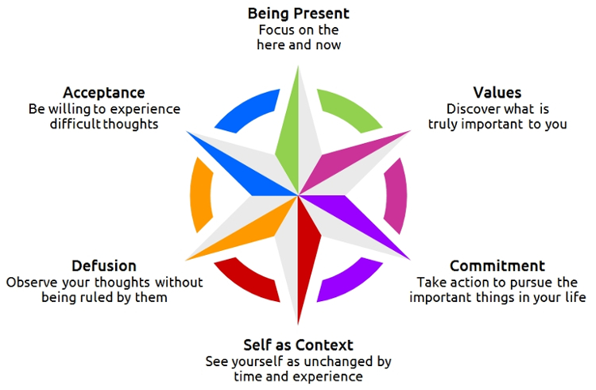
ACT is a set of skills and strategies, a way
of thinking about ourselves, the world and
our problems, which helps us to live a better
life.

ACT helps us to work out what is truly
important and meaningful in our lives –
our values – and to find ways to live out
our values in small ways every day.

ACT teaches us ways to relate to difficult
thoughts and feelings differently, so they
have much less influence over our lives.

Key Components of ACT:

A Accept your feelings and thoughts, and be present
Through mindfulness practice, we develop insights and expand our awareness of our uncomfortable thoughts and feelings. We find ways to let them be there rather than trying to avoid or control them.
C Choose wise actions in line with your values
We identify what it is that truly gives your life richness and meaning, exploring “choice points” where we can take actions which align with out “best selves” or take us away from our values
T Take committed action
We find ways to do the things that bring your life meaning and richness every day

Change the things you can change
Accept the things you can’t change
Practice being fully present so you gradually learn to know the difference

We learn to explore our emotional experiences from a place of curiosity, compassion, and acceptance.

We trust that painful feelings are a part of living a rich, fulfilling grand life.

We understand that the illusion of control – over ourselves, our lives, the world, and the future – can cause internal “struggles” which help us to feel better in the short term but compound problems over the long term.

We understand that when it comes to your thoughts and feelings, even if they are uncomfortable and unpleasant…
It’s OK if they come
It’s OK if they stay, and
It’s OK if they go

