2024 TCGH Health Clinic




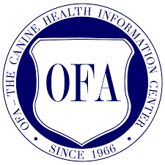

Date: November 2nd, 2024
Time: 10:00 a.m. - 2:00 p.m.
Location: Gulf Coast Animal Eye Clinic
1551 Campbell Road, Houston TX 77055

Dr. J.F. Swanson, board certified ophthalmologist, will examine for hereditary eye defects and complete forms for OFA CAER certification.
Dr. Jenifer Lunney, board certified cardiologist, will conduct a basic cardiac (auscultation only) exam to detect heart murmurs and will complete OFA forms.
Dr. Max Banwell, board certified orthopaedic surgeon, will conduct patellae exams and complete OFA forms.

Preregistration and prepayment are required. For more information and payment options, please visit toyclubgh.com.

Questions? Contact the TCGH Health Clinic Chair: Mary Nicole Morrison
Tel: (281) 932-2807 E-mail: ckcsmommy@yahoo.com

We look forward to seeing you & your dogs there!

