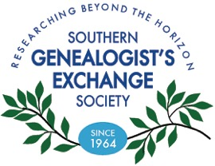

Past and Present
Newsletter of The Southern Genealogist’s Exchange Society
June 2019

Quote of the month
“Plagiarism: Stealing a ride on someone else’s train of thought.”-- Russell E Curran

Genealogy detectives at the SGES Library
AA-8 Passports of Southeastern Pioneers 1770-1823
by Dorothy Williams Potter

Don't let the title of this book fool you as it is a treasure trove of information for people that lived in the southeastern United States! This amazing book contains transcribed information from passports that were issued for individuals and families that wanted to travel or migrate to the "foreign lands" of Indian, Spanish, and British Territories. The entries provide the names of the passport recipients, the official granting the passport, the date the passport was granted, plus sometimes the county they lived in or other tidbits. You never know what you might find in this little gem!

Announcements
The SGES Library is staffed by volunteers. It is our intent to be open the specified days and times indicated in this newsletter. Issues do occasional arise, so we ask that you call ahead 904-778-1000 to make sure library will be open the specific day you wish to visit.

Troy Bruce Poe passed away February 26, 2019 and was buried in Wildwood, Florida.
He had been a member of SGES since 2002. Troy was born in Alabama but lived most of his life in Florida.

Story of the month
By Kathy Sutherland Finn

Years ago, in the 1970’s, I noticed a small amber crackle glass pitcher in my Mother’s china cabinet. I asked her where it came from. She said, “It’s your Dad’s. Ask him.” I did. He said he had had it all his life and frankly, couldn’t remember where it originated.

Years passed. I forgot all about the small amber crackle glass pitcher, but I did become addicted to genealogy research, as most of us are. I knew my paternal Grandfather, Samuel Joshua Sutherland, quite well. He was the son of John Clark and Leah (Hamon) Sutherland. Sam was born in Kanawha County, WV in 1900. His father was John Clark Sutherland, b. 1860 in Russell County, VA. He married in Roane County, WV, 1888, Leah Hamon, b. 1866 in Roane County, WV. Leah Hamon was the first child of Joshua and Frances (Caldwell Ellis) Hamon. Her brother, Robert E. Lee Hamon followed in 1868. Robert married Syntha Leander Anderson b. 1871 and they had six children, the last being Okie Boyd “Hoot” Hamon b. 1902.

In 2017, with more time to devote to genealogy, I started digging deeper in my Hamon line.
I discovered, as most people do, facts they wished didn’t know and facts they were surprised by! In my research on the Hamon family, I found that Hoot, as he was always referred to, married Mamie Marie Byron b. 1909, and in 1930, Hoot founded Scott Depot glass factory in Scott Depot, WV. When I found this information, I still did not connect it to the little amber crackle glass pitcher that I had inherited, packed and hauled around for decades.

I had also been making it a point of adding old sayings and memories from family members to my tree. As I was working on my Dad, John William Sutherland, b. 1927, and his pithy sayings, I recalled a story he told of being 12 or 13 and his father, Sam, telling him on many Saturdays to get up, hitch the wagon and take his Grandmother, Leah Hamon Sutherland to visit her family. He always complained. He had better things to do, as all teenagers think. He told me he would drive her to visit her nephews at a “factory.” That factory was actually Scott Depot Glass

Factory. When I finally put it together, I looked at the little amber crackle pitcher again. It wasn’t marked and it had small dimple. A defect. I went online and typed in Scott Depot Glass and up popped Hamon Glass in Scott Depot! Hoot Hamon, the founder had three sons, Robert, Richard and Leo. Robert Lee Hamon b. 1925-2003 became a renowned artisan glass blower! I found websites with pictures of his gorgeous art! I was amazed!!

For fun, I typed in Hamon Glass on EBay and up popped an amber crackle glass vase with the Hamon Glass mark that was the exact mate of my pitcher!!! It was for sale for $3.95 plus shipping. I purchased and as soon as it arrived, I knew beyond a shadow of a doubt that my little pitcher with the dimple was Hamon Glass. I had found a family heirloom!!!

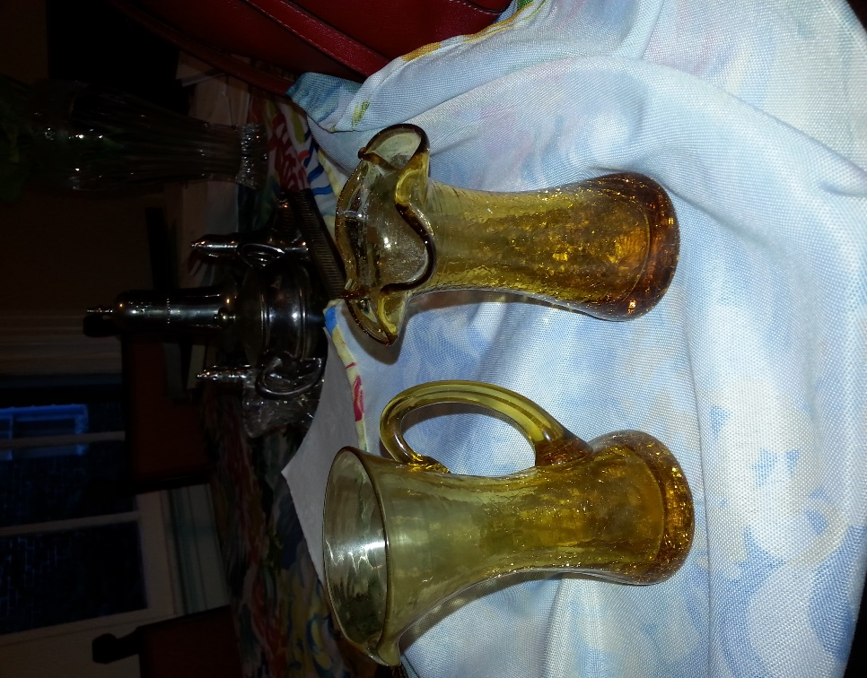
Now my scenario of how my Dad and then myself came to own that little defective amber crackle glass pitcher is thus: In 1940 Putnam County, WV, John, age 13 is forced to drive his grandmother, Leah Hamon Sutherland 10 miles in the wagon to visit her family. He’s put out. He sulks in the wagon. Hoot Hamon comes out to discard the defective pitcher and sees his “cousin” in a snit. He gives him the pitcher instead of tossing away. John just takes it home. Doesn’t pay one whit of attention and it just becomes one of the things he owns when he marries in 1950.

Now the little pitcher and vase are proudly displayed in the front in my china cabinet! I have written the story down and placed in each piece so if they are separated, someone will know their whole history. I still get excited every time I research and find something exceptional, but I don’t know if I’ll ever have another aha moment such as I had with the Hamon amber crackle glass pitcher and vase.

Website
Noted Genealogist researcher/author Thomas MacEntee has made available to the public, free access to his “Genealogy Do-Over” program. This is a project-based initiative to improve genealogy research skills while having fun too. Although started in 2018, it is still applicable in 2019.
Topics: 1) Evaluating Evidence and 2) Reviewing Online Education Options
For Month 6 of The Genealogy Do-Over we turn to one the most important and often neglected areas of genealogical research: Evidence Evaluation. As I’ve stated in the past, not determining whether a source was credible, would often come back to haunt me in later research. I’ve admitted this shortcoming and now I’m resolved to do something about it!
In addition, we begin to look at different types of educational opportunities available for genealogists. This month, the focus is on those offerings online, both free and fee-based. Ongoing education is a crucial part of not only becoming a good genealogist, but keeping your current skills finely honed and acquiring new skills!

Evaluating Evidence
Once I’ve gathered various bits of evidence for a proof point, such as my own birth date, and I’ve entered them in my research log, the next task: evaluating the evidence to determine whether my birth date can be proven or not.
In the past my evaluation of evidence consisted of saying to myself, “Well, if it is in a book it must be true!” or “If it is on someone’s tree, why would they lie?” Then I would enter the data in my genealogy database program and go on my merry way.
Now, I’m using a process to really look at the evidence I’ve found and to “rank” it based on certain elements.
I’ve included the basic evaluation information in a separate tab of my Genealogy Research Log so I can refer to it when evaluating a line entry in the research log. I also make notes in the Analysis column to support my theory as to proving or disproving my birth date.

Reviewing Online Education Options
Starting this month, The Genealogy Do-Over asks participants to starting reviewing options for genealogy education and the focus is online resources (we look for “offline” resources next month!).
As you can imagine, I’m a big proponent of not just genealogy education, but online genealogy education as well.
So why do we pursue genealogy education? Not only to become better genealogists, but also because new record sets come online or are available at repositories and we want to use them as efficiently as possible. In addition, we may discover an ancestor from a new location and we’re not familiar with research in that area.
https://abundantgenealogy.com/genealogy-do-over-month-6-june-2018/

©2018, copyright Thomas MacEntee. Used with permission.

New additions to the SGES Library
IN 041 Family Maps of Marion County Indiana –G Boyd
FL 563-563.5 Biographical Rosters of Florida’s Confederate & Union Soldiers 1861-1865
FL 1305 A genealogical Record of the Davis, Swann and Cabell Families of North Carolina
And Virginia—Thomas Frederick Davis
SC 238 Orangeburgh District 1768-1868 History and Records—Daniel Marchant Culler
HT 89 Courthouse Research for Family Historians—Christine Rose
FH 1307 When Descendants Become Ancestors—David A Kendall, PhD

